Table of Contents

**Acknowledgement: 3**

**1. Introduction: 4**

**2. Current System: 4**

**3. Problem Background: 4**

**4. Purposed System: 5**

**5. Objective for creating: 5**

**6. Outline Screen Design: 6**

**6.1 Index page: 6**

**6.2 News Page: 7**

**6.3 In Theater Page: 8**

**6.4 Coming Soon: 9**

**6.5 Ticket Booking Page: 10**

**6.6 Contact Form: 11**

**6.7 Login Form: 12**

**6.8 Registration Page: 13**

**7. Output Design: 14**

**7.1 Index Page: 14**

**7.2 News Page: 15**

**7.3 In Theater Page: 16**

**7.4 Coming Soon Page: 17**

**7.5 Book Ticket Page: 18**

**7.6 Contact Page: 19**

**7.7 Login Page: 20**

**7.8 Registration Page: 21**

**7.9 Book Success Page: 21**

**7.10 Registration Success Page: 22**

**7.11 Sign Up Success Page: 22**

**8. HTML and Internal Java Script Program Listing: 23**

**9. Test Case: 24**

**9.1 Sample Test Cases: 25**

**10. User Guide: 44**

**10.1 Minimum System requirement: 44**

**10.2 User Manual: 45**

**11. Conclusion: 47**

**11.1 Strength: 48**

**11.2 Weakness: 48**

**11.3 Enhancement: 48**

**References: 49**

**Turnitin Report: 50**

# Acknowledgement:

Among the various courses, I choose Information Technology (Computer Science) as my Bachelor degree. Subject which is very crucial as well as fundamental to be more practical and familiar with the computer technology, science and human world. For the course I choose **Informatics College Pokhara** for my further career.

In conducting this report, I have received munificent help from many personnel, which I like to put on record here, with deep gratitude and great pleasure.

First and foremost, I am obliged to my college. I must honestly admit that I am lucky enough to get this life time opportunity to expose myself to **CPG103 project**.

I would like to thanks all my Informatics family for such kind support. I would like to express my heartily gratitude to my teachers **Mr.Topman Garbuja** for providing details and various opportunities to this assignment.

Thanks again.

Bibek Poudel.

# Introduction:

Website is a group of World Wide Web pages usually containing hyperlinks to each other and made available online by an individual, company, educational institution, government, or organization.

The title of my project is “Watch Trailer” where the main goal provided to the user is to watch all the latest Hollywood movies trailer as well as the primary goal is to book a movie ticket online. This website is made by using HTML, CSS and JAVASCRIPT to obtain the final result. User can find the all movies trailer in home page, interesting news in news page, and upcoming movies in coming soon, movies which are playing in cinema hall are listed in in theaters, and in contact page the user can book a movie. At the top of the home page the user can find the login and registration page where user can register their details to login the website. Each and every form pages are well validated of this website but still it doesn’t stores the registered user information.

# Current System:

The present system of this site is established by utilizing HTML codes just and the recognition is not in the correct method. The site has an unsightly looks with minimum functions. That site is simply utilize for the news function specifically.

# Problem Background:

Trailer can be described as “an ad or an industrial for a feature movie that will be displayed in the future at a movie theater, the outcome of technical and innovative work.” I have chosen this website as my project because I have seen people cannot find movie trailer list, their proper review, and booking system online at same website, they have to visit different website for movie information. On the other hand, the major problem of this website is that the interface of this site is not more appealing for the users. The user’s information and booked tickets are recorded in a note pad.Some are poorly designed with irregular position of content which makes confusion to the viewers, have bunch of different links, doesn’t have form validation for booking and many more. So, I tried to improve some of the problems in this project.

# Purposed System:

I have actually purposed this system altering all the codes by utilizing CSS, JavaScript and HTML codes. Generally the JavaScript are utilized for the recognition of the kind aspects, the CSS is not more utilized more for the visual user interface however utilize generally for the text and department components. Some of the code of HTML5 is likewise utilized for the recognition function.

Looking at the above problem background above, I have tried to make my website better for user. Some of the feature are considered below:

* Users can easily open the website and can book ticket from home online, which saves time of the user.
* The user interface design is better with suitable color for user interest.
* Each and every form have been properly validate so that user can input their details correctly.
* The news on the second page of this website provide latest news on celebrity as well as movie discussion.
* Links used in this website are understandable, user friendly.
* Social links are attached at the bottom of the website in most of the pages so that user can follow, rate and review on their social pages.

# Objective for creating:

The major objective for creating this website are listed below:

* To promote every movie trailer present in this website.
* For the better user interface design.
* To provide all movie details, rating, comments to the user via this website.
* To make sure for each and every form are validated using JavaScript.
* To make it user friendly i.e., easier to use.
* To book ticket from home using this website.
* To promote watch trailer website and earn money using Google AdSense.

# Outline Screen Design:

## Index page:

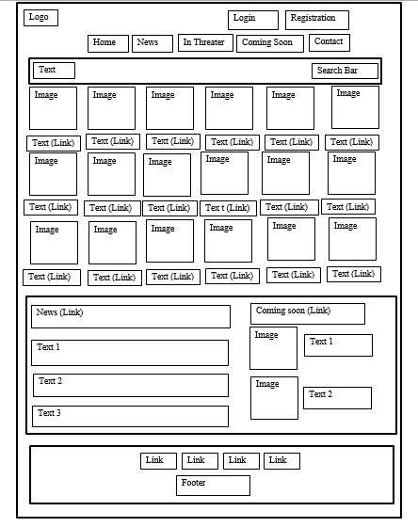

## News Page:

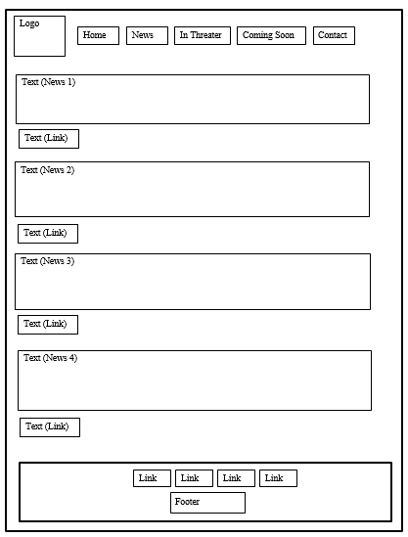

## In Theater Page:

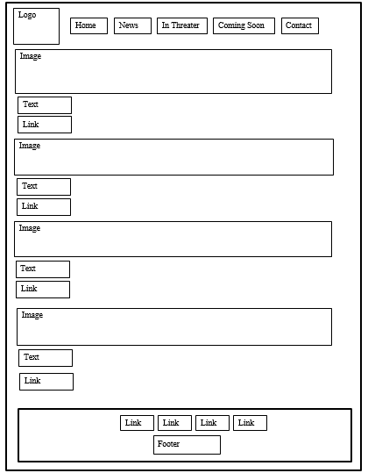

## Coming Soon:

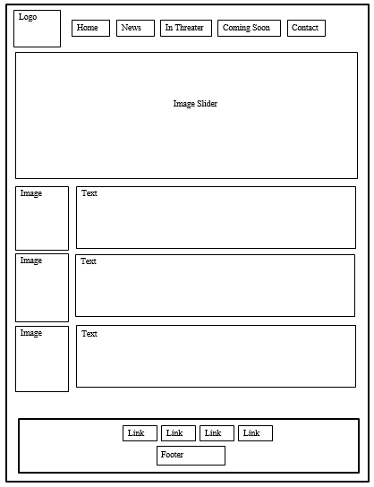

## Ticket Booking Page:

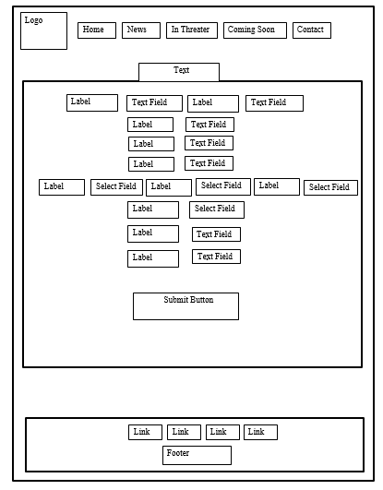

## Contact Form:

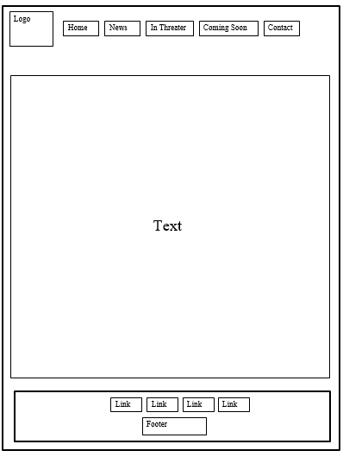

## Login Form:

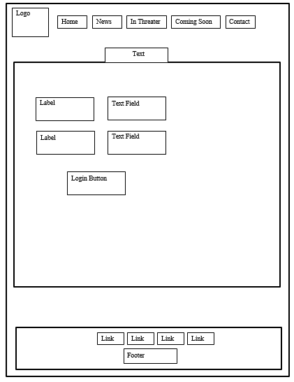

## Registration Page:

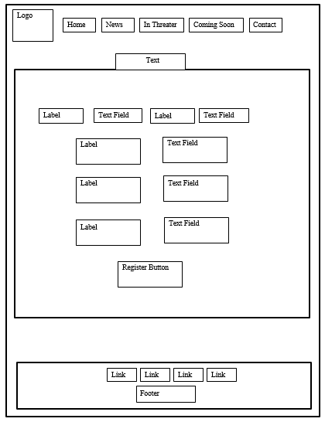

# Output Design:

## Index Page:

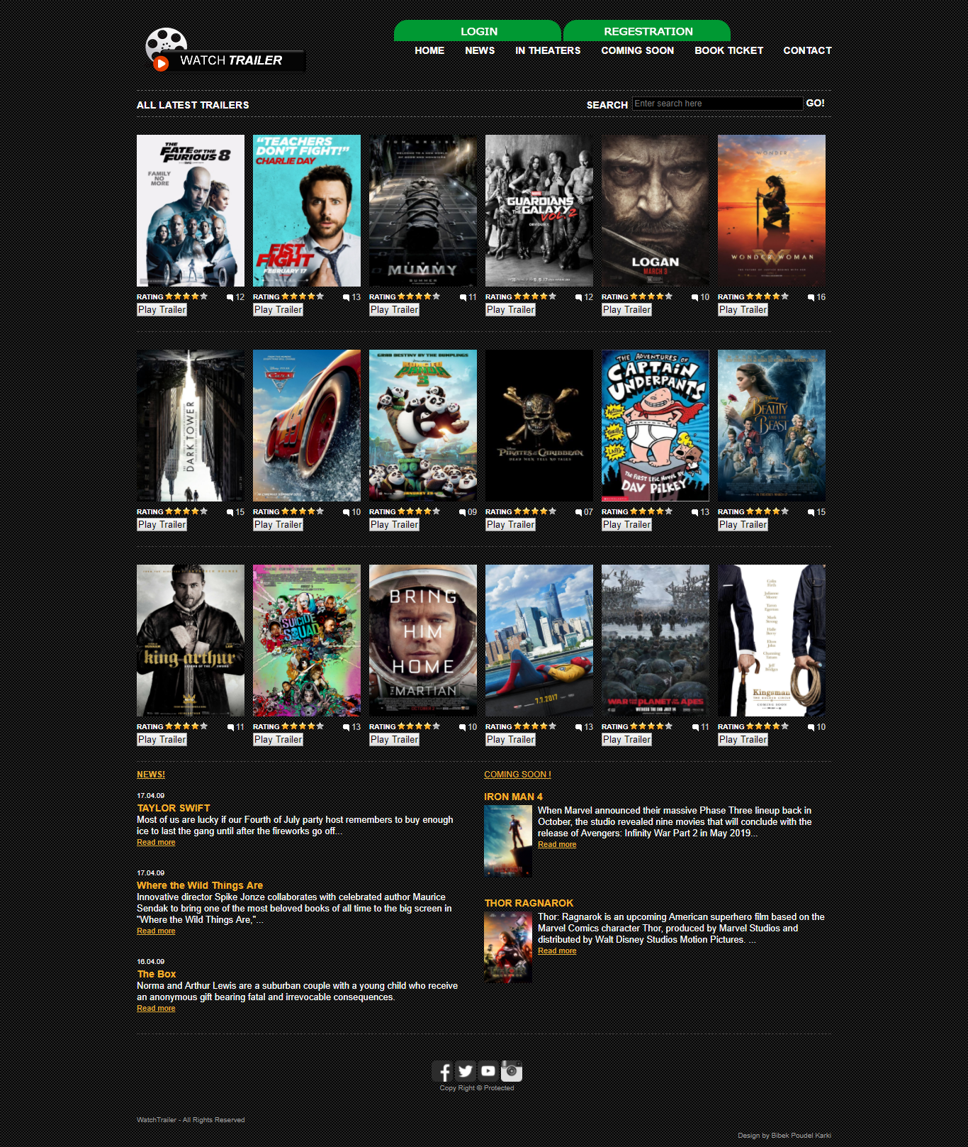

## News Page:

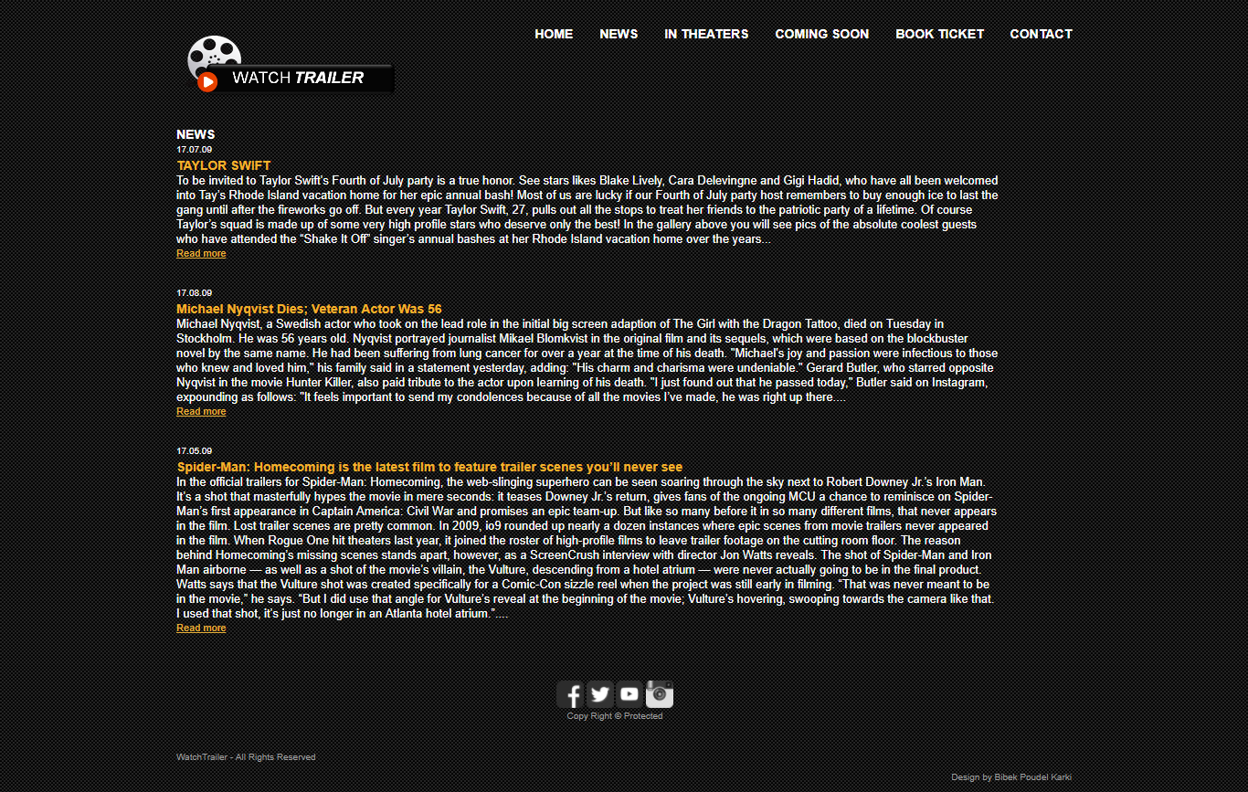

## In Theater Page:

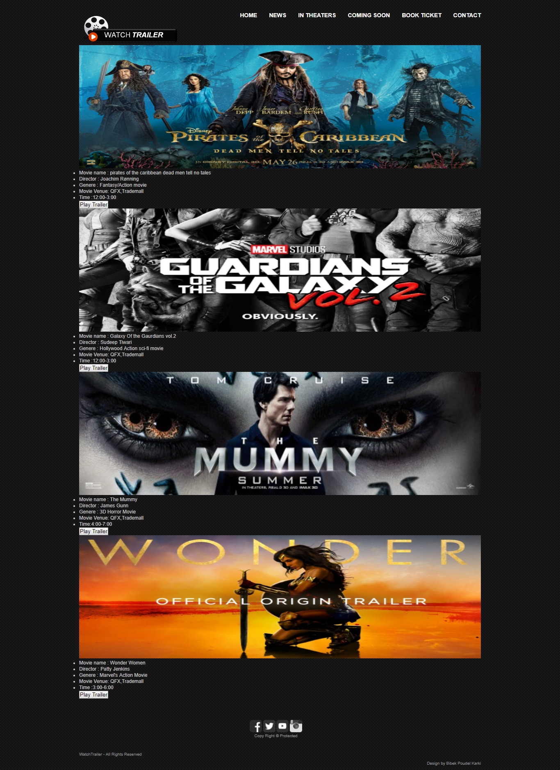

## Coming Soon Page:

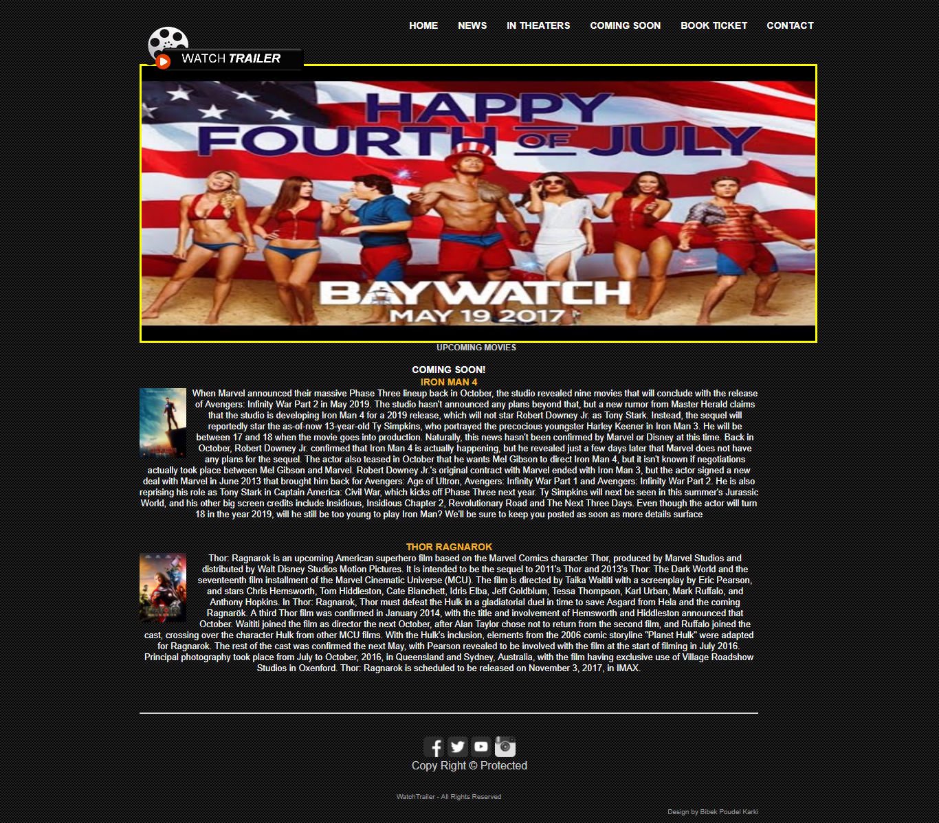

## Book Ticket Page:

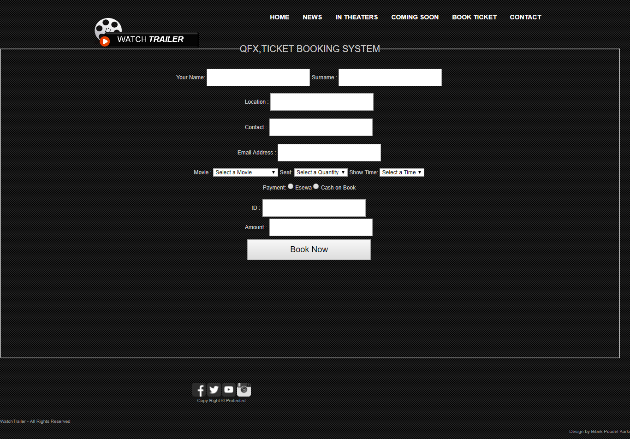

## Contact Page:

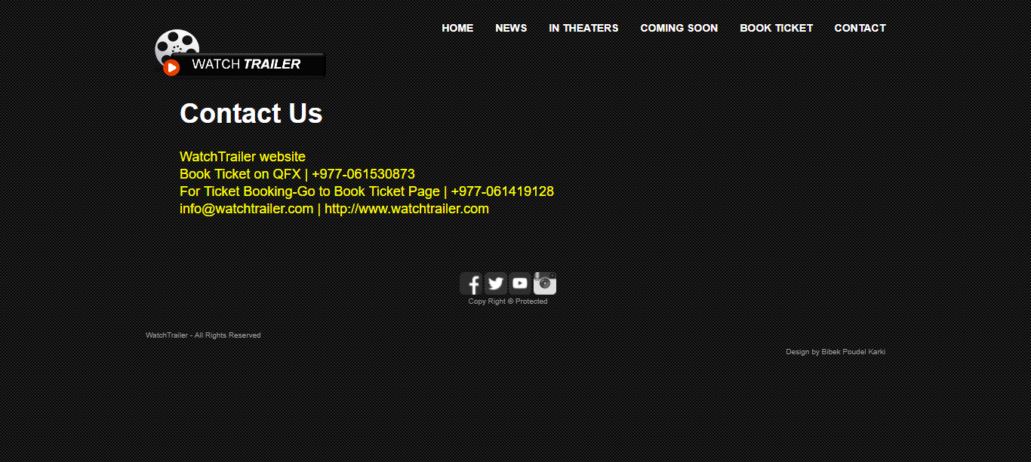

## Login Page:

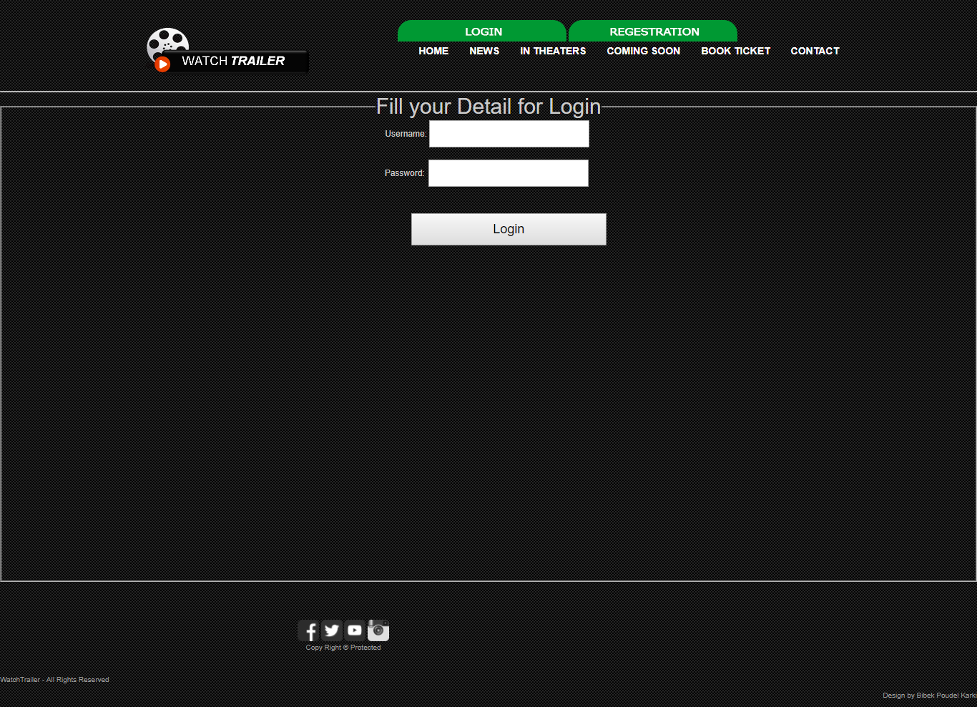

## Registration Page:

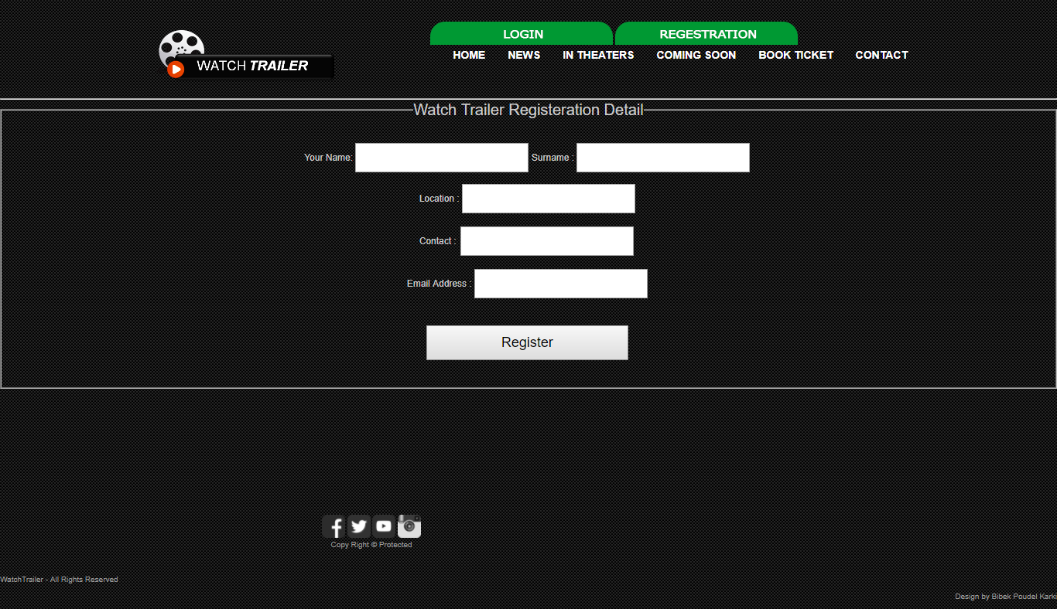

## Book Success Page:

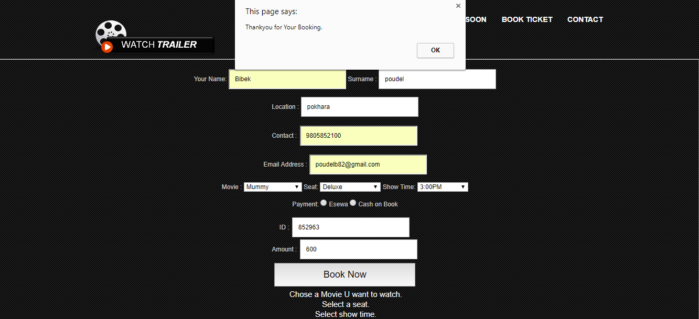

## Registration Success Page:

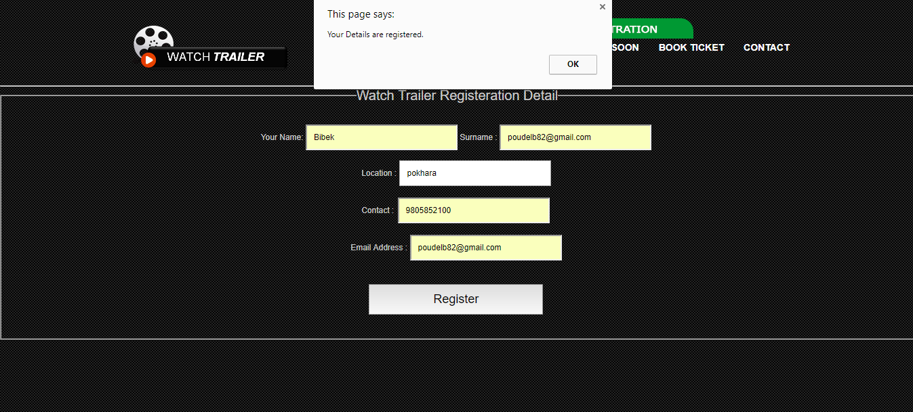

* 1. Sign Up Success Page:

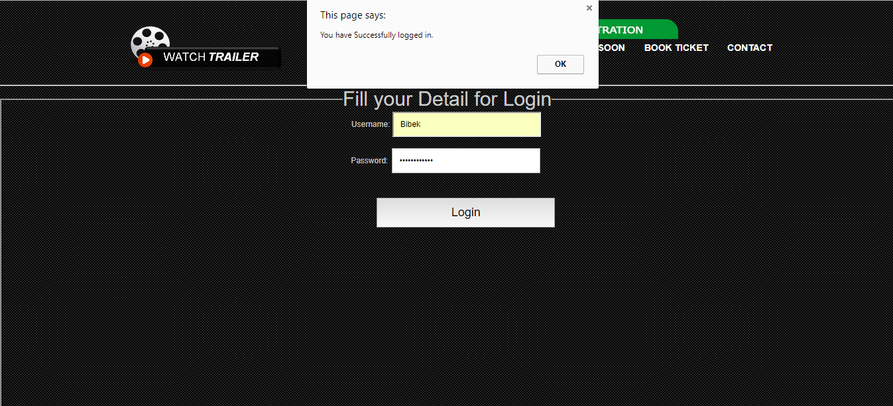

# HTML and Internal Java Script Program Listing:

* **Index.html as home page:**

<!DOCTYPE html>

<head>

<title>WatchTrailer</title>

<meta http-equiv="Content-Type" content="text/html; charset=utf-8" />

<meta http-equiv="X-UA-Compatible" content="IE=edge,chrome=1">

<meta name="viewport" content="width=device-width, initial-scale=1">

<link rel="stylesheet" href="css/style.css" type="text/css" media="all" /><!-- link to style.css-->

<link href="css/showYtVideo.css" rel="stylesheet" type="text/css"><!-- link to showYtVideo.css-->

</head>

<body>

<!-- START PAGE SOURCE -->

<div id="shell">

<div id="header"><!-- div for header -->

<h1 id="logo"><a href="index.html">WatchTrailer</a></h1>

<div id="navigation">

<tr>

<td colspan= "1" height="50" align="right">

<a href="login.html"><img src="css/menu/logintop.png"></a>

</td>

<td colspan= "1" height="50" align="left">

<a href="registration.html"><img src="css/menu/regestration.png"></a>

</td>

</tr>

<ul><!-- unordered list-->

<li><a href="index.html">HOME</a></li>

<li><a href="news.html">NEWS</a></li>

<li><a href="inthreater.html">IN THEATERS</a></li>

<li><a href="comingsoon.html">COMING SOON</a></li>

<li><a href="bookticket.html">BOOK TICKET</a></li>

<li><a href="contact.html">CONTACT</a></li>

</ul>

</div>

<div id="sub-navigation"><!-- start of div -->

<ul><!-- unordered list-->

<li><a href="#">ALL LATEST TRAILERS</a></li>

</ul>

<div id="search"><!-- div search-->

<form action="#" method="get" accept-charset="utf-8">

<label for="search-field">SEARCH</label>

<input type="text" name="search field" value="Enter search here" id="search-field" class="blink search-field" />

<input type="submit" value="GO!" class="search-button" />

</form>

</div>

</div>

</div>

<div id="main">

<div id="content">

<div class="box">

<div class="head">

<h2></h2>

</div>

<div class="movie">

<div class="movie-image"> <span class="play"><span class="name">F8</span></span> <a href="#"><img src="css/images/f8.jpg" alt="" /></a> </div>

<div class="rating">

<p>RATING</p>

<div class="stars">

<div class="stars-in"> </div>

</div>

<span class="comments">12</span> </div>

<button id="JwMKRevYa_M" type="button" class="show-video">Play Trailer</button><!-- button-->

</div>

<div class="movie">

<div class="movie-image"> <span class="play"><span class="name">Fist Fight</span></span> <a href="#"><img src="css/images/fistfight.jpg" alt="" /></a> </div>

<div class="rating">

<p>RATING</p>

<div class="stars">

<div class="stars-in"> </div>

</div>

<span class="comments">13</span> </div>

<button id="9aIzXYo6VCE" type="button" class="show-video">Play Trailer</button>

</div>

<div class="movie">

<div class="movie-image"> <span class="play"><span class="name">The Mummy</span></span> <a href="#"><img src="css/images/themummy.jpg" alt="" /></a> </div>

<div class="rating">

<p>RATING</p>

<div class="stars">

<div class="stars-in"> </div>

</div>

<span class="comments">11</span> </div>

<button id="IjHgzkQM2Sg" type="button" class="show-video">Play Trailer</button>

</div>

<div class="movie">

<div class="movie-image"> <span class="play"><span class="name">Guardians of the Galaxy 2</span></span> <a href="#"><img src="css/images/guardiansofthegalaxy2.jpg" alt="" /></a> </div>

<div class="rating">

<p>RATING</p>

<div class="stars">

<div class="stars-in"> </div>

</div>

<span class="comments">12</span> </div>

<button id="dW1BIid8Osg" type="button" class="show-video">Play Trailer</button>

</div>

<div class="movie">

<div class="movie-image"> <span class="play"><span class="name">Logan</span></span> <a href="#"><img src="css/images/logan.jpg" alt="" /></a> </div>

<div class="rating">

<p>RATING</p>

<div class="stars">

<div class="stars-in"> </div>

</div>

<span class="comments">10</span> </div>

<button id="Div0iP65aZo" type="button" class="show-video">Play Trailer</button>

</div>

<div class="movie last">

<div class="movie-image"> <span class="play"><span class="name">Wonder Women</span></span> <a href="#"><img src="css/images/wonderwomen.jpg" alt="" /></a> </div>

<div class="rating">

<p>RATING</p>

<div class="stars">

<div class="stars-in"> </div>

</div>

<span class="comments">16</span> </div>

<button id="VSB4wGIdDwo" type="button" class="show-video">Play Trailer</button>

</div>

<div class="cl">&nbsp;</div>

</div>

<div class="box">

<div class="head">

</div>

<div class="movie">

<div class="movie-image"> <span class="play"><span class="name">thedarktower</span></span> <a href="#"><img src="css/images/thedarktower.jpg" alt="" /></a> </div>

<div class="rating">

<p>RATING</p>

<div class="stars">

<div class="stars-in"> </div>

</div>

<span class="comments">15</span> </div>

<button id="GjwfqXTebIY" type="button" class="show-video">Play Trailer</button>

</div>

<div class="movie">

<div class="movie-image"> <span class="play"><span class="name">Cars3</span></span> <a href="#"><img src="css/images/cars3.jpg" alt="" /></a> </div>

<div class="rating">

<p>RATING</p>

<div class="stars">

<div class="stars-in"> </div>

</div>

<span class="comments">10</span> </div>

<button id="2LeOH9AGJQM" type="button" class="show-video">Play Trailer</button>

</div>

<div class="movie">

<div class="movie-image"> <span class="play"><span class="name">KUNG FU PANDA 3</span></span> <a href="#"><img src="css/images/kungfupanda3.jpg" alt="" /></a> </div>

<div class="rating">

<p>RATING</p>

<div class="stars">

<div class="stars-in"> </div>

</div>

<span class="comments">09</span> </div>

<button id="10r9ozshGVE" type="button" class="show-video">Play Trailer</button>

</div>

<div class="movie">

<div class="movie-image"> <span class="play"><span class="name">poc</span></span> <a href="#"><img src="css/images/poc.jpg" alt="" /></a> </div>

<div class="rating">

<p>RATING</p>

<div class="stars">

<div class="stars-in"> </div>

</div>

<span class="comments">07</span> </div>

<button id="Hgeu5rhoxxY" type="button" class="show-video">Play Trailer</button>

</div>

<div class="movie">

<div class="movie-image"> <span class="play"><span class="name">Captainunderpants</span></span> <a href="#"><img src="css/images/captainunderpants.jpg" alt="" /></a> </div>

<div class="rating">

<p>RATING</p>

<div class="stars">

<div class="stars-in"> </div>

</div>

<span class="comments">13</span> </div>

<button id="E_xlMWImhxk" type="button" class="show-video">Play Trailer</button>

</div>

<div class="movie last">

<div class="movie-image"> <span class="play"><span class="name">beautyandthebeast</span></span> <a href="#"><img src="css/images/beautyandthebeast.jpg" alt="" /></a> </div>

<div class="rating">

<p>RATING</p>

<div class="stars">

<div class="stars-in"> </div>

</div>

<span class="comments">15</span> </div>

<button id="OvW_L8sTu5E" type="button" class="show-video">Play Trailer</button>

</div>

<div class="cl">&nbsp;</div>

</div>

<div class="box">

<div class="head">

</div>

<div class="movie">

<div class="movie-image"> <span class="play"><span class="name">King Arthur</span></span> <a href="#"><img src="css/images/kingarthur.jpg" alt="" /></a> </div>

<div class="rating">

<p>RATING</p>

<div class="stars">

<div class="stars-in"> </div>

</div>

<span class="comments">11</span> </div>

<button id="4luDtkC3Oy0" type="button" class="show-video">Play Trailer</button>

</div>

<div class="movie">

<div class="movie-image"> <span class="play"><span class="name">Sucide Squad</span></span> <a href="#"><img src="css/images/sucidesquad.jpg" alt="" /></a> </div>

<div class="rating">

<p>RATING</p>

<div class="stars">

<div class="stars-in"> </div>

</div>

<span class="comments">13</span> </div>

<button id="CmRih_VtVAs" type="button" class="show-video">Play Trailer</button>

</div>

<div class="movie">

<div class="movie-image"> <span class="play"><span class="name">The Martin</span></span> <a href="#"><img src="css/images/themartin.jpg" alt="" /></a> </div>

<div class="rating">

<p>RATING</p>

<div class="stars">

<div class="stars-in"> </div>

</div>

<span class="comments">10</span> </div>

<button id="ej3ioOneTy8" type="button" class="show-video">Play Trailer</button>

</div>

<div class="movie">

<div class="movie-image"> <span class="play"><span class="name">spidermanhomecoming</span></span> <a href="#"><img src="css/images/spidermanhomecoming.jpg" alt="" /></a> </div>

<div class="rating">

<p>RATING</p>

<div class="stars">

<div class="stars-in"> </div>

</div>

<span class="comments">13</span> </div>

<button id="DiTECkLZ8HM" type="button" class="show-video">Play Trailer</button>

</div>

<div class="movie">

<div class="movie-image"> <span class="play"><span class="name">warofape</span></span> <a href="#"><img src="css/images/warofape.jpg" alt="" /></a> </div>

<div class="rating">

<p>RATING</p>

<div class="stars">

<div class="stars-in"> </div>

</div>

<span class="comments">11</span> </div>

<button id="JDcAlo8i2y8" type="button" class="show-video">Play Trailer</button>

</div>

<div class="movie last">

<div class="movie-image"> <span class="play"><span class="name">kingsman2</span></span> <a href="#"><img src="css/images/kingsman2.jpg" alt="" /></a> </div>

<div class="rating">

<p>RATING</p>

<div class="stars">

<div class="stars-in"> </div>

</div>

<span class="comments">10</span> </div>

<button id="6Nxc-3WpMbg" type="button" class="show-video">Play Trailer</button>

</div>

<div class="cl">&nbsp;</div>

</div>

</div>

<div id="news">

<div class="head">

<a href="news.html"><strong> NEWS! </strong></a><!-- link to news-->

</div>

<div class="content">

<p class="date">17.04.09</p>

<h4>TAYLOR SWIFT</h4>

<p>Most of us are lucky if our Fourth of July party host remembers to buy enough ice to last the gang until after the fireworks go off... </p>

<a href="news.html">Read more</a> </div>

<div class="content">

<p class="date">17.04.09</p>

<h4>Michael Nyqvist Dies; Veteran Actor Was 56</h4>

<p>Michael Nyqvist, a Swedish actor who took on the lead role in the initial big screen adaption of The Girl with the Dragon Tattoo, died on Tuesday in Stockholm.

He was 56 years old....</p>

<a href="news.html">Read more</a> </div>

<div class="content">

<p class="date">16.04.09</p>

<h4>Spider-Man: Homecoming is the latest film to feature trailer scenes you’ll never see</h4>

<p>In the official trailers for Spider-Man: Homecoming, the web-slinging superhero can be seen soaring through the sky next to Robert Downey Jr.’s Iron Man...</p>

<a href="news.html">Read more</a> </div>

</div>

<div id="coming">

<div class="head">

<a href="comingsoon.html">COMING SOON !</a>

</div>

<div class="content">

<h4>IRON MAN 4 </h4>

<a href="#"><img src="css/images/coming-soon1.jpg" alt="" /></a>

<p>When Marvel announced their massive Phase Three lineup back in October, the studio revealed nine movies that will conclude with the release of Avengers: Infinity War Part 2 in May 2019...</p>

<a href="comingsoon.html">Read more</a> </div>

<div class="cl">&nbsp;</div>

<div class="content">

<h4>THOR RAGNAROK </h4>

<a href="#"><img src="css/images/coming-soon2.jpg" alt="" /></a>

<p>Thor: Ragnarok is an upcoming American superhero film based on the Marvel Comics character Thor, produced by Marvel Studios and distributed by Walt Disney Studios Motion Pictures. ...</p>

<a href="comingsoon.html">Read more</a> </div>

</div>

<div class="cl">&nbsp;</div>

</div>

<div id="footer"><!-- div for footer -->

<tr>

<td colspan="4" height="20">

</td>

</tr>

</table>

<table border="0px" cellspacing="0" cellpadding="0" width="960px" height="100" background:url('images/body-bg.gif');><!-- table for link to social medias -->

<tr>

<td>

<center>

<a href="http://www.facebook.com"><img src="css/social icons/facebook.png" height="30" width="30"></a>

<a href="http://www.twitter.com"><img src="css/social icons/twitter.png" height="30" width="30"></a>

<a href="http://www.youtube.com"><img src="css/social icons/youtube.png" height="30" width="30"></a>

<a href="http://www.instagram.com"><img src="css/social icons/instagram.png" height="30" width="30"></a>

<p>Copy Right &copy; Protected</p>

</center>

</td>

</tr>

</table>

<p <a href="#">WatchTrailer</a> - All Rights Reserved</p>

<p class="rf">Design by <a href="http://watchtrailer.com/">Bibek Poudel Karki</a></p>

<div style="clear:both;"></div>

</div>

</div>

<script src="http://code.jquery.com/jquery-1.11.3.min.js"></script><!-- link to javascript-->

<script src="js/jquery.showYtVideo.js"></script><!-- link to java script-->

<script>

jQuery(document).ready(function ($) {

$('.show-video').on('click', function () {

var id = this.id;

$.showYtVideo({

videoId: id

});

});

});

</script>

<!-- END PAGE SOURCE -->

</body><!-- end of body-->

</html>

* **News.html:**

<!DOCTYPE html>

<head>

<title>WatchTrailer</title>

<meta http-equiv="Content-Type" content="text/html; charset=utf-8" />

<meta http-equiv="X-UA-Compatible" content="IE=edge,chrome=1">

<meta name="viewport" content="width=device-width, initial-scale=1">

<link rel="stylesheet" href="css/style.css" type="text/css" media="all" /><!-- link to style.css -->

<link href="showYtVideo.css" rel="stylesheet" type="text/css"><!-- link to showYtVideo.css -->

<script src="http://code.jquery.com/jquery-1.11.3.min.js"></script>

<script src="jquery.showYtVideo.js"></script>

</head>

<body>

<!-- START PAGE SOURCE -->

<div id="shell">

<div id="header">

<h1 id="logo"><a href="index.html">WatchTrailer</a></h1>

<div id="navigation">

<ul>

<li><a href="index.html" href="#">HOME</a></li>

<li><a href="news.html">NEWS</a></li>

<li><a href="inthreater.html">IN THEATERS</a></li>

<li><a href="comingsoon.html">COMING SOON</a></li>

<li><a href="bookticket.html">BOOK TICKET</a></li>

<li><a href="contact.html">CONTACT</a></li>

</ul>

</div>

</div>

<div id="news1">

<div class="head">

<br><br>

<h3>NEWS</h3>

</div>

<div class="content">

<p class="date">17.07.09</p>

<h4>TAYLOR SWIFT</h4>

<p>To be invited to Taylor Swift’s Fourth of July party is a true honor. See stars likes Blake Lively, Cara Delevingne and Gigi Hadid, who have all

been welcomed into Tay’s Rhode Island vacation home for her epic annual bash! Most of us are lucky if our Fourth of July party host remembers to buy

enough ice to last the gang until after the fireworks go off. But every year Taylor Swift, 27, pulls out all the stops to treat her friends to the

patriotic party of a lifetime. Of course Taylor’s squad is made up of some very high profile stars who deserve only the best! In the gallery above

you will see pics of the absolute coolest guests who have attended the “Shake It Off” singer’s annual bashes at her Rhode Island vacation home over

the years... </p>

<a href="news1.html">Read more</a> </div>

<div class="content">

<p class="date">17.08.09</p>

<h4>Michael Nyqvist Dies; Veteran Actor Was 56</h4>

<p>Michael Nyqvist, a Swedish actor who took on the lead role in the initial big screen adaption of The Girl with the Dragon Tattoo, died on Tuesday

in Stockholm. He was 56 years old. Nyqvist portrayed journalist Mikael Blomkvist in the original film and its sequels, which were based on the

blockbuster novel by the same name. He had been suffering from lung cancer for over a year at the time of his death. "Michael's joy and passion

were infectious to those who knew and loved him," his family said in a statement yesterday, adding: "His charm and charisma were undeniable."

Gerard Butler, who starred opposite Nyqvist in the movie Hunter Killer, also paid tribute to the actor upon learning of his death. "I just found out

that he passed today," Butler said on Instagram, expounding as follows: "It feels important to send my condolences because of all the movies I’ve made,

he was right up there....</p>

<a href="news2.html">Read more</a> </div>

<div class="content">

<p class="date">17.05.09</p>

<h4>Spider-Man: Homecoming is the latest film to feature trailer scenes you’ll never see</h4>

<p>In the official trailers for Spider-Man: Homecoming, the web-slinging superhero can be seen soaring through the sky next to Robert Downey Jr.’s Iron

Man. It’s a shot that masterfully hypes the movie in mere seconds: it teases Downey Jr.’s return, gives fans of the ongoing MCU a chance to reminisce

on Spider-Man’s first appearance in Captain America: Civil War and promises an epic team-up. But like so many before it in so many different films, that

never appears in the film. Lost trailer scenes are pretty common. In 2009, io9 rounded up nearly a dozen instances where epic scenes from movie trailers

never appeared in the film. When Rogue One hit theaters last year, it joined the roster of high-profile films to leave trailer footage on the cutting

room floor. The reason behind Homecoming’s missing scenes stands apart, however, as a ScreenCrush interview with director Jon Watts reveals. The shot

of Spider-Man and Iron Man airborne — as well as a shot of the movie’s villain, the Vulture, descending from a hotel atrium — were never actually going

to be in the final product. Watts says that the Vulture shot was created specifically for a Comic-Con sizzle reel when the project was still early in

filming. “That was never meant to be in the movie,” he says. “But I did use that angle for Vulture’s reveal at the beginning of the movie; Vulture’s

hovering, swooping towards the camera like that. I used that shot, it’s just no longer in an Atlanta hotel atrium.”....</p>

<a href="news3.html">Read more</a> </div>

</div>

<div id="footer">

<tr>

<td colspan="4" height="20">

</td>

</tr>

</table>

<table border="0px" cellspacing="0" cellpadding="0" width="960px" height="100" background:url('images/body-bg.gif');><!-- table for link to social medias -->

<tr>

<td>

<center>

<a href="http://www.facebook.com"><img src="css/social icons/facebook.png" height="30" width="30"></a>

<a href="http://www.twitter.com"><img src="css/social icons/twitter.png" height="30" width="30"></a>

<a href="http://www.youttube.com"><img src="css/social icons/youtube.png" height="30" width="30"></a>

<a href="http://www.instagram.com"><img src="css/social icons/instagram.png" height="30" width="30"></a>

<p>Copy Right &copy; Protected</p>

</center>

</td>

</tr>

</table>

<p <a href="#">WatchTrailer</a> - All Rights Reserved</p>

<p class="rf">Design by <a href="http://watchtrailer.com/">Bibek Poudel Karki</a></p>

<div style="clear:both;"></div>

</div>

</div>

<!-- END PAGE SOURCE -->

</body>

</html>

* **News1.html:**

<!DOCTYPE html>

<head>

<title>WatchTrailer</title>

<meta http-equiv="Content-Type" content="text/html; charset=utf-8" />

<meta http-equiv="X-UA-Compatible" content="IE=edge,chrome=1">

<meta name="viewport" content="width=device-width, initial-scale=1">

<link rel="stylesheet" href="css/style.css" type="text/css" media="all" /><!-- link to style.css -->

<link href="showYtVideo.css" rel="stylesheet" type="text/css"><!-- link to showYtVideo.css -->

<script src="http://code.jquery.com/jquery-1.11.3.min.js"></script>

<script src="jquery.showYtVideo.js"></script>

</head>

<body>

<!-- START PAGE SOURCE -->

<div id="shell">

<div id="header">

<h1 id="logo"><a href="index.html">WatchTrailer</a></h1>

<div id="navigation">

<ul>

<li><a href="index.html" href="#">HOME</a></li>

<li><a href="news.html">NEWS</a></li>

<li><a href="inthreater.html">IN THEATERS</a></li>

<li><a href="comingsoon.html">COMING SOON</a></li>

<li><a href="bookticket.html">BOOK TICKET</a></li>

<li><a href="contact.html">CONTACT</a></li>

</ul>

</div>

</div>

<div id="news1">

<div class="head">

<h3>NEWS</h3>

</div>

<div class="content">

<p class="date">12.04.09</p>

<h4>TAYLOR SWIFT</h4>

<p> To be invited to Taylor Swift’s Fourth of July party is a true honor. See stars likes Blake Lively, Cara Delevingne

and Gigi Hadid, who have all been welcomed into Tay’s Rhode Island vacation home for her epic annual bash!

Most of us are lucky if our Fourth of July party host remembers to buy enough ice to last the gang until after the fireworks

go off. But every year Taylor Swift, 27, pulls out all the stops to treat her friends to the patriotic party of a

lifetime. Of course Taylor’s squad is made up of some very high profile stars who deserve only the best! In the gallery

above you will see pics of the absolute coolest guests who have attended the “Shake It Off” singer’s annual bashes at

her Rhode Island vacation home over the years. As you can see from the epic pics, her pals are worth the extra money

she shells out every year for the par-Tay! Taylor’s party guests have included celebs like Ed Sheeran, Martha Hunt, the HAIM sisters, Gigi Hadid, Karlie Kloss, Cara Delevingne, Blake Lively and husband Ryan Reynolds, Uzo Aduba, Ruby Rose, Rachel Platten and Tay’s former beau Tom Hiddleston (may their relationship rest in peace). Based on the pics Taylor and her guests always share (and believe us, they share A LOT) the squad always has an amazing time. Of course, who wouldn’t be happy with a giant waterslide and even more giant glasses of white wine?

Tay and her girls always take pics of themselves frolicking around in the ocean together in the cutest patriotic

swimsuits. And the singer spent last year packing on the PDA with Tom, who famously wore an “I ♥ T.S.” T-shirt. We

can’t wait to see who attends her party this year, and if the guest list is even more epic than usual! Who knows,

maybe we will even see Tay’s new beau Joe Alwyn flaunting his feelings for her via T-shirt or enjoying a trip down

the waterslide!</p>

</div>

<div id="footer">

<tr>

<td colspan="4" height="20">

</td>

</tr>

</table>

<table border="0px" cellspacing="0" cellpadding="0" width="960px" height="100" background:url('images/body-bg.gif');><!-- table for link to social medias -->

<tr>

<td>

<center>

<a href="http://www.facebook.com"><img src="css/social icons/facebook.png" height="30" width="30"></a>

<a href="http://www.twitter.com"><img src="css/social icons/twitter.png" height="30" width="30"></a>

<a href="http://www.youtube.com"><img src="css/social icons/youtube.png" height="30" width="30"></a>

<a href="http://www.instagram.com"><img src="css/social icons/instagram.png" height="30" width="30"></a>

<p>Copy Right &copy; Protected</p>

</center>

</td>

</tr>

</table>

<p <a href="#">WatchTrailer</a> - All Rights Reserved</p>

<p class="rf">Design by <a href="http://watchtrailer.com/">Bibek Poudel Karki</a></p>

<div style="clear:both;"></div>

</div>

</div>

<!-- END PAGE SOURCE -->

</body>

</html>

* **News2.html:**

<!DOCTYPE html>

<head>

<title>WatchTrailer</title>

<meta http-equiv="Content-Type" content="text/html; charset=utf-8" />

<meta http-equiv="X-UA-Compatible" content="IE=edge,chrome=1">

<meta name="viewport" content="width=device-width, initial-scale=1">

<link rel="stylesheet" href="css/style.css" type="text/css" media="all" /><!-- link to style.css -->

<link href="showYtVideo.css" rel="stylesheet" type="text/css"><!-- link to showYtVideo.css -->

<script src="http://code.jquery.com/jquery-1.11.3.min.js"></script>

<script src="jquery.showYtVideo.js"></script>

</head>

<body>

<!-- START PAGE SOURCE -->

<div id="shell">

<div id="header">

<h1 id="logo"><a href="index.html">WatchTrailer</a></h1>

<div id="navigation">

<ul>

<li><a href="index.html" href="#">HOME</a></li>

<li><a href="news.html">NEWS</a></li>

<li><a href="inthreater.html">IN THEATERS</a></li>

<li><a href="comingsoon.html">COMING SOON</a></li>

<li><a href="bookticket.html">BOOK TICKET</a></li>

<li><a href="contact.html">CONTACT</a></li>

</ul>

</div>

</div>

<div id="news1">

<div class="head">

<h3>NEWS</h3>

</div>

<p class="date">17.08.09</p>

<h4>Michael Nyqvist Dies; Veteran Actor Was 56</h4>

<p>Michael Nyqvist, a Swedish actor who took on the lead role in the initial big screen adaption of The Girl with the Dragon Tattoo, died on Tuesday in Stockholm.

He was 56 years old. Nyqvist portrayed journalist Mikael Blomkvist in the original film and its sequels, which were based on the blockbuster novel by the same name.

He had been suffering from lung cancer for over a year at the time of his death.

"Michael's joy and passion were infectious to those who knew and loved him," his family said in a statement yesterday, adding:

"His charm and charisma were undeniable."

Gerard Butler, who starred opposite Nyqvist in the movie Hunter Killer, also paid tribute to the actor upon learning of his death.

"I just found out that he passed today," Butler said on Instagram, expounding as follows:

"It feels important to send my condolences because of all the movies I’ve made, he was right up there.

"He’s one of my favorites, if not my favorite, in terms of somebody who just had such incredible talent and childlike qualities and playfulness.

"But more than anything, just incredible humility and warmth and this cheeky kind of glint in his eyes.

"And to see all the young actors we worked with thinking how are they going to be if they ever make it, and if you see somebody like that and see how they handle themselves with such dignity and integrity and fun like he still loves what he does, and anyway it breaks my heart."

In the caption to this Instagram video, Butler wrote:

"Sending my condolences to Michael Nyqvist and his family. Incredibly talented and an extraordinary human being. My heart is broken."

Nyqvist, who spent the first year of his life in an orphanage, fell in love with acting during his senior year of high school in Nebraska after landing a small role in a production of Death of a Salesman.

After years of trying to break through in the industry, Nyqvist got his big break as Rolf, an abusive alcoholic husband, in the 2000 film Together.

He earned his first nomination for a Guldbagge, the annual cinema awards in Sweden, for the role and went on from there to anchor various television shows and films.</p>

</div>

<div id="footer">

<tr>

<td colspan="4" height="20">

</td>

</tr>

</table>

<table border="0px" cellspacing="0" cellpadding="0" width="960px" height="100" background:url('images/body-bg.gif');><!-- table for link to social medias -->

<tr>

<td>

<center>

<a href="http://www.facebook.com"><img src="css/social icons/facebook.png" height="30" width="30"></a>

<a href="http://www.twitter.com"><img src="css/social icons/twitter.png" height="30" width="30"></a>

<a href="http://www.youtube.com"><img src="css/social icons/youtube.png" height="30" width="30"></a>

<a href="http://www.instagram.com"><img src="css/social icons/instagram.png" height="30" width="30"></a>

<p>Copy Right &copy; Protected</p>

</center>

</td>

</tr>

</table>

<p <a href="#">WatchTrailer</a> - All Rights Reserved</p>

<p class="rf">Design by <a href="http://watchtrailer.com/">Bibek Poudel Karki</a></p>

<div style="clear:both;"></div>

</div>

</div>

<!-- END PAGE SOURCE -->

</body>

</html>

* **News3.html:**

<!DOCTYPE html>

<head>

<title>WatchTrailer</title>

<meta http-equiv="Content-Type" content="text/html; charset=utf-8" />

<meta http-equiv="X-UA-Compatible" content="IE=edge,chrome=1">

<meta name="viewport" content="width=device-width, initial-scale=1">

<link rel="stylesheet" href="css/style.css" type="text/css" media="all" /><!-- link to style.css -->

<link href="showYtVideo.css" rel="stylesheet" type="text/css"><!-- link to showYtVideo.css -->

<script src="http://code.jquery.com/jquery-1.11.3.min.js"></script>

<script src="jquery.showYtVideo.js"></script>

</head>

<body>

<!-- START PAGE SOURCE -->

<div id="shell">

<div id="header">

<h1 id="logo"><a href="index.html">WatchTrailer</a></h1>

<div id="navigation">

<ul>

<li><a href="index.html" href="#">HOME</a></li>

<li><a href="news.html">NEWS</a></li>

<li><a href="inthreater.html">IN THEATERS</a></li>

<li><a href="comingsoon.html">COMING SOON</a></li>

<li><a href="bookticket.html">BOOK TICKET</a></li>

<li><a href="contact.html">CONTACT</a></li>

</ul>

</div>

</div>

<div id="news1">

<div class="head">

<h3>NEWS</h3>

</div>

<div class="content">

<p class="date">10.04.09</p>

<h4>Spider-Man: Homecoming is the latest film to feature trailer scenes you’ll never see</h4>

<p>In the official trailers for Spider-Man: Homecoming, the web-slinging superhero can be seen soaring through the sky next to Robert Downey Jr.’s Iron Man. It’s a shot that masterfully hypes the movie in mere seconds: it teases Downey Jr.’s return, gives fans of the ongoing MCU a chance to reminisce on Spider-Man’s first appearance in Captain America: Civil War and promises an epic team-up. But like so many before it in so many different films, that scene never appears in the film.

Lost trailer scenes are pretty common. In 2009, io9 rounded up nearly a dozen instances where epic scenes from movie trailers never appeared in the film. When Rogue One hit theaters last year, it joined the roster of high-profile films to leave trailer footage on the cutting room floor.

The reason behind Homecoming’s missing scenes stands apart, however, as a ScreenCrush interview with director Jon Watts reveals. The shot of Spider-Man and Iron Man airborne — as well as a shot of the movie’s villain, the Vulture, descending from a hotel atrium — were never actually going to be in the final product.

Watts says that the Vulture shot was created specifically for a Comic-Con sizzle reel when the project was still early in filming. “That was never meant to be in the movie,” he says. “But I did use that angle for Vulture’s reveal at the beginning of the movie; Vulture’s hovering, swooping towards the camera like that. I used that shot, it’s just no longer in an Atlanta hotel atrium.”

As for that scene of Spider-Man and Iron Man swooping through Queens? It, too, was never in the movie. “I think what happened was in the very first trailer they wanted a shot of Spider-Man and Iron Man flying together,” Watts says. “And they were going to use something from the Staten Island Ferry [scene], but it just didn’t look that great — the background plate, because the Staten Island terminal is a very simple building. It almost looks like an unrendered 3D object.”

So, the pair wound up with Queens as a backdrop. “Because we couldn’t just create a whole new shot, so let’s just use one of these shots of the subway; put them in there,” Watts says. “I feel a little weird that there’s a shot in the trailer that’s not in the movie at all, but it’s a cool shot.”

Shooting scenes for a movie that creators have no intention of actually placing in their films can sound a lot like a bait-and-switch. Fans who pay attention to trailers are paying money to see what they’ve been promised. But trailers, and the marketing teams who make them, have a job to make their movies exciting or interesting in just a few minutes. And at a time when trailers have become major draws unto themselves, thanks to hungry online audiences, the need to create content that viewers connect to is even greater.

The reality is that film trailers are still marketing materials, and marketing materials are there to sell you on an idea. It would’ve been nice to see that scene in Homecoming, but you don’t always get what you pay for.

Correction: A previous version of this piece stated that Spider-Man’s first appearance was in Avengers: Age of Ultron. That was false. His first appearance was in Captain America: Civil War. We’ve updated the piece accordingly..</p>

</div>

<div id="footer">

<tr>

<td colspan="4" height="20">

</td>

</tr>

</table>

<table border="0px" cellspacing="0" cellpadding="0" width="960px" height="100" background:url('images/body-bg.gif');><!-- table for link to social medias -->

<tr>

<td>

<center>

<a href="http://www.facebook.com"><img src="css/social icons/facebook.png" height="30" width="30"></a>

<a href="http://www.twitter.com"><img src="css/social icons/twitter.png" height="30" width="30"></a>

<a href="http://www.youtube.com"><img src="css/social icons/youtube.png" height="30" width="30"></a>

<a href="http://www.instagram.com"><img src="css/social icons/instagram.png" height="30" width="30"></a>

<p>Copy Right &copy; Protected</p>

</center>

</td>

</tr>

</table>

<p <a href="#">WatchTrailer</a> - All Rights Reserved</p>

<p class="rf">Design by <a href="http://watchtrailer.com/">Bibek Poudel Karki</a></p>

<div style="clear:both;"></div>

</div>

</div>

<!-- END PAGE SOURCE -->

</body>

</html>

* **In theater.html:**

<!DOCTYPE html>

<head>

<title>WatchTrailer</title>

<meta http-equiv="Content-Type" content="text/html; charset=utf-8" />

<meta http-equiv="X-UA-Compatible" content="IE=edge,chrome=1">

<meta name="viewport" content="width=device-width, initial-scale=1">

<link rel="stylesheet" href="css/style.css" type="text/css" media="all" /><!-- link to style.css -->

<link href="showYtVideo.css" rel="stylesheet" type="text/css"><!-- link to showYtVideo.css -->

</head>

<body>

<!-- START PAGE SOURCE -->

<div id="shell">

<div id="header">

<h1 id="logo"><a href="index.html">WatchTrailer</a></h1>

<div id="navigation">

<ul>

<li><a href="index.html" href="#">HOME</a></li>

<li><a href="news.html">NEWS</a></li>

<li><a href="inthreater.html">IN THEATERS</a></li>

<li><a href="comingsoon.html">COMING SOON</a></li>

<li><a href="bookticket.html">BOOK TICKET</a></li>

<li><a href="contact.html">CONTACT</a></li>

</ul>

</div>

<br><br>

<div class="slideshow-container">

<br><br>

<div class="mySlidesfade1">

<img src="css/images/poc1.jpg" height="300" width="100%">

<div class="text">

<ul>

<li>Movie name : pirates of the caribbean dead men tell no tales</li>

<li>Director : Joachim Rønning</li>

<li>Genere : Fantasy/Action movie</li>

<li>Movie Venue: QFX,Trademall</li>

<li>Time :12:00-3:00 <script></script></li>

<li><a href="bookticket.html">BOOK TICKET</a></li><!-- link to book ticket page -->

</ul>

</div>

</div>

<div class="mySlides fade">

<img src="css/images/GOG.jpg" height="300" width="100%">

<div class="text">

<ul>

<li>Movie name : Galaxy Of the Gaurdians vol.2</li>

<li>Director : Sudeep Tiwari</li>

<li>Genere : Hollywood Action sci-fi movie</li>

<li>Movie Venue: QFX,Trademall</li>

<li>Time :12:00-3:00 <script></script></li>

<li><a href="bookticket.html">BOOK TICKET</a></li><!-- link to book ticket page -->

</ul>

</div>

</div>

<div class="mySlides fade">

<img src="css/images/TM.jpg" height="300" width="100%">

<div class="text">

<ul>

<li>Movie name : The Mummy</li>

<li>Director : James Gunn</li>

<li>Genere : 3D Horror Movie</li>

<li>Movie Venue: QFX,Trademall</li>

<li>Time:4:00-7:00<script></script></li>

<li><a href="bookticket.html">BOOK TICKET</a></li><!-- link to book ticket page -->

</ul>

</div>

</div>

<div class="mySlides fade">

<img src="css/images/WM.jpg" height="300" width="100%">

<div class="text">

<ul>

<li>Movie name : Wonder Women</li>

<li>Director : Patty Jenkins</li>

<li>Genere : Marvel's Action Movie</li>

<li>Movie Venue: QFX,Trademall</li>

<li>Time :3:00-6:00<script></script></li>

<li><a href="bookticket.html">BOOK TICKET</a></li><!-- link to book ticket page -->

</ul>

</div>

</div>

</div>

<br>

<div id="footer">

<tr>

<td colspan="4" height="20">

</td>

</tr>

</table>

<table border="0px" cellspacing="0" cellpadding="0" width="960px" height="100" background:url('images/body-bg.gif');><!-- table for link to social medias -->

<tr>

<td>

<center>

<a href="http://www.facebook.com"><img src="css/social icons/facebook.png" height="30" width="30"></a>

<a href="http://www.twitter.com"><img src="css/social icons/twitter.png" height="30" width="30"></a>

<a href="http://www.youtube.com"><img src="css/social icons/youtube.png" height="30" width="30"></a>

<a href="http://www.instagram.com"><img src="css/social icons/instagram.png" height="30" width="30"></a>

<p>Copy Right &copy; Protected</p>

</center>

</td>

</tr>

</table>

<p <a href="#">WatchTrailer</a> - All Rights Reserved</p>

<p class="rf">Design by <a href="http://watchtrailer.com/">Bibek Poudel Karki</a></p>

<div style="clear:both;"></div>

</div>

</div>

<script src="http://code.jquery.com/jquery-1.11.3.min.js"></script>

<script src="js/jquery.showYtVideo.js"></script>

<script>

jQuery(document).ready(function ($) {

$('.show-video').on('click', function () {

var id = this.id;

$.showYtVideo({

videoId: id

});

});

});

</script>

<!-- END PAGE SOURCE -->

</body>

</html>

* **Comingsoon.html:**

<html>

<head>

<title>WatchTrailer</title>

<link href="css/site.css" rel="stylesheet" type="text/css" />

<meta http-equiv="Content-Type" content="text/html; charset=utf-8" />

<meta http-equiv="X-UA-Compatible" content="IE=edge,chrome=1">

<meta name="viewport" content="width=device-width, initial-scale=1">

<link rel="stylesheet" href="css/style.css" type="text/css" media="all" /><!-- link to style.css -->

<link href="css/showYtVideo.css" rel="stylesheet" type="text/css"><!-- link to showYtVideo.css-->

</head>

<body>

<div id="shell">

<div id="header">

<h1 id="logo"><a href="index.html">WatchTrailer</a></h1>

<div id="navigation">

<ul>

<li><a href="index.html">HOME</a></li>

<li><a href="news.html">NEWS</a></li>

<li><a href="inthreater.html">IN THEATERS</a></li>

<li><a href="comingsoon.html">COMING SOON</a></li>

<li><a href="bookticket.html">BOOK TICKET</a></li>

<li><a href="contact.html">CONTACT</a></li>

</ul>

</div>

<div>

<img id="topimg" src="css/images1/home/e.jpg" height="400px" width="100%"/><!-- picture slideshow -->

<p><b>UPCOMING MOVIES</b> </p>

</div>

<div></div>

<div></div>

<div id="news1">

<div class="head">

<h3>COMING SOON<strong>!</strong></h3>

</div>

<div class="content">

<h4>IRON MAN 4 </h4>

<a href="#"><img src="css/images/coming-soon1.jpg" alt="" /></a>

<p>When Marvel announced their massive Phase Three lineup back in October, the studio revealed nine movies that will

conclude with the release of Avengers: Infinity War Part 2 in May 2019. The studio hasn't announced any plans beyond

that, but a new rumor from Master Herald claims that the studio is developing Iron Man 4 for a 2019 release, which

will not star Robert Downey Jr. as Tony Stark. Instead, the sequel will reportedly star the as-of-now 13-year-old Ty

Simpkins, who portrayed the precocious youngster Harley Keener in Iron Man 3. He will be between 17 and 18 when the

movie goes into production. Naturally, this news hasn't been confirmed by Marvel or Disney at this time.

Back in October, Robert Downey Jr. confirmed that Iron Man 4 is actually happening, but he revealed just a few days

later that Marvel does not have any plans for the sequel. The actor also teased in October that he wants Mel Gibson

to direct Iron Man 4, but it isn't known if negotiations actually took place between Mel Gibson and Marvel. Robert

Downey Jr.'s original contract with Marvel ended with Iron Man 3, but the actor signed a new deal with Marvel in June

2013 that brought him back for Avengers: Age of Ultron, Avengers: Infinity War Part 1 and Avengers: Infinity War Part

2. He is also reprising his role as Tony Stark in Captain America: Civil War, which kicks off Phase Three next year.

Ty Simpkins will next be seen in this summer's Jurassic World, and his other big screen credits include Insidious, Insidious

Chapter 2, Revolutionary Road and The Next Three Days. Even though the actor will turn 18 in the year 2019, will he still be

too young to play Iron Man? We'll be sure to keep you posted as soon as more details surface</p>

<div></div>

<div class="cl">&nbsp;</div>

<br><br>

<div class="content">

<h4>THOR RAGNAROK </h4>

<a href="#"><img src="css/images/coming-soon2.jpg" alt="" /></a>

<p>Thor: Ragnarok is an upcoming American superhero film based on the Marvel Comics character Thor, produced by Marvel

Studios and distributed by Walt Disney Studios Motion Pictures. It is intended to be the sequel to 2011's Thor and

2013's Thor: The Dark World and the seventeenth film installment of the Marvel Cinematic Universe (MCU). The film is

directed by Taika Waititi with a screenplay by Eric Pearson, and stars Chris Hemsworth, Tom Hiddleston, Cate Blanchett,

Idris Elba, Jeff Goldblum, Tessa Thompson, Karl Urban, Mark Ruffalo, and Anthony Hopkins. In Thor: Ragnarok, Thor must

defeat the Hulk in a gladiatorial duel in time to save Asgard from Hela and the coming Ragnarök.

A third Thor film was confirmed in January 2014, with the title and involvement of Hemsworth and Hiddleston

announced that October. Waititi joined the film as director the next October, after Alan Taylor chose not to

return from the second film, and Ruffalo joined the cast, crossing over the character Hulk from other MCU films.

With the Hulk's inclusion, elements from the 2006 comic storyline "Planet Hulk" were adapted for Ragnarok. The

rest of the cast was confirmed the next May, with Pearson revealed to be involved with the film at the start of

filming in July 2016. Principal photography took place from July to October, 2016, in Queensland and Sydney,

Australia, with the film having exclusive use of Village Roadshow Studios in Oxenford.

Thor: Ragnarok is scheduled to be released on November 3, 2017, in IMAX.</p>

</div>

<div class="cl">&nbsp;</div>

</div>

<hr class="fix" />

<script src="js/slider.js"></script><!-- link to book slider.js -->

<div id="footer">

<tr>

<td colspan="4" height="20">

</td>

</tr>

</table>

<table border="0px" cellspacing="0" cellpadding="0" width="960px" height="100" background:url('images/body-bg.gif');><!-- table for link to social medias -->

<tr>

<td>

<center>

<a href="http://www.facebook.com"><img src="css/social icons/facebook.png" height="30" width="30"></a>

<a href="http://www.twitter.com"><img src="css/social icons/twitter.png" height="30" width="30"></a>

<a href="http://www.youtube.com"><img src="css/social icons/youtube.png" height="30" width="30"></a>

<a href="http://www.instagram.com"><img src="css/social icons/instagram.png" height="30" width="30"></a>

<p>Copy Right &copy; Protected</p>

</center>

</td>

</tr>

</table>

<p <a href="#">WatchTrailer</a> - All Rights Reserved</p>

<p class="rf">Design by <a href="http://watchtrailer.com/">Bibek Poudel Karki</a></p>

<div style="clear:both;"></div>

</div>

</div>

</body>

</html>

* **Bookticket.html:**

<!DOCTYPE html>

<head>

<title>Book Ticket</title>

<meta http-equiv="Content-Type" content="text/html; charset=utf-8" />

<meta http-equiv="X-UA-Compatible" content="IE=edge,chrome=1">

<meta name="viewport" content="width=device-width, initial-scale=1">

<link rel="stylesheet" href="css/style.css" type="text/css" media="all" /><!-- Link to style.css -->

<link href="showYtVideo.css" rel="stylesheet" type="text/css"><!-- Link to showYtVideo.css -->

<script src="http://code.jquery.com/jquery-1.11.3.min.js"></script>

<script src="jquery.showYtVideo.js"></script>

</head>

<style>

.l1{

height:700px;

width:1344px;

clear:both;

text-align:center;

}

fieldset{

width:100%px;

height:680px;

align:center;

}

legend{

font-size:20px;

}

.error{

color:red;

font-size:15px;

}

input[type=text]

{

width:200px;

padding:10px;

}

input[type=password]

{

margin:2px;

width:200px;

padding:10px;

}

input[type=number]

{

margin:2px;

width:200px;

padding:10px;

}

input[type=submit]

{

width:20%;

font-size:1.5em;

padding:10px;

margin:5px;

}

input[id=extra]

{

width:20%;

font-size:1.5em;

padding:10px;

}

.success{

color:green;

padding:25px;

text-align:center;

font-size:20px;

}

form fieldset a{

width:50px;

height:50px;

padding:10px;

}

</style>

<body>

<!-- START PAGE SOURCE -->

<div id="shell">

<div id="header">

<h1 id="logo"><a href="index.html">WatchTrailer</a></h1>

<div id="navigation">

<ul>

<li><a href="index.html" href="#">HOME</a></li>

<li><a href="news.html">NEWS</a></li>

<li><a href="inthreater.html">IN THEATERS</a></li>

<li><a href="comingsoon.html">COMING SOON</a></li>

<li><a href="bookticket.html">BOOK TICKET</a></li>

<li><a href="contact.html">CONTACT</a></li>

</ul>

</div>

</div>

</div>

<div class="l1">

<form id="form" action="" method="post">

<fieldset>

<legend>QFX,TICKET BOOKING SYSTEM</legend> <br><br>

<label> Your Name:

<input id="name1" type="text" name="username">

</label>

<label> Surname :

<input id="name2" type="text" name="username">

</label> <br><br>

<label> Location :

<input id="address" type="text" name="address">

</label><br><br>

<label> Contact :

<input id="phone" type="number" name="Phone">

</label><br><br>

<label> Email Address :

<input id="email" type="text" name="email">

</label><br><br>

<label for="ex">Movie : </label>

<select id="movie" name="level" >

<option value="">Select a Movie</option>

<option value="fate8">POC</option>

<option value="fist5">Fist Five</option>

<option value="logan">Guardians of galaxy 2</option>

<option value="ww">Wonder Woman</option>

<option value="cars3">Cars 3</option>

<option value="mummy">Mummy</option>

</select>

<label for="ext">Seat: </label>

<select id="seat" name="level" >

<option value="">Select a Quantity</option>

<option value="1">Cabin</option>

<option value="2">Balcony</option>

<option value="3">Deluxe</option>

<option value="4">Special</option>

<option value="5">Drescal</option>

</select>

<label for="ext">Show Time: </label>

<select id="showtime" name="level" >

<option value="">Select a Time</option>

<option value="1">8:00AM</option>

<option value="2">12:00PM</option>

<option value="3">3:00PM</option>

<option value="4">6:00PM</option>

<option value="5">9:00PM</option>

</select>

<br><br>

<p>Payment:

<label>

<input id="radio1" type="radio" name="payment" value="yes"/> Esewa

</label>

<input id="radio" type="radio" name="payment" value="noo"/> Cash on Book

</label><br>

</p>

<br>

<label> ID :

<input id="card" type="number" name="card">

</label><br>

<label> Amount :

<input id="amount" type="number" name="amount">

</label><br>

<input type="submit" value="Book Now" />

<br />

<p id="errorMessage" class="error">

</p>

</fieldset>

</form>

<p id="successMessage" class="success">

</p>

</div>

</div>

<div id="footer">

<tr>

<td colspan="4" height="20">

</td>

</tr>

</table>

<table border="0px" cellspacing="0" cellpadding="0" width="960px" height="100" background:url('images/body-bg.gif');><!-- table for link to social medias -->

<tr>

<td>

<center>

<a href="http://www.facebook.com"><img src="css/social icons/facebook.png" height="30" width="30"></a><!-- link to facebook -->

<a href="http://www.twitter.com"><img src="css/social icons/twitter.png" height="30" width="30"></a><!-- link to twitter -->

<a href="http://www.youtube.com"><img src="css/social icons/youtube.png" height="30" width="30"></a><!-- link to youtube -->

<a href="http://www.instagram.com"><img src="css/social icons/instagram.png" height="30" width="30"></a><!-- link to instagram -->

<p>Copy Right &copy; Protected</p>

</center>

</td>

</tr>

</table>

<p <a href="#">WatchTrailer</a> - All Rights Reserved</p>

<p class="rf">Design by <a href="http://watchtrailer.com/">Bibek Poudel Karki</a></p>

<div style="clear:both;"></div>

</div>

</div>

<script src="js/bookticket.js"></script>

<!-- END PAGE SOURCE -->

</body>

</html>

* **Contact.html:**

<!DOCTYPE html>

<head>

<title>WatchTrailer</title>

<meta http-equiv="Content-Type" content="text/html; charset=utf-8" />

<meta http-equiv="X-UA-Compatible" content="IE=edge,chrome=1">

<meta name="viewport" content="width=device-width, initial-scale=1">

<link rel="stylesheet" href="css/style.css" type="text/css" media="all" />

<link href="css/showYtVideo.css" rel="stylesheet" type="text/css">

</head>

<body>

<!-- START PAGE SOURCE -->

<div id="shell">

<div id="header">

<h1 id="logo"><a href="index.html">WatchTrailer</a></h1>

<div id="navigation">

<ul>

<li><a href="index.html">HOME</a></li>

<li><a href="news.html">NEWS</a></li>

<li><a href="inthreater.html">IN THEATERS</a></li>

<li><a href="comingsoon.html">COMING SOON</a></li>

<li><a href="bookticket.html">BOOK TICKET</a></li>

<li><a href="contact.html">CONTACT</a></li>

</ul>

</div>

<center>

<table width="960" border="0" cellpadding="" cellspacing="35">

<tr>

<td colspan="2"><font color="white"><font size="4px"><h1>Contact Us<font color="yellow"></h1><br>

WatchTrailer website<br>

Book Ticket on QFX | +977-061530873<br>

For Ticket Booking-Go to Book Ticket Page | +977-061419128<br>

info@watchtrailer.com | http://www.watchtrailer.com

</td>

</tr>

</table>

</center>

<div id="footer">

<tr>

<td colspan="4" height="20">

</td>

</tr>

</table>

<table border="0px" cellspacing="0" cellpadding="0" width="960px" height="100" background:url('images/body-bg.gif');><!-- table for link to social medias -->

<tr>

<td>

<center>

<a href="http://www.facebook.com"><img src="css/social icons/facebook.png" height="30" width="30"></a>

<a href="http://www.twitter.com"><img src="css/social icons/twitter.png" height="30" width="30"></a>

<a href="http://www.youtube.com"><img src="css/social icons/youtube.png" height="30" width="30"></a>

<a href="http://www.instagram.com"><img src="css/social icons/instagram.png" height="30" width="30"></a>

<p>Copy Right &copy; Protected</p>

</center>

</td>

</tr>

</table>

<p <a href="#">WatchTrailer</a> - All Rights Reserved</p>

<p class="rf">Design by <a href="http://watchtrailer.com/">Bibek Poudel Karki</a></p>

<div style="clear:both;"></div>

</div>

</div>

<!-- END PAGE SOURCE -->

</body>

</html>

* **Registration.html:**

<!DOCTYPE html>

<head>

<title>WatchTrailer</title>

<meta http-equiv="Content-Type" content="text/html; charset=utf-8" />

<meta http-equiv="X-UA-Compatible" content="IE=edge,chrome=1">

<meta name="viewport" content="width=device-width, initial-scale=1">

<link rel="stylesheet" href="css/style.css" type="text/css" media="all" /><!-- link to style.css -->

<link href="css/showYtVideo.css" rel="stylesheet" type="text/css"><!-- link to showYtVideo.css -->

</head>

<style>

legend{

font-size:20px;

}

fieldset{

text-align:center;

padding:30px;

}

.r1{

width:100%;

height:500px;

clear:both;

}

.error{

color:white;

font-size:15px;

}

input[type=text]

{

width:200px;

padding:10px;

}

input[type=password]

{

margin:2px;

width:200px;

padding:10px;

}

input[type=number]

{

margin:2px;

width:200px;

padding:10px;

}

input[type=submit]

{

width:20%;

font-size:1.5em;

padding:10px;

margin:5px;

}

</style>

<body>

<!-- START PAGE SOURCE -->

<div id="shell">

<div id="header">

<h1 id="logo"><a href="index.html">WatchTrailer</a></h1>

<div id="navigation">

<tr>

<td colspan= "1" height="50" align="right">

<a href="login.html"><img src="css/menu/logintop.png"></a>

</td>

<td colspan= "1" height="50" align="left">

<a href="regestration.html"><img src="css/menu/regestration.png"></a>

</td>

</tr>

<ul>

<li><a href="index.html">HOME</a></li>

<li><a href="news.html">NEWS</a></li>

<li><a href="inthreater.html">IN THEATERS</a></li>

<li><a href="comingsoon.html">COMING SOON</a></li>

<li><a href="bookticket.html">BOOK TICKET</a></li>

<li><a href="contact.html">CONTACT</a></li>

</ul>

</div>

</div>

</div>

<hr style="clear:both;">

<div class="r1">

<form id="form" action="" method="post">

<fieldset>

<legend>Watch Trailer Registeration Detail</legend>

<label> Your Name:

<input id="name1" type="text" name="username">

</label>

<label> Surname :

<input id="name2" type="text" name="username">

</label> <br><br>

<label> Location :

<input id="address" type="text" name="address">

</label><br><br>

<label> Contact :

<input id="phone" type="number" name="Phone">

</label><br><br>

<label> Email Address :

<input id="email" type="text" name="email">

</label><br><br>

<br>

<input type="submit" value="Register" />

<br />

<p id="errorMessage" class="error">

</p>

</fieldset>

</form>

<p id="successMessage" class="success">

</p>

</div>

<script src="http://code.jquery.com/jquery-1.11.3.min.js"></script>

<script src="js/jquery.showYtVideo.js"></script>

<script src="js/regestration.js"></script>

<div id="footer">

<tr>

<td colspan="4" height="20">

</td>

</tr>

</table>

<table border="0px" cellspacing="0" cellpadding="0" width="960px" height="100" background:url('images/body-bg.gif');><!-- link to social midea -->

<tr>

<td>

<center>

<a href="http://www.facebook.com"><img src="css/social icons/facebook.png" height="30" width="30"></a>

<a href="http://www.twitter.com"><img src="css/social icons/twitter.png" height="30" width="30"></a>

<a href="http://www.youttube.com"><img src="css/social icons/youtube.png" height="30" width="30"></a>

<a href="http://www.instagram.com"><img src="css/social icons/instagram.png" height="30" width="30"></a>

<p>Copy Right &copy; Protected</p>

</center>

</td>

</tr>

</table><p <a href="#">WatchTrailer</a> - All Rights Reserved</p>

<p class="rf">Design by <a href="http://watchtrailer.com/">Bibek Poudel Karki</a></p>

<div style="clear:both;"></div>

</div>

</div>

<!-- END PAGE SOURCE -->

</body>

</html>

* **Login.html:**

<!DOCTYPE html>

<head>

<title>WatchTrailer</title>

<meta http-equiv="Content-Type" content="text/html; charset=utf-8" />

<meta http-equiv="X-UA-Compatible" content="IE=edge,chrome=1">

<meta name="viewport" content="width=device-width, initial-scale=1">

<link rel="stylesheet" href="css/style.css" type="text/css" media="all" /><!-- link to style.css -->

<link href="css/showYtVideo.css" rel="stylesheet" type="text/css"><!-- link to showYtVideo.css -->

</head>

<style>

.l1{

height:700px;

width:100%;

clear:both;

text-align:center;

}

fieldset{

width:100%px;

height:680px;

align:center;

}

legend{

font-size:30px;

}

.error{

color:white;

font-size:15px;

}

input[type=text]

{

width:200px;

padding:10px;

}

input[type=password]

{

margin:2px;

width:200px;

padding:10px;

}

input[type=number]

{

margin:2px;

width:200px;

padding:10px;

}

input[type=submit]

{

width:20%;

font-size:1.5em;

padding:10px;

margin:5px;

}

input[id=extra]

{

width:20%;

font-size:1.5em;

padding:10px;

}

.success{

color:green;

padding:25px;

text-align:center;

font-size:20px;

}

form fieldset a{

width:50px;

height:50px;

padding:10px;

}

</style>

<body>

<!-- START PAGE SOURCE -->

<div id="shell">

<div id="header">

<h1 id="logo"><a href="index.html">WatchTrailer</a></h1>

<div id="navigation">

<tr>

<td colspan= "1" height="50" align="right">

<a href="login.html"><img src="css/menu/logintop.png"></a>

</td>

<td colspan= "1" height="50" align="left">

<a href="registration.html"><img src="css/menu/regestration.png"></a>

</td>

</tr>

<ul>

<li><a href="index.html">HOME</a></li>

<li><a href="news.html">NEWS</a></li>

<li><a href="inthreater.html">IN THEATERS</a></li>

<li><a href="comingsoon.html">COMING SOON</a></li>

<li><a href="bookticket.html">BOOK TICKET</a></li>

<li><a href="contact.html">CONTACT</a></li>

</ul>

</div>

</div>

</div>

<hr style="clear:both;">

<div class="l1">

<form id="form1" action="index.html" method="post">

<fieldset>

<legend>Fill your Detail for Login </legend>

<label> Username:

<input id="username" type="text" name="username">

</label><br>

<label> &nbsp;&nbsp;&nbsp;&nbsp;&nbsp;

&nbsp;&nbsp;&nbsp;&nbsp;&nbsp;<br>

Password:

<input id="password" type="password" name="password">

</label><br>

<br/>

&nbsp;&nbsp;&nbsp;&nbsp;&nbsp;

&nbsp;&nbsp;&nbsp;&nbsp;&nbsp;

&nbsp;&nbsp;&nbsp;&nbsp;&nbsp;

<br>

&nbsp;&nbsp;&nbsp;&nbsp;&nbsp;

&nbsp;&nbsp;&nbsp;&nbsp;&nbsp;

&nbsp;&nbsp;&nbsp;&nbsp;&nbsp;

<input type="submit" value="Login" />

<br />

<p id="errorMessage" class="error">

</p>

</fieldset>

</form>

<p id="successMessage" class="success">

</p>

</div>

<script src="http://code.jquery.com/jquery-1.11.3.min.js"></script>

<script src="js/jquery.showYtVideo.js"></script>

<script src="js/login1.js"></script>

<div id="footer"><!-- starting of footer -->

<tr>

<td colspan="4" height="20">

</td>

</tr>

</table>

<table border="0px" cellspacing="0" cellpadding="0" width="960px" height="100" background:url('images/body-bg.gif');><!-- link to social midea -->

<tr>

<td>

<center>

<a href="http://www.facebook.com"><img src="css/social icons/facebook.png" height="30" width="30"></a>

<a href="http://www.twitter.com"><img src="css/social icons/twitter.png" height="30" width="30"></a>

<a href="http://www.youttube.com"><img src="css/social icons/youtube.png" height="30" width="30"></a>

<a href="http://www.instagram.com"><img src="css/social icons/instagram.png" height="30" width="30"></a>

<p>Copy Right &copy; Protected</p>

</center>

</td>

</tr>

</table>

<p <a href="#">WatchTrailer</a> - All Rights Reserved</p>

<p class="rf">Design by <a href="http://watchtrailer.com/">Bibek Poudel Karki</a></p>

<div style="clear:both;"></div>

</div>

</div>

<!-- END PAGE SOURCE -->

</body>

</html>

* **ShowYtvideo.css:**

.modal {

padding: 30px;

left: 50%;

top: 50%;

position: fixed;

z-index: 500;

background: #fff;

-moz-border-radius: 4px;

-webkit-border-radius: 4px;

border-radius: 4px;

}.modal.size-m {

width: 600px;

height: 400px;

}.modal.size-l {

width: 700px;

height: 500px;

}.modal.size-s {

width: 500px;

height: 300px;

}.modal-bg {

position: fixed;

height: 100%;

width: 100%;

background-color: #000;

opacity: 0.5;

top: 0;

left: 0;

z-index: 100;

}.modal-close {

color: #b1b0ac;

font-size: 30px;

line-height: .5;

position: absolute;

top: 10px;

right: 10px;

font-weight: bold;

cursor: pointer;

}

.modal-close:hover {

color: #e72626;

}

* **Site.css:**

body{

width:960px;

margin-left:auto;

margin-right:auto;

font-family:Arial;

background-color:#fff9e1;

}

div,h2{

text-align:center;

}

.column1,.column2{

float:left;

width:50%;

}

img{

border:3px solid yellow;

}

.fix{

clear:both;

}

* **Style.css:**

* {

margin:0;

padding:0;

outline:0;

}

.mySlidesfade1{

margin-top:50px;

}

body {

font-size:12px;

line-height:1.3;

font-family:Arial, Helvetica, Sans-Serif;

color:#ccc;

background:url('images/body-bg.gif');

}

a {

color:#e7b038;

text-decoration:underline;

cursor:pointer;

}

a:hover {

text-decoration:none;

}

a img {

border:0;

}

input, textarea, select {

font-size:12px;

font-family:Arial, Helvetica, sans-serif;

}

textarea {

overflow:auto;

}

.cl {

display:block;

height:0;

font-size:0;

line-height:0;

text-indent:-4000px;

clear:both;

}

.notext {

font-size:0;

line-height:0;

text-indent:-4000px;

}

.left, .alignleft {

float:left;

display:inline;

}

.right, .alignright {

float:right;

display:inline;

}

.text-right {

text-align:right;

}

h2 {

font-size:10px;

color:#f2a223;

font-weight:bold;

}

h3 {

font-size:14px;

color:#fff;

font-weight:bold;

}

h4 {

font-size:14px;

color:#f3b12b;

font-weight:bold;

}

#shell {

width:980px;

margin:0 auto;

}

#header {

position:relative;

}

h1#logo {

position:absolute;

top:37px;

left:0;

}

h1#logo a {

float:left;

width:239px;

height:100px;

background:url('images/logo1.jpg') no-repeat 0 0;

font-size:0;

line-height:0;

text-indent:-4000px;

}

#navigation {

float:right;

clear:right;

padding-top:28px;

padding-bottom:47px;

}

#navigation ul {

list-style:none;

}

#navigation ul li {

float:left;

display:inline;

padding-left:29px;

}

#navigation ul li a {

font-size:14px;

font-weight:bold;

color:#fff;

text-decoration:none;

}

#navigation ul li a.active, #navigation ul li a:hover {

color:#d91d2a;

}

#sub-navigation {

display:block;

clear:right;

border-top:1px dashed #666;

border-bottom:1px dashed #666;

padding:8px 0;

}

#sub-navigation ul {

list-style:none;

}

#sub-navigation ul li {

float:left;

display:inline;

padding-right:23px;

}

#sub-navigation ul li a {

font-size:14px;

font-weight:bold;

color:#fff;

line-height:24px;

text-decoration:none;

}

#sub-navigation ul li a:hover {

text-decoration:underline;

}

#search {

width:346px;

margin:0 0 0 auto;

}

#search label {

float:left;

display:inline;

font-size:14px;

font-weight:bold;

color:#fff;

line-height:24px;

padding-right:6px;

}

#search .search-field {

width:238px;

border:1px solid #413e3e;

background:#000;

color:#787878;

padding:2px 0 2px 2px;

}

#search .search-button {

font-size:14px;

font-weight:bold;

border:0;

background:none;

color:#fff;

cursor:pointer;

}

#main {

border-bottom:1px dashed #413e3e;

}

#content {

}

.box {

width:980px;

border-bottom:1px dashed #413e3e;

padding-bottom:21px;

}

.box .head {

width:980px;

padding-top:14px;

padding-bottom:11px;

}

.box .head h2 {

float:left;

display:inline;

}

.box .movie {

width:152px;

float:left;

padding-right:12px;

}

.movie-image {

float:left;

width:152px;

height:214px;

position:relative;

}

.movie-image img {

width:152px;

height:214px;

}

.movie-image a {

float:left;

display:inline;

width:152px;

height:214px;

position:relative;

z-index:2;

}

.play {

position:absolute;

top:0;

left:0;

width:152px;

height:214px;

background:url('images/image-hover.png');

display:block;

z-index:5;

cursor:pointer;

display:none;

}

.movie span.name {

font-weight:bold;

color:#fff;

font-size:14px;

text-align:center;

padding-top:160px;

display:block;

}

.box .last {

padding:0;

}

.rating {

float:left;

width:152px;

padding-top:8px;

}

.rating p {

float:left;

font-size:10px;

color:#fff;

font-weight:bold;

}

.rating .stars {

float:left;

width:60px;

height:11px;

background:url('images/stars.gif') no-repeat 0 0;

margin-left:2px;

}

.rating .stars-in {

width:48px;

display:inline;

background:url('images/stars.gif') no-repeat 0 bottom;

position:absolute;

height:11px;

font-size:0;

line-height:0;

text-indent:-4000px;

}

.comments {

background:url('images/comments.gif') no-repeat 0 center;

padding-left:12px;

float:right;

}

#news {

width:460px;

float:left;

}

#news1 {

margin-top:15px;

width:900px;

float:left;

}

#news .head {

width:460px;

padding-top:11px;

padding-bottom:14px;

}

#news h3, #coming h3 {

float:left;

}

#coming {

width:490px;

float:left;

padding-left:30px;

}

#coming .head {

width:490px;

padding-top:11px;

padding-bottom:14px;

}

#coming .head strong {

color:#ff361a;

}

#coming .content {

min-height:130px;

height:auto !important;

height:130px;

padding-bottom:20px;

}

#coming .content h4 {

padding-bottom:3px;

}

.content {

padding-bottom:28px;

}

.content .date {

font-size:10px;

color:#fff;

}

.content img {

float:left;

width:68px;

padding-right:8px;

}

.content p {

font-size:13px;

color:#fff;

line-height:16px;

}

.content a {

font-size:11px;

}

#footer {

padding:15px 0 0 0;

font-size:10px;

}

#footer, #footer a {

color:#9c9c9c;

text-decoration:none;

}

#footer a:hover {

text-decoration:none;

}

#footer p {

margin:0;

padding:0 0 11px 0;

line-height:normal;

white-space:nowrap;

}

#footer .lf {

float:left;

}

#footer .rf {

float:right;

}

* **Bookticket.js:**

function checkFormEntry()

{

document.getElementById("errorMessage").innerHTML="";

document.getElementById("successMessage").innerHTML="";

var errors="";

if(document.getElementById("name1").value.length<3)

{

errors +="Enter Your correct Name.<br>";

}

if(document.getElementById("name2").value.length<5)

{

errors +="Please Enter a valid Surname <br>";

}

if(document.getElementById("movie").value=="")

{

errors +="Chose a Movie U want to watch.<br>";

}

if(document.getElementById("seat").value=="")

{

errors +="Select a seat.<br>";

}

if(document.getElementById("showtime").value=="")

{

errors +="Select show time.<br>";

}

if(document.getElementById("address").value.length<5)

{

errors +="Location Must be 5 characters.<br>";

}

if(document.getElementById("phone").value.length<10)

{

errors +="COntact Number must be 10 digit.<br>";

}

if(document.getElementById("card").value.length<5)

{

errors +="ID must contain 5 digits.<br>";

}

if(document.getElementById("amount").value.length<3)

{

errors +="Amount must contain hundreds<br>";

}

if(document.getElementById("email").value.length<10)

{

errors +="Enter a Valid Email Address.<br>";

}

if(errors!="")

{

document.getElementById("errorMessage").innerHTML=errors;

}

else{

window.location.href="index.html";

alert("Thankyou for Your Booking. ")

}

return false;

}

document.getElementById("form").onsubmit=checkFormEntry;

* **Jquery.ShowYtvideo.js:**

/**

* @name jQuery showPopup plugin

* @author Vlad Kozelsky

* @description Show modal window

* @version 1.0

*/

(function($) {

$.showYtVideo = function(options) {

options = $.extend({

modalSize: 'm',

shadowOpacity: 0.5,

shadowColor: '#000',

clickOutside: 1,

closeButton: 1,

videoId: ''

}, options);

var modal = $('<div class="modal size-' + options.modalSize + '"></div>');

var closeButton = $('<div class="modal-close">&#215;</div>');

if (options.closeButton) {

closeButton.appendTo(modal);

}

var modalBg = $('<div class="modal-bg"></div>');

modal.appendTo('body');

modalBg.appendTo('body');

var videoWidth = modal.width();

var videoHeight = modal.height();

var modalWidth = modal.outerWidth();

var modalHeight = modal.outerHeight();

if (options.videoId) {

var iframe = $('<iframe width="'

+ videoWidth

+ '" height="'

+ videoHeight

+ '" src="https://www.youtube.com/embed/'

+ options.videoId

+ '" frameborder="0" allowfullscreen></iframe>');

iframe.appendTo(modal);

} else {

console.error('showYtVideo plugin error: videoId not specified');

}

modal.css({

marginLeft: -modalWidth/2,

marginTop: -modalHeight/2

});

modalBg.css({

opacity: options.shadowOpacity,

backgroundColor: options.shadowColor

});

closeButton.on('click', function() {

$(this).parent().fadeOut(350, function() {

$(this).detach();

modalBg.detach();

})

});

if (options.clickOutside) {

$(document).mouseup(function(e) {

if (!modal.is(e.target) && modal.has(e.target).length === 0) {

modal.fadeOut(350, function() {

$(this).detach();

modalBg.detach();

});

}

});

}

}

})(jQuery);

* **Login1.js:**

function checkFormEntry()

{document.getElementById("errorMessage").innerHTML="";

document.getElementById("successMessage").innerHTML="";

var errors="";

if(document.getElementById("username").value.length<5)

{

errors="The username must be at least 5 Character.<br />";

}

if(document.getElementById("password").value.length<8)

{

alert("Please Type Correct 8 digit Password");

}

if(errors!="")

{

document.getElementById("errorMessage").innerHTML=errors;

}

else{

window.location.href="index.html";

alert("You have Successfully logged in.")

}

return false;

}

document.getElementById("form1").onsubmit=checkFormEntry;

* **Slider.js:**

var i=0;

var imagefiles=['a.jpg','b.jpg','c.jpg','d.jpg','e.jpg'];

window.setInterval(startSlider,2000);

function startSlider()

{

document.getElementById("topimg").src="css/images1/home/"+imagefiles[i];

i++;

if(i>4)

{

i=0;

}

}

var j=0;

var image_files=['a.jpg','b.jpg','c.jpg','d.jpg'];

window.setInterval(startsSlider,1000);

* **Regestration.js:**

function checkFormEntry()

{

document.getElementById("errorMessage").innerHTML="";

document.getElementById("successMessage").innerHTML="";

var errors="";

if(document.getElementById("name1").value.length<3)

{

errors +="Enter Your correct Name.<br>";

}

if(document.getElementById("name2").value.length<5)

{

errors +="Please Enter a valid Surname <br>";

}

if(document.getElementById("address").value.length<5)

{

errors +="Location Must be 5 characters.<br>";

}

if(document.getElementById("phone").value.length<10)

{

errors +="COntact Number must be 10 digit.<br>";

}

if(document.getElementById("email").value.length<10)

{

errors +="Enter a Valid Email Address.<br>";

}

if(errors!="")

{

document.getElementById("errorMessage").innerHTML=errors;

}

else{

window.location.href="index.html";

alert("Your Details are registered. ")

}

return false;

}

document.getElementById("form").onsubmit=checkFormEntry;

* **Jquery3.2.1min.js:**

/*! jQuery v3.2.1 | (c) JS Foundation and other contributors | jquery.org/license */

!function(a,b){"use strict";"object"==typeof module&&"object"==typeof module.exports?module.exports=a.document?b(a,!0):function(a){if(!a.document)throw new Error("jQuery requires a window with a document");return b(a)}:b(a)}("undefined"!=typeof window?window:this,function(a,b){"use strict";var c=[],d=a.document,e=Object.getPrototypeOf,f=c.slice,g=c.concat,h=c.push,i=c.indexOf,j={},k=j.toString,l=j.hasOwnProperty,m=l.toString,n=m.call(Object),o={};function p(a,b){b=b||d;var c=b.createElement("script");c.text=a,b.head.appendChild(c).parentNode.removeChild(c)}var q="3.2.1",r=function(a,b){return new r.fn.init(a,b)},s=/^[\s\uFEFF\xA0]+|[\s\uFEFF\xA0]+$/g,t=/^-ms-/,u=/-([a-z])/g,v=function(a,b){return b.toUpperCase()};r.fn=r.prototype={jquery:q,constructor:r,length:0,toArray:function(){return f.call(this)},get:function(a){return null==a?f.call(this):a<0?this[a+this.length]:this[a]},pushStack:function(a){var b=r.merge(this.constructor(),a);return b.prevObject=this,b},each:function(a){return r.each(this,a)},map:function(a){return this.pushStack(r.map(this,function(b,c){return a.call(b,c,b)}))},slice:function(){return this.pushStack(f.apply(this,arguments))},first:function(){return this.eq(0)},last:function(){return this.eq(-1)},eq:function(a){var b=this.length,c=+a+(a<0?b:0);return this.pushStack(c>=0&&c<b?[this[c]]:[])},end:function(){return this.prevObject||this.constructor()},push:h,sort:c.sort,splice:c.splice},r.extend=r.fn.extend=function(){var a,b,c,d,e,f,g=arguments[0]||{},h=1,i=arguments.length,j=!1;for("boolean"==typeof g&&(j=g,g=arguments[h]||{},h++),"object"==typeof g||r.isFunction(g)||(g={}),h===i&&(g=this,h--);h<i;h++)if(null!=(a=arguments[h]))for(b in a)c=g[b],d=a[b],g!==d&&(j&&d&&(r.isPlainObject(d)||(e=Array.isArray(d)))?(e?(e=!1,f=c&&Array.isArray(c)?c:[]):f=c&&r.isPlainObject(c)?c:{},g[b]=r.extend(j,f,d)):void 0!==d&&(g[b]=d));return g},r.extend({expando:"jQuery"+(q+Math.random()).replace(/\D/g,""),isReady:!0,error:function(a){throw new Error(a)},noop:function(){},isFunction:function(a){return"function"===r.type(a)},isWindow:function(a){return null!=a&&a===a.window},isNumeric:function(a){var b=r.type(a);return("number"===b||"string"===b)&&!isNaN(a-parseFloat(a))},isPlainObject:function(a){var b,c;return!(!a||"[object Object]"!==k.call(a))&&(!(b=e(a))||(c=l.call(b,"constructor")&&b.constructor,"function"==typeof c&&m.call(c)===n))},isEmptyObject:function(a){var b;for(b in a)return!1;return!0},type:function(a){return null==a?a+"":"object"==typeof a||"function"==typeof a?j[k.call(a)]||"object":typeof a},globalEval:function(a){p(a)},camelCase:function(a){return a.replace(t,"ms-").replace(u,v)},each:function(a,b){var c,d=0;if(w(a)){for(c=a.length;d<c;d++)if(b.call(a[d],d,a[d])===!1)break}else for(d in a)if(b.call(a[d],d,a[d])===!1)break;return a},trim:function(a){return null==a?"":(a+"").replace(s,"")},makeArray:function(a,b){var c=b||[];return null!=a&&(w(Object(a))?r.merge(c,"string"==typeof a?[a]:a):h.call(c,a)),c},inArray:function(a,b,c){return null==b?-1:i.call(b,a,c)},merge:function(a,b){for(var c=+b.length,d=0,e=a.length;d<c;d++)a[e++]=b[d];return a.length=e,a},grep:function(a,b,c){for(var d,e=[],f=0,g=a.length,h=!c;f<g;f++)d=!b(a[f],f),d!==h&&e.push(a[f]);return e},map:function(a,b,c){var d,e,f=0,h=[];if(w(a))for(d=a.length;f<d;f++)e=b(a[f],f,c),null!=e&&h.push(e);else for(f in a)e=b(a[f],f,c),null!=e&&h.push(e);return g.apply([],h)},guid:1,proxy:function(a,b){var c,d,e;if("string"==typeof b&&(c=a[b],b=a,a=c),r.isFunction(a))return d=f.call(arguments,2),e=function(){return a.apply(b||this,d.concat(f.call(arguments)))},e.guid=a.guid=a.guid||r.guid++,e},now:Date.now,support:o}),"function"==typeof Symbol&&(r.fn[Symbol.iterator]=c[Symbol.iterator]),r.each("Boolean Number String Function Array Date RegExp Object Error Symbol".split(" "),function(a,b){j["[object "+b+"]"]=b.toLowerCase()});function w(a){var b=!!a&&"length"in a&&a.length,c=r.type(a);return"function"!==c&&!r.isWindow(a)&&("array"===c||0===b||"number"==typeof b&&b>0&&b-1 in a)}var x=function(a){var b,c,d,e,f,g,h,i,j,k,l,m,n,o,p,q,r,s,t,u="sizzle"+1*new Date,v=a.document,w=0,x=0,y=ha(),z=ha(),A=ha(),B=function(a,b){return a===b&&(l=!0),0},C={}.hasOwnProperty,D=[],E=D.pop,F=D.push,G=D.push,H=D.slice,I=function(a,b){for(var c=0,d=a.length;c<d;c++)if(a[c]===b)return c;return-1},J="checked|selected|async|autofocus|autoplay|controls|defer|disabled|hidden|ismap|loop|multiple|open|readonly|required|scoped",K="[\\x20\\t\\r\\n\\f]",L="(?:\\\\.|[\\w-]|[^\0-\\xa0])+",M="\\["+K+"*("+L+")(?:"+K+"*([*^$|!~]?=)"+K+"*(?:'((?:\\\\.|[^\\\\'])*)'|\"((?:\\\\.|[^\\\\\"])*)\"|("+L+"))|)"+K+"*\\]",N=":("+L+")(?:\\((('((?:\\\\.|[^\\\\'])*)'|\"((?:\\\\.|[^\\\\\"])*)\")|((?:\\\\.|[^\\\\()[\\]]|"+M+")*)|.*)\\)|)",O=new RegExp(K+"+","g"),P=new RegExp("^"+K+"+|((?:^|[^\\\\])(?:\\\\.)*)"+K+"+$","g"),Q=new RegExp("^"+K+"*,"+K+"*"),R=new RegExp("^"+K+"*([>+~]|"+K+")"+K+"*"),S=new RegExp("="+K+"*([^\\]'\"]*?)"+K+"*\\]","g"),T=new RegExp(N),U=new RegExp("^"+L+"$"),V={ID:new RegExp("^#("+L+")"),CLASS:new RegExp("^\\.("+L+")"),TAG:new RegExp("^("+L+"|[*])"),ATTR:new RegExp("^"+M),PSEUDO:new RegExp("^"+N),CHILD:new RegExp("^:(only|first|last|nth|nth-last)-(child|of-type)(?:\\("+K+"*(even|odd|(([+-]|)(\\d*)n|)"+K+"*(?:([+-]|)"+K+"*(\\d+)|))"+K+"*\\)|)","i"),bool:new RegExp("^(?:"+J+")$","i"),needsContext:new RegExp("^"+K+"*[>+~]|:(even|odd|eq|gt|lt|nth|first|last)(?:\\("+K+"*((?:-\\d)?\\d*)"+K+"*\\)|)(?=[^-]|$)","i")},W=/^(?:input|select|textarea|button)$/i,X=/^h\d$/i,Y=/^[^{]+\{\s*\[native \w/,Z=/^(?:#([\w-]+)|(\w+)|\.([\w-]+))$/,$=/[+~]/,_=new RegExp("\\\\([\\da-f]{1,6}"+K+"?|("+K+")|.)","ig"),aa=function(a,b,c){var d="0x"+b-65536;return d!==d||c?b:d<0?String.fromCharCode(d+65536):String.fromCharCode(d>>10|55296,1023&d|56320)},ba=/([\0-\x1f\x7f]|^-?\d)|^-$|[^\0-\x1f\x7f-\uFFFF\w-]/g,ca=function(a,b){return b?"\0"===a?"\ufffd":a.slice(0,-1)+"\\"+a.charCodeAt(a.length-1).toString(16)+" ":"\\"+a},da=function(){m()},ea=ta(function(a){return a.disabled===!0&&("form"in a||"label"in a)},{dir:"parentNode",next:"legend"});try{G.apply(D=H.call(v.childNodes),v.childNodes),D[v.childNodes.length].nodeType}catch(fa){G={apply:D.length?function(a,b){F.apply(a,H.call(b))}:function(a,b){var c=a.length,d=0;while(a[c++]=b[d++]);a.length=c-1}}}function ga(a,b,d,e){var f,h,j,k,l,o,r,s=b&&b.ownerDocument,w=b?b.nodeType:9;if(d=d||[],"string"!=typeof a||!a||1!==w&&9!==w&&11!==w)return d;if(!e&&((b?b.ownerDocument||b:v)!==n&&m(b),b=b||n,p)){if(11!==w&&(l=Z.exec(a)))if(f=l[1]){if(9===w){if(!(j=b.getElementById(f)))return d;if(j.id===f)return d.push(j),d}else if(s&&(j=s.getElementById(f))&&t(b,j)&&j.id===f)return d.push(j),d}else{if(l[2])return G.apply(d,b.getElementsByTagName(a)),d;if((f=l[3])&&c.getElementsByClassName&&b.getElementsByClassName)return G.apply(d,b.getElementsByClassName(f)),d}if(c.qsa&&!A[a+" "]&&(!q||!q.test(a))){if(1!==w)s=b,r=a;else if("object"!==b.nodeName.toLowerCase()){(k=b.getAttribute("id"))?k=k.replace(ba,ca):b.setAttribute("id",k=u),o=g(a),h=o.length;while(h--)o[h]="#"+k+" "+sa(o[h]);r=o.join(","),s=$.test(a)&&qa(b.parentNode)||b}if(r)try{return G.apply(d,s.querySelectorAll(r)),d}catch(x){}finally{k===u&&b.removeAttribute("id")}}}return i(a.replace(P,"$1"),b,d,e)}function ha(){var a=[];function b(c,e){return a.push(c+" ")>d.cacheLength&&delete b[a.shift()],b[c+" "]=e}return b}function ia(a){return a[u]=!0,a}function ja(a){var b=n.createElement("fieldset");try{return!!a(b)}catch(c){return!1}finally{b.parentNode&&b.parentNode.removeChild(b),b=null}}function ka(a,b){var c=a.split("|"),e=c.length;while(e--)d.attrHandle[c[e]]=b}function la(a,b){var c=b&&a,d=c&&1===a.nodeType&&1===b.nodeType&&a.sourceIndex-b.sourceIndex;if(d)return d;if(c)while(c=c.nextSibling)if(c===b)return-1;return a?1:-1}function ma(a){return function(b){var c=b.nodeName.toLowerCase();return"input"===c&&b.type===a}}function na(a){return function(b){var c=b.nodeName.toLowerCase();return("input"===c||"button"===c)&&b.type===a}}function oa(a){return function(b){return"form"in b?b.parentNode&&b.disabled===!1?"label"in b?"label"in b.parentNode?b.parentNode.disabled===a:b.disabled===a:b.isDisabled===a||b.isDisabled!==!a&&ea(b)===a:b.disabled===a:"label"in b&&b.disabled===a}}function pa(a){return ia(function(b){return b=+b,ia(function(c,d){var e,f=a([],c.length,b),g=f.length;while(g--)c[e=f[g]]&&(c[e]=!(d[e]=c[e]))})})}function qa(a){return a&&"undefined"!=typeof a.getElementsByTagName&&a}c=ga.support={},f=ga.isXML=function(a){var b=a&&(a.ownerDocument||a).documentElement;return!!b&&"HTML"!==b.nodeName},m=ga.setDocument=function(a){var b,e,g=a?a.ownerDocument||a:v;return g!==n&&9===g.nodeType&&g.documentElement?(n=g,o=n.documentElement,p=!f(n),v!==n&&(e=n.defaultView)&&e.top!==e&&(e.addEventListener?e.addEventListener("unload",da,!1):e.attachEvent&&e.attachEvent("onunload",da)),c.attributes=ja(function(a){return a.className="i",!a.getAttribute("className")}),c.getElementsByTagName=ja(function(a){return a.appendChild(n.createComment("")),!a.getElementsByTagName("*").length}),c.getElementsByClassName=Y.test(n.getElementsByClassName),c.getById=ja(function(a){return o.appendChild(a).id=u,!n.getElementsByName||!n.getElementsByName(u).length}),c.getById?(d.filter.ID=function(a){var b=a.replace(_,aa);return function(a){return a.getAttribute("id")===b}},d.find.ID=function(a,b){if("undefined"!=typeof b.getElementById&&p){var c=b.getElementById(a);return c?[c]:[]}}):(d.filter.ID=function(a){var b=a.replace(_,aa);return function(a){var c="undefined"!=typeof a.getAttributeNode&&a.getAttributeNode("id");return c&&c.value===b}},d.find.ID=function(a,b){if("undefined"!=typeof b.getElementById&&p){var c,d,e,f=b.getElementById(a);if(f){if(c=f.getAttributeNode("id"),c&&c.value===a)return[f];e=b.getElementsByName(a),d=0;while(f=e[d++])if(c=f.getAttributeNode("id"),c&&c.value===a)return[f]}return[]}}),d.find.TAG=c.getElementsByTagName?function(a,b){return"undefined"!=typeof b.getElementsByTagName?b.getElementsByTagName(a):c.qsa?b.querySelectorAll(a):void 0}:function(a,b){var c,d=[],e=0,f=b.getElementsByTagName(a);if("*"===a){while(c=f[e++])1===c.nodeType&&d.push(c);return d}return f},d.find.CLASS=c.getElementsByClassName&&function(a,b){if("undefined"!=typeof b.getElementsByClassName&&p)return b.getElementsByClassName(a)},r=[],q=[],(c.qsa=Y.test(n.querySelectorAll))&&(ja(function(a){o.appendChild(a).innerHTML="<a id='"+u+"'></a><select id='"+u+"-\r\\' msallowcapture=''><option selected=''></option></select>",a.querySelectorAll("[msallowcapture^='']").length&&q.push("[*^$]="+K+"*(?:''|\"\")"),a.querySelectorAll("[selected]").length||q.push("\\["+K+"*(?:value|"+J+")"),a.querySelectorAll("[id~="+u+"-]").length||q.push("~="),a.querySelectorAll(":checked").length||q.push(":checked"),a.querySelectorAll("a#"+u+"+*").length||q.push(".#.+[+~]")}),ja(function(a){a.innerHTML="<a href='' disabled='disabled'></a><select disabled='disabled'><option/></select>";var b=n.createElement("input");b.setAttribute("type","hidden"),a.appendChild(b).setAttribute("name","D"),a.querySelectorAll("[name=d]").length&&q.push("name"+K+"*[*^$|!~]?="),2!==a.querySelectorAll(":enabled").length&&q.push(":enabled",":disabled"),o.appendChild(a).disabled=!0,2!==a.querySelectorAll(":disabled").length&&q.push(":enabled",":disabled"),a.querySelectorAll("*,:x"),q.push(",.*:")})),(c.matchesSelector=Y.test(s=o.matches||o.webkitMatchesSelector||o.mozMatchesSelector||o.oMatchesSelector||o.msMatchesSelector))&&ja(function(a){c.disconnectedMatch=s.call(a,"*"),s.call(a,"[s!='']:x"),r.push("!=",N)}),q=q.length&&new RegExp(q.join("|")),r=r.length&&new RegExp(r.join("|")),b=Y.test(o.compareDocumentPosition),t=b||Y.test(o.contains)?function(a,b){var c=9===a.nodeType?a.documentElement:a,d=b&&b.parentNode;return a===d||!(!d||1!==d.nodeType||!(c.contains?c.contains(d):a.compareDocumentPosition&&16&a.compareDocumentPosition(d)))}:function(a,b){if(b)while(b=b.parentNode)if(b===a)return!0;return!1},B=b?function(a,b){if(a===b)return l=!0,0;var d=!a.compareDocumentPosition-!b.compareDocumentPosition;return d?d:(d=(a.ownerDocument||a)===(b.ownerDocument||b)?a.compareDocumentPosition(b):1,1&d||!c.sortDetached&&b.compareDocumentPosition(a)===d?a===n||a.ownerDocument===v&&t(v,a)?-1:b===n||b.ownerDocument===v&&t(v,b)?1:k?I(k,a)-I(k,b):0:4&d?-1:1)}:function(a,b){if(a===b)return l=!0,0;var c,d=0,e=a.parentNode,f=b.parentNode,g=[a],h=[b];if(!e||!f)return a===n?-1:b===n?1:e?-1:f?1:k?I(k,a)-I(k,b):0;if(e===f)return la(a,b);c=a;while(c=c.parentNode)g.unshift(c);c=b;while(c=c.parentNode)h.unshift(c);while(g[d]===h[d])d++;return d?la(g[d],h[d]):g[d]===v?-1:h[d]===v?1:0},n):n},ga.matches=function(a,b){return ga(a,null,null,b)},ga.matchesSelector=function(a,b){if((a.ownerDocument||a)!==n&&m(a),b=b.replace(S,"='$1']"),c.matchesSelector&&p&&!A[b+" "]&&(!r||!r.test(b))&&(!q||!q.test(b)))try{var d=s.call(a,b);if(d||c.disconnectedMatch||a.document&&11!==a.document.nodeType)return d}catch(e){}return ga(b,n,null,[a]).length>0},ga.contains=function(a,b){return(a.ownerDocument||a)!==n&&m(a),t(a,b)},ga.attr=function(a,b){(a.ownerDocument||a)!==n&&m(a);var e=d.attrHandle[b.toLowerCase()],f=e&&C.call(d.attrHandle,b.toLowerCase())?e(a,b,!p):void 0;return void 0!==f?f:c.attributes||!p?a.getAttribute(b):(f=a.getAttributeNode(b))&&f.specified?f.value:null},ga.escape=function(a){return(a+"").replace(ba,ca)},ga.error=function(a){throw new Error("Syntax error, unrecognized expression: "+a)},ga.uniqueSort=function(a){var b,d=[],e=0,f=0;if(l=!c.detectDuplicates,k=!c.sortStable&&a.slice(0),a.sort(B),l){while(b=a[f++])b===a[f]&&(e=d.push(f));while(e--)a.splice(d[e],1)}return k=null,a},e=ga.getText=function(a){var b,c="",d=0,f=a.nodeType;if(f){if(1===f||9===f||11===f){if("string"==typeof a.textContent)return a.textContent;for(a=a.firstChild;a;a=a.nextSibling)c+=e(a)}else if(3===f||4===f)return a.nodeValue}else while(b=a[d++])c+=e(b);return c},d=ga.selectors={cacheLength:50,createPseudo:ia,match:V,attrHandle:{},find:{},relative:{">":{dir:"parentNode",first:!0}," ":{dir:"parentNode"},"+":{dir:"previousSibling",first:!0},"~":{dir:"previousSibling"}},preFilter:{ATTR:function(a){return a[1]=a[1].replace(_,aa),a[3]=(a[3]||a[4]||a[5]||"").replace(_,aa),"~="===a[2]&&(a[3]=" "+a[3]+" "),a.slice(0,4)},CHILD:function(a){return a[1]=a[1].toLowerCase(),"nth"===a[1].slice(0,3)?(a[3]||ga.error(a[0]),a[4]=+(a[4]?a[5]+(a[6]||1):2*("even"===a[3]||"odd"===a[3])),a[5]=+(a[7]+a[8]||"odd"===a[3])):a[3]&&ga.error(a[0]),a},PSEUDO:function(a){var b,c=!a[6]&&a[2];return V.CHILD.test(a[0])?null:(a[3]?a[2]=a[4]||a[5]||"":c&&T.test(c)&&(b=g(c,!0))&&(b=c.indexOf(")",c.length-b)-c.length)&&(a[0]=a[0].slice(0,b),a[2]=c.slice(0,b)),a.slice(0,3))}},filter:{TAG:function(a){var b=a.replace(_,aa).toLowerCase();return"*"===a?function(){return!0}:function(a){return a.nodeName&&a.nodeName.toLowerCase()===b}},CLASS:function(a){var b=y[a+" "];return b||(b=new RegExp("(^|"+K+")"+a+"("+K+"|$)"))&&y(a,function(a){return b.test("string"==typeof a.className&&a.className||"undefined"!=typeof a.getAttribute&&a.getAttribute("class")||"")})},ATTR:function(a,b,c){return function(d){var e=ga.attr(d,a);return null==e?"!="===b:!b||(e+="","="===b?e===c:"!="===b?e!==c:"^="===b?c&&0===e.indexOf(c):"*="===b?c&&e.indexOf(c)>-1:"$="===b?c&&e.slice(-c.length)===c:"~="===b?(" "+e.replace(O," ")+" ").indexOf(c)>-1:"|="===b&&(e===c||e.slice(0,c.length+1)===c+"-"))}},CHILD:function(a,b,c,d,e){var f="nth"!==a.slice(0,3),g="last"!==a.slice(-4),h="of-type"===b;return 1===d&&0===e?function(a){return!!a.parentNode}:function(b,c,i){var j,k,l,m,n,o,p=f!==g?"nextSibling":"previousSibling",q=b.parentNode,r=h&&b.nodeName.toLowerCase(),s=!i&&!h,t=!1;if(q){if(f){while(p){m=b;while(m=m[p])if(h?m.nodeName.toLowerCase()===r:1===m.nodeType)return!1;o=p="only"===a&&!o&&"nextSibling"}return!0}if(o=[g?q.firstChild:q.lastChild],g&&s){m=q,l=m[u]||(m[u]={}),k=l[m.uniqueID]||(l[m.uniqueID]={}),j=k[a]||[],n=j[0]===w&&j[1],t=n&&j[2],m=n&&q.childNodes[n];while(m=++n&&m&&m[p]||(t=n=0)||o.pop())if(1===m.nodeType&&++t&&m===b){k[a]=[w,n,t];break}}else if(s&&(m=b,l=m[u]||(m[u]={}),k=l[m.uniqueID]||(l[m.uniqueID]={}),j=k[a]||[],n=j[0]===w&&j[1],t=n),t===!1)while(m=++n&&m&&m[p]||(t=n=0)||o.pop())if((h?m.nodeName.toLowerCase()===r:1===m.nodeType)&&++t&&(s&&(l=m[u]||(m[u]={}),k=l[m.uniqueID]||(l[m.uniqueID]={}),k[a]=[w,t]),m===b))break;return t-=e,t===d||t%d===0&&t/d>=0}}},PSEUDO:function(a,b){var c,e=d.pseudos[a]||d.setFilters[a.toLowerCase()]||ga.error("unsupported pseudo: "+a);return e[u]?e(b):e.length>1?(c=[a,a,"",b],d.setFilters.hasOwnProperty(a.toLowerCase())?ia(function(a,c){var d,f=e(a,b),g=f.length;while(g--)d=I(a,f[g]),a[d]=!(c[d]=f[g])}):function(a){return e(a,0,c)}):e}},pseudos:{not:ia(function(a){var b=[],c=[],d=h(a.replace(P,"$1"));return d[u]?ia(function(a,b,c,e){var f,g=d(a,null,e,[]),h=a.length;while(h--)(f=g[h])&&(a[h]=!(b[h]=f))}):function(a,e,f){return b[0]=a,d(b,null,f,c),b[0]=null,!c.pop()}}),has:ia(function(a){return function(b){return ga(a,b).length>0}}),contains:ia(function(a){return a=a.replace(_,aa),function(b){return(b.textContent||b.innerText||e(b)).indexOf(a)>-1}}),lang:ia(function(a){return U.test(a||"")||ga.error("unsupported lang: "+a),a=a.replace(_,aa).toLowerCase(),function(b){var c;do if(c=p?b.lang:b.getAttribute("xml:lang")||b.getAttribute("lang"))return c=c.toLowerCase(),c===a||0===c.indexOf(a+"-");while((b=b.parentNode)&&1===b.nodeType);return!1}}),target:function(b){var c=a.location&&a.location.hash;return c&&c.slice(1)===b.id},root:function(a){return a===o},focus:function(a){return a===n.activeElement&&(!n.hasFocus||n.hasFocus())&&!!(a.type||a.href||~a.tabIndex)},enabled:oa(!1),disabled:oa(!0),checked:function(a){var b=a.nodeName.toLowerCase();return"input"===b&&!!a.checked||"option"===b&&!!a.selected},selected:function(a){return a.parentNode&&a.parentNode.selectedIndex,a.selected===!0},empty:function(a){for(a=a.firstChild;a;a=a.nextSibling)if(a.nodeType<6)return!1;return!0},parent:function(a){return!d.pseudos.empty(a)},header:function(a){return X.test(a.nodeName)},input:function(a){return W.test(a.nodeName)},button:function(a){var b=a.nodeName.toLowerCase();return"input"===b&&"button"===a.type||"button"===b},text:function(a){var b;return"input"===a.nodeName.toLowerCase()&&"text"===a.type&&(null==(b=a.getAttribute("type"))||"text"===b.toLowerCase())},first:pa(function(){return[0]}),last:pa(function(a,b){return[b-1]}),eq:pa(function(a,b,c){return[c<0?c+b:c]}),even:pa(function(a,b){for(var c=0;c<b;c+=2)a.push(c);return a}),odd:pa(function(a,b){for(var c=1;c<b;c+=2)a.push(c);return a}),lt:pa(function(a,b,c){for(var d=c<0?c+b:c;--d>=0;)a.push(d);return a}),gt:pa(function(a,b,c){for(var d=c<0?c+b:c;++d<b;)a.push(d);return a})}},d.pseudos.nth=d.pseudos.eq;for(b in{radio:!0,checkbox:!0,file:!0,password:!0,image:!0})d.pseudos[b]=ma(b);for(b in{submit:!0,reset:!0})d.pseudos[b]=na(b);function ra(){}ra.prototype=d.filters=d.pseudos,d.setFilters=new ra,g=ga.tokenize=function(a,b){var c,e,f,g,h,i,j,k=z[a+" "];if(k)return b?0:k.slice(0);h=a,i=[],j=d.preFilter;while(h){c&&!(e=Q.exec(h))||(e&&(h=h.slice(e[0].length)||h),i.push(f=[])),c=!1,(e=R.exec(h))&&(c=e.shift(),f.push({value:c,type:e[0].replace(P," ")}),h=h.slice(c.length));for(g in d.filter)!(e=V[g].exec(h))||j[g]&&!(e=j[g](e))||(c=e.shift(),f.push({value:c,type:g,matches:e}),h=h.slice(c.length));if(!c)break}return b?h.length:h?ga.error(a):z(a,i).slice(0)};function sa(a){for(var b=0,c=a.length,d="";b<c;b++)d+=a[b].value;return d}function ta(a,b,c){var d=b.dir,e=b.next,f=e||d,g=c&&"parentNode"===f,h=x++;return b.first?function(b,c,e){while(b=b[d])if(1===b.nodeType||g)return a(b,c,e);return!1}:function(b,c,i){var j,k,l,m=[w,h];if(i){while(b=b[d])if((1===b.nodeType||g)&&a(b,c,i))return!0}else while(b=b[d])if(1===b.nodeType||g)if(l=b[u]||(b[u]={}),k=l[b.uniqueID]||(l[b.uniqueID]={}),e&&e===b.nodeName.toLowerCase())b=b[d]||b;else{if((j=k[f])&&j[0]===w&&j[1]===h)return m[2]=j[2];if(k[f]=m,m[2]=a(b,c,i))return!0}return!1}}function ua(a){return a.length>1?function(b,c,d){var e=a.length;while(e--)if(!a[e](b,c,d))return!1;return!0}:a[0]}function va(a,b,c){for(var d=0,e=b.length;d<e;d++)ga(a,b[d],c);return c}function wa(a,b,c,d,e){for(var f,g=[],h=0,i=a.length,j=null!=b;h<i;h++)(f=a[h])&&(c&&!c(f,d,e)||(g.push(f),j&&b.push(h)));return g}function xa(a,b,c,d,e,f){return d&&!d[u]&&(d=xa(d)),e&&!e[u]&&(e=xa(e,f)),ia(function(f,g,h,i){var j,k,l,m=[],n=[],o=g.length,p=f||va(b||"*",h.nodeType?[h]:h,[]),q=!a||!f&&b?p:wa(p,m,a,h,i),r=c?e||(f?a:o||d)?[]:g:q;if(c&&c(q,r,h,i),d){j=wa(r,n),d(j,[],h,i),k=j.length;while(k--)(l=j[k])&&(r[n[k]]=!(q[n[k]]=l))}if(f){if(e||a){if(e){j=[],k=r.length;while(k--)(l=r[k])&&j.push(q[k]=l);e(null,r=[],j,i)}k=r.length;while(k--)(l=r[k])&&(j=e?I(f,l):m[k])>-1&&(f[j]=!(g[j]=l))}}else r=wa(r===g?r.splice(o,r.length):r),e?e(null,g,r,i):G.apply(g,r)})}function ya(a){for(var b,c,e,f=a.length,g=d.relative[a[0].type],h=g||d.relative[" "],i=g?1:0,k=ta(function(a){return a===b},h,!0),l=ta(function(a){return I(b,a)>-1},h,!0),m=[function(a,c,d){var e=!g&&(d||c!==j)||((b=c).nodeType?k(a,c,d):l(a,c,d));return b=null,e}];i<f;i++)if(c=d.relative[a[i].type])m=[ta(ua(m),c)];else{if(c=d.filter[a[i].type].apply(null,a[i].matches),c[u]){for(e=++i;e<f;e++)if(d.relative[a[e].type])break;return xa(i>1&&ua(m),i>1&&sa(a.slice(0,i-1).concat({value:" "===a[i-2].type?"*":""})).replace(P,"$1"),c,i<e&&ya(a.slice(i,e)),e<f&&ya(a=a.slice(e)),e<f&&sa(a))}m.push(c)}return ua(m)}function za(a,b){var c=b.length>0,e=a.length>0,f=function(f,g,h,i,k){var l,o,q,r=0,s="0",t=f&&[],u=[],v=j,x=f||e&&d.find.TAG("*",k),y=w+=null==v?1:Math.random()||.1,z=x.length;for(k&&(j=g===n||g||k);s!==z&&null!=(l=x[s]);s++){if(e&&l){o=0,g||l.ownerDocument===n||(m(l),h=!p);while(q=a[o++])if(q(l,g||n,h)){i.push(l);break}k&&(w=y)}c&&((l=!q&&l)&&r--,f&&t.push(l))}if(r+=s,c&&s!==r){o=0;while(q=b[o++])q(t,u,g,h);if(f){if(r>0)while(s--)t[s]||u[s]||(u[s]=E.call(i));u=wa(u)}G.apply(i,u),k&&!f&&u.length>0&&r+b.length>1&&ga.uniqueSort(i)}return k&&(w=y,j=v),t};return c?ia(f):f}return h=ga.compile=function(a,b){var c,d=[],e=[],f=A[a+" "];if(!f){b||(b=g(a)),c=b.length;while(c--)f=ya(b[c]),f[u]?d.push(f):e.push(f);f=A(a,za(e,d)),f.selector=a}return f},i=ga.select=function(a,b,c,e){var f,i,j,k,l,m="function"==typeof a&&a,n=!e&&g(a=m.selector||a);if(c=c||[],1===n.length){if(i=n[0]=n[0].slice(0),i.length>2&&"ID"===(j=i[0]).type&&9===b.nodeType&&p&&d.relative[i[1].type]){if(b=(d.find.ID(j.matches[0].replace(_,aa),b)||[])[0],!b)return c;m&&(b=b.parentNode),a=a.slice(i.shift().value.length)}f=V.needsContext.test(a)?0:i.length;while(f--){if(j=i[f],d.relative[k=j.type])break;if((l=d.find[k])&&(e=l(j.matches[0].replace(_,aa),$.test(i[0].type)&&qa(b.parentNode)||b))){if(i.splice(f,1),a=e.length&&sa(i),!a)return G.apply(c,e),c;break}}}return(m||h(a,n))(e,b,!p,c,!b||$.test(a)&&qa(b.parentNode)||b),c},c.sortStable=u.split("").sort(B).join("")===u,c.detectDuplicates=!!l,m(),c.sortDetached=ja(function(a){return 1&a.compareDocumentPosition(n.createElement("fieldset"))}),ja(function(a){return a.innerHTML="<a href='#'></a>","#"===a.firstChild.getAttribute("href")})||ka("type|href|height|width",function(a,b,c){if(!c)return a.getAttribute(b,"type"===b.toLowerCase()?1:2)}),c.attributes&&ja(function(a){return a.innerHTML="<input/>",a.firstChild.setAttribute("value",""),""===a.firstChild.getAttribute("value")})||ka("value",function(a,b,c){if(!c&&"input"===a.nodeName.toLowerCase())return a.defaultValue}),ja(function(a){return null==a.getAttribute("disabled")})||ka(J,function(a,b,c){var d;if(!c)return a[b]===!0?b.toLowerCase():(d=a.getAttributeNode(b))&&d.specified?d.value:null}),ga}(a);r.find=x,r.expr=x.selectors,r.expr[":"]=r.expr.pseudos,r.uniqueSort=r.unique=x.uniqueSort,r.text=x.getText,r.isXMLDoc=x.isXML,r.contains=x.contains,r.escapeSelector=x.escape;var y=function(a,b,c){var d=[],e=void 0!==c;while((a=a[b])&&9!==a.nodeType)if(1===a.nodeType){if(e&&r(a).is(c))break;d.push(a)}return d},z=function(a,b){for(var c=[];a;a=a.nextSibling)1===a.nodeType&&a!==b&&c.push(a);return c},A=r.expr.match.needsContext;function B(a,b){return a.nodeName&&a.nodeName.toLowerCase()===b.toLowerCase()}var C=/^<([a-z][^\/\0>:\x20\t\r\n\f]*)[\x20\t\r\n\f]*\/?>(?:<\/\1>|)$/i,D=/^.[^:#\[\.,]*$/;function E(a,b,c){return r.isFunction(b)?r.grep(a,function(a,d){return!!b.call(a,d,a)!==c}):b.nodeType?r.grep(a,function(a){return a===b!==c}):"string"!=typeof b?r.grep(a,function(a){return i.call(b,a)>-1!==c}):D.test(b)?r.filter(b,a,c):(b=r.filter(b,a),r.grep(a,function(a){return i.call(b,a)>-1!==c&&1===a.nodeType}))}r.filter=function(a,b,c){var d=b[0];return c&&(a=":not("+a+")"),1===b.length&&1===d.nodeType?r.find.matchesSelector(d,a)?[d]:[]:r.find.matches(a,r.grep(b,function(a){return 1===a.nodeType}))},r.fn.extend({find:function(a){var b,c,d=this.length,e=this;if("string"!=typeof a)return this.pushStack(r(a).filter(function(){for(b=0;b<d;b++)if(r.contains(e[b],this))return!0}));for(c=this.pushStack([]),b=0;b<d;b++)r.find(a,e[b],c);return d>1?r.uniqueSort(c):c},filter:function(a){return this.pushStack(E(this,a||[],!1))},not:function(a){return this.pushStack(E(this,a||[],!0))},is:function(a){return!!E(this,"string"==typeof a&&A.test(a)?r(a):a||[],!1).length}});var F,G=/^(?:\s*(<[\w\W]+>)[^>]*|#([\w-]+))$/,H=r.fn.init=function(a,b,c){var e,f;if(!a)return this;if(c=c||F,"string"==typeof a){if(e="<"===a[0]&&">"===a[a.length-1]&&a.length>=3?[null,a,null]:G.exec(a),!e||!e[1]&&b)return!b||b.jquery?(b||c).find(a):this.constructor(b).find(a);if(e[1]){if(b=b instanceof r?b[0]:b,r.merge(this,r.parseHTML(e[1],b&&b.nodeType?b.ownerDocument||b:d,!0)),C.test(e[1])&&r.isPlainObject(b))for(e in b)r.isFunction(this[e])?this[e](b[e]):this.attr(e,b[e]);return this}return f=d.getElementById(e[2]),f&&(this[0]=f,this.length=1),this}return a.nodeType?(this[0]=a,this.length=1,this):r.isFunction(a)?void 0!==c.ready?c.ready(a):a(r):r.makeArray(a,this)};H.prototype=r.fn,F=r(d);var I=/^(?:parents|prev(?:Until|All))/,J={children:!0,contents:!0,next:!0,prev:!0};r.fn.extend({has:function(a){var b=r(a,this),c=b.length;return this.filter(function(){for(var a=0;a<c;a++)if(r.contains(this,b[a]))return!0})},closest:function(a,b){var c,d=0,e=this.length,f=[],g="string"!=typeof a&&r(a);if(!A.test(a))for(;d<e;d++)for(c=this[d];c&&c!==b;c=c.parentNode)if(c.nodeType<11&&(g?g.index(c)>-1:1===c.nodeType&&r.find.matchesSelector(c,a))){f.push(c);break}return this.pushStack(f.length>1?r.uniqueSort(f):f)},index:function(a){return a?"string"==typeof a?i.call(r(a),this[0]):i.call(this,a.jquery?a[0]:a):this[0]&&this[0].parentNode?this.first().prevAll().length:-1},add:function(a,b){return this.pushStack(r.uniqueSort(r.merge(this.get(),r(a,b))))},addBack:function(a){return this.add(null==a?this.prevObject:this.prevObject.filter(a))}});function K(a,b){while((a=a[b])&&1!==a.nodeType);return a}r.each({parent:function(a){var b=a.parentNode;return b&&11!==b.nodeType?b:null},parents:function(a){return y(a,"parentNode")},parentsUntil:function(a,b,c){return y(a,"parentNode",c)},next:function(a){return K(a,"nextSibling")},prev:function(a){return K(a,"previousSibling")},nextAll:function(a){return y(a,"nextSibling")},prevAll:function(a){return y(a,"previousSibling")},nextUntil:function(a,b,c){return y(a,"nextSibling",c)},prevUntil:function(a,b,c){return y(a,"previousSibling",c)},siblings:function(a){return z((a.parentNode||{}).firstChild,a)},children:function(a){return z(a.firstChild)},contents:function(a){return B(a,"iframe")?a.contentDocument:(B(a,"template")&&(a=a.content||a),r.merge([],a.childNodes))}},function(a,b){r.fn[a]=function(c,d){var e=r.map(this,b,c);return"Until"!==a.slice(-5)&&(d=c),d&&"string"==typeof d&&(e=r.filter(d,e)),this.length>1&&(J[a]||r.uniqueSort(e),I.test(a)&&e.reverse()),this.pushStack(e)}});var L=/[^\x20\t\r\n\f]+/g;function M(a){var b={};return r.each(a.match(L)||[],function(a,c){b[c]=!0}),b}r.Callbacks=function(a){a="string"==typeof a?M(a):r.extend({},a);var b,c,d,e,f=[],g=[],h=-1,i=function(){for(e=e||a.once,d=b=!0;g.length;h=-1){c=g.shift();while(++h<f.length)f[h].apply(c[0],c[1])===!1&&a.stopOnFalse&&(h=f.length,c=!1)}a.memory||(c=!1),b=!1,e&&(f=c?[]:"")},j={add:function(){return f&&(c&&!b&&(h=f.length-1,g.push(c)),function d(b){r.each(b,function(b,c){r.isFunction(c)?a.unique&&j.has(c)||f.push(c):c&&c.length&&"string"!==r.type(c)&&d(c)})}(arguments),c&&!b&&i()),this},remove:function(){return r.each(arguments,function(a,b){var c;while((c=r.inArray(b,f,c))>-1)f.splice(c,1),c<=h&&h--}),this},has:function(a){return a?r.inArray(a,f)>-1:f.length>0},empty:function(){return f&&(f=[]),this},disable:function(){return e=g=[],f=c="",this},disabled:function(){return!f},lock:function(){return e=g=[],c||b||(f=c=""),this},locked:function(){return!!e},fireWith:function(a,c){return e||(c=c||[],c=[a,c.slice?c.slice():c],g.push(c),b||i()),this},fire:function(){return j.fireWith(this,arguments),this},fired:function(){return!!d}};return j};function N(a){return a}function O(a){throw a}function P(a,b,c,d){var e;try{a&&r.isFunction(e=a.promise)?e.call(a).done(b).fail(c):a&&r.isFunction(e=a.then)?e.call(a,b,c):b.apply(void 0,[a].slice(d))}catch(a){c.apply(void 0,[a])}}r.extend({Deferred:function(b){var c=[["notify","progress",r.Callbacks("memory"),r.Callbacks("memory"),2],["resolve","done",r.Callbacks("once memory"),r.Callbacks("once memory"),0,"resolved"],["reject","fail",r.Callbacks("once memory"),r.Callbacks("once memory"),1,"rejected"]],d="pending",e={state:function(){return d},always:function(){return f.done(arguments).fail(arguments),this},"catch":function(a){return e.then(null,a)},pipe:function(){var a=arguments;return r.Deferred(function(b){r.each(c,function(c,d){var e=r.isFunction(a[d[4]])&&a[d[4]];f[d[1]](function(){var a=e&&e.apply(this,arguments);a&&r.isFunction(a.promise)?a.promise().progress(b.notify).done(b.resolve).fail(b.reject):b[d[0]+"With"](this,e?[a]:arguments)})}),a=null}).promise()},then:function(b,d,e){var f=0;function g(b,c,d,e){return function(){var h=this,i=arguments,j=function(){var a,j;if(!(b<f)){if(a=d.apply(h,i),a===c.promise())throw new TypeError("Thenable self-resolution");j=a&&("object"==typeof a||"function"==typeof a)&&a.then,r.isFunction(j)?e?j.call(a,g(f,c,N,e),g(f,c,O,e)):(f++,j.call(a,g(f,c,N,e),g(f,c,O,e),g(f,c,N,c.notifyWith))):(d!==N&&(h=void 0,i=[a]),(e||c.resolveWith)(h,i))}},k=e?j:function(){try{j()}catch(a){r.Deferred.exceptionHook&&r.Deferred.exceptionHook(a,k.stackTrace),b+1>=f&&(d!==O&&(h=void 0,i=[a]),c.rejectWith(h,i))}};b?k():(r.Deferred.getStackHook&&(k.stackTrace=r.Deferred.getStackHook()),a.setTimeout(k))}}return r.Deferred(function(a){c[0][3].add(g(0,a,r.isFunction(e)?e:N,a.notifyWith)),c[1][3].add(g(0,a,r.isFunction(b)?b:N)),c[2][3].add(g(0,a,r.isFunction(d)?d:O))}).promise()},promise:function(a){return null!=a?r.extend(a,e):e}},f={};return r.each(c,function(a,b){var g=b[2],h=b[5];e[b[1]]=g.add,h&&g.add(function(){d=h},c[3-a][2].disable,c[0][2].lock),g.add(b[3].fire),f[b[0]]=function(){return f[b[0]+"With"](this===f?void 0:this,arguments),this},f[b[0]+"With"]=g.fireWith}),e.promise(f),b&&b.call(f,f),f},when:function(a){var b=arguments.length,c=b,d=Array(c),e=f.call(arguments),g=r.Deferred(),h=function(a){return function(c){d[a]=this,e[a]=arguments.length>1?f.call(arguments):c,--b||g.resolveWith(d,e)}};if(b<=1&&(P(a,g.done(h(c)).resolve,g.reject,!b),"pending"===g.state()||r.isFunction(e[c]&&e[c].then)))return g.then();while(c--)P(e[c],h(c),g.reject);return g.promise()}});var Q=/^(Eval|Internal|Range|Reference|Syntax|Type|URI)Error$/;r.Deferred.exceptionHook=function(b,c){a.console&&a.console.warn&&b&&Q.test(b.name)&&a.console.warn("jQuery.Deferred exception: "+b.message,b.stack,c)},r.readyException=function(b){a.setTimeout(function(){throw b})};var R=r.Deferred();r.fn.ready=function(a){return R.then(a)["catch"](function(a){r.readyException(a)}),this},r.extend({isReady:!1,readyWait:1,ready:function(a){(a===!0?--r.readyWait:r.isReady)||(r.isReady=!0,a!==!0&&--r.readyWait>0||R.resolveWith(d,[r]))}}),r.ready.then=R.then;function S(){d.removeEventListener("DOMContentLoaded",S),

a.removeEventListener("load",S),r.ready()}"complete"===d.readyState||"loading"!==d.readyState&&!d.documentElement.doScroll?a.setTimeout(r.ready):(d.addEventListener("DOMContentLoaded",S),a.addEventListener("load",S));var T=function(a,b,c,d,e,f,g){var h=0,i=a.length,j=null==c;if("object"===r.type(c)){e=!0;for(h in c)T(a,b,h,c[h],!0,f,g)}else if(void 0!==d&&(e=!0,r.isFunction(d)||(g=!0),j&&(g?(b.call(a,d),b=null):(j=b,b=function(a,b,c){return j.call(r(a),c)})),b))for(;h<i;h++)b(a[h],c,g?d:d.call(a[h],h,b(a[h],c)));return e?a:j?b.call(a):i?b(a[0],c):f},U=function(a){return 1===a.nodeType||9===a.nodeType||!+a.nodeType};function V(){this.expando=r.expando+V.uid++}V.uid=1,V.prototype={cache:function(a){var b=a[this.expando];return b||(b={},U(a)&&(a.nodeType?a[this.expando]=b:Object.defineProperty(a,this.expando,{value:b,configurable:!0}))),b},set:function(a,b,c){var d,e=this.cache(a);if("string"==typeof b)e[r.camelCase(b)]=c;else for(d in b)e[r.camelCase(d)]=b[d];return e},get:function(a,b){return void 0===b?this.cache(a):a[this.expando]&&a[this.expando][r.camelCase(b)]},access:function(a,b,c){return void 0===b||b&&"string"==typeof b&&void 0===c?this.get(a,b):(this.set(a,b,c),void 0!==c?c:b)},remove:function(a,b){var c,d=a[this.expando];if(void 0!==d){if(void 0!==b){Array.isArray(b)?b=b.map(r.camelCase):(b=r.camelCase(b),b=b in d?[b]:b.match(L)||[]),c=b.length;while(c--)delete d[b[c]]}(void 0===b||r.isEmptyObject(d))&&(a.nodeType?a[this.expando]=void 0:delete a[this.expando])}},hasData:function(a){var b=a[this.expando];return void 0!==b&&!r.isEmptyObject(b)}};var W=new V,X=new V,Y=/^(?:\{[\w\W]*\}|\[[\w\W]*\])$/,Z=/[A-Z]/g;function $(a){return"true"===a||"false"!==a&&("null"===a?null:a===+a+""?+a:Y.test(a)?JSON.parse(a):a)}function _(a,b,c){var d;if(void 0===c&&1===a.nodeType)if(d="data-"+b.replace(Z,"-$&").toLowerCase(),c=a.getAttribute(d),"string"==typeof c){try{c=$(c)}catch(e){}X.set(a,b,c)}else c=void 0;return c}r.extend({hasData:function(a){return X.hasData(a)||W.hasData(a)},data:function(a,b,c){return X.access(a,b,c)},removeData:function(a,b){X.remove(a,b)},_data:function(a,b,c){return W.access(a,b,c)},_removeData:function(a,b){W.remove(a,b)}}),r.fn.extend({data:function(a,b){var c,d,e,f=this[0],g=f&&f.attributes;if(void 0===a){if(this.length&&(e=X.get(f),1===f.nodeType&&!W.get(f,"hasDataAttrs"))){c=g.length;while(c--)g[c]&&(d=g[c].name,0===d.indexOf("data-")&&(d=r.camelCase(d.slice(5)),_(f,d,e[d])));W.set(f,"hasDataAttrs",!0)}return e}return"object"==typeof a?this.each(function(){X.set(this,a)}):T(this,function(b){var c;if(f&&void 0===b){if(c=X.get(f,a),void 0!==c)return c;if(c=_(f,a),void 0!==c)return c}else this.each(function(){X.set(this,a,b)})},null,b,arguments.length>1,null,!0)},removeData:function(a){return this.each(function(){X.remove(this,a)})}}),r.extend({queue:function(a,b,c){var d;if(a)return b=(b||"fx")+"queue",d=W.get(a,b),c&&(!d||Array.isArray(c)?d=W.access(a,b,r.makeArray(c)):d.push(c)),d||[]},dequeue:function(a,b){b=b||"fx";var c=r.queue(a,b),d=c.length,e=c.shift(),f=r._queueHooks(a,b),g=function(){r.dequeue(a,b)};"inprogress"===e&&(e=c.shift(),d--),e&&("fx"===b&&c.unshift("inprogress"),delete f.stop,e.call(a,g,f)),!d&&f&&f.empty.fire()},_queueHooks:function(a,b){var c=b+"queueHooks";return W.get(a,c)||W.access(a,c,{empty:r.Callbacks("once memory").add(function(){W.remove(a,[b+"queue",c])})})}}),r.fn.extend({queue:function(a,b){var c=2;return"string"!=typeof a&&(b=a,a="fx",c--),arguments.length<c?r.queue(this[0],a):void 0===b?this:this.each(function(){var c=r.queue(this,a,b);r._queueHooks(this,a),"fx"===a&&"inprogress"!==c[0]&&r.dequeue(this,a)})},dequeue:function(a){return this.each(function(){r.dequeue(this,a)})},clearQueue:function(a){return this.queue(a||"fx",[])},promise:function(a,b){var c,d=1,e=r.Deferred(),f=this,g=this.length,h=function(){--d||e.resolveWith(f,[f])};"string"!=typeof a&&(b=a,a=void 0),a=a||"fx";while(g--)c=W.get(f[g],a+"queueHooks"),c&&c.empty&&(d++,c.empty.add(h));return h(),e.promise(b)}});var aa=/[+-]?(?:\d*\.|)\d+(?:[eE][+-]?\d+|)/.source,ba=new RegExp("^(?:([+-])=|)("+aa+")([a-z%]*)$","i"),ca=["Top","Right","Bottom","Left"],da=function(a,b){return a=b||a,"none"===a.style.display||""===a.style.display&&r.contains(a.ownerDocument,a)&&"none"===r.css(a,"display")},ea=function(a,b,c,d){var e,f,g={};for(f in b)g[f]=a.style[f],a.style[f]=b[f];e=c.apply(a,d||[]);for(f in b)a.style[f]=g[f];return e};function fa(a,b,c,d){var e,f=1,g=20,h=d?function(){return d.cur()}:function(){return r.css(a,b,"")},i=h(),j=c&&c[3]||(r.cssNumber[b]?"":"px"),k=(r.cssNumber[b]||"px"!==j&&+i)&&ba.exec(r.css(a,b));if(k&&k[3]!==j){j=j||k[3],c=c||[],k=+i||1;do f=f||".5",k/=f,r.style(a,b,k+j);while(f!==(f=h()/i)&&1!==f&&--g)}return c&&(k=+k||+i||0,e=c[1]?k+(c[1]+1)*c[2]:+c[2],d&&(d.unit=j,d.start=k,d.end=e)),e}var ga={};function ha(a){var b,c=a.ownerDocument,d=a.nodeName,e=ga[d];return e?e:(b=c.body.appendChild(c.createElement(d)),e=r.css(b,"display"),b.parentNode.removeChild(b),"none"===e&&(e="block"),ga[d]=e,e)}function ia(a,b){for(var c,d,e=[],f=0,g=a.length;f<g;f++)d=a[f],d.style&&(c=d.style.display,b?("none"===c&&(e[f]=W.get(d,"display")||null,e[f]||(d.style.display="")),""===d.style.display&&da(d)&&(e[f]=ha(d))):"none"!==c&&(e[f]="none",W.set(d,"display",c)));for(f=0;f<g;f++)null!=e[f]&&(a[f].style.display=e[f]);return a}r.fn.extend({show:function(){return ia(this,!0)},hide:function(){return ia(this)},toggle:function(a){return"boolean"==typeof a?a?this.show():this.hide():this.each(function(){da(this)?r(this).show():r(this).hide()})}});var ja=/^(?:checkbox|radio)$/i,ka=/<([a-z][^\/\0>\x20\t\r\n\f]+)/i,la=/^$|\/(?:java|ecma)script/i,ma={option:[1,"<select multiple='multiple'>","</select>"],thead:[1,"<table>","</table>"],col:[2,"<table><colgroup>","</colgroup></table>"],tr:[2,"<table><tbody>","</tbody></table>"],td:[3,"<table><tbody><tr>","</tr></tbody></table>"],_default:[0,"",""]};ma.optgroup=ma.option,ma.tbody=ma.tfoot=ma.colgroup=ma.caption=ma.thead,ma.th=ma.td;function na(a,b){var c;return c="undefined"!=typeof a.getElementsByTagName?a.getElementsByTagName(b||"*"):"undefined"!=typeof a.querySelectorAll?a.querySelectorAll(b||"*"):[],void 0===b||b&&B(a,b)?r.merge([a],c):c}function oa(a,b){for(var c=0,d=a.length;c<d;c++)W.set(a[c],"globalEval",!b||W.get(b[c],"globalEval"))}var pa=/<|&#?\w+;/;function qa(a,b,c,d,e){for(var f,g,h,i,j,k,l=b.createDocumentFragment(),m=[],n=0,o=a.length;n<o;n++)if(f=a[n],f||0===f)if("object"===r.type(f))r.merge(m,f.nodeType?[f]:f);else if(pa.test(f)){g=g||l.appendChild(b.createElement("div")),h=(ka.exec(f)||["",""])[1].toLowerCase(),i=ma[h]||ma._default,g.innerHTML=i[1]+r.htmlPrefilter(f)+i[2],k=i[0];while(k--)g=g.lastChild;r.merge(m,g.childNodes),g=l.firstChild,g.textContent=""}else m.push(b.createTextNode(f));l.textContent="",n=0;while(f=m[n++])if(d&&r.inArray(f,d)>-1)e&&e.push(f);else if(j=r.contains(f.ownerDocument,f),g=na(l.appendChild(f),"script"),j&&oa(g),c){k=0;while(f=g[k++])la.test(f.type||"")&&c.push(f)}return l}!function(){var a=d.createDocumentFragment(),b=a.appendChild(d.createElement("div")),c=d.createElement("input");c.setAttribute("type","radio"),c.setAttribute("checked","checked"),c.setAttribute("name","t"),b.appendChild(c),o.checkClone=b.cloneNode(!0).cloneNode(!0).lastChild.checked,b.innerHTML="<textarea>x</textarea>",o.noCloneChecked=!!b.cloneNode(!0).lastChild.defaultValue}();var ra=d.documentElement,sa=/^key/,ta=/^(?:mouse|pointer|contextmenu|drag|drop)|click/,ua=/^([^.]*)(?:\.(.+)|)/;function va(){return!0}function wa(){return!1}function xa(){try{return d.activeElement}catch(a){}}function ya(a,b,c,d,e,f){var g,h;if("object"==typeof b){"string"!=typeof c&&(d=d||c,c=void 0);for(h in b)ya(a,h,c,d,b[h],f);return a}if(null==d&&null==e?(e=c,d=c=void 0):null==e&&("string"==typeof c?(e=d,d=void 0):(e=d,d=c,c=void 0)),e===!1)e=wa;else if(!e)return a;return 1===f&&(g=e,e=function(a){return r().off(a),g.apply(this,arguments)},e.guid=g.guid||(g.guid=r.guid++)),a.each(function(){r.event.add(this,b,e,d,c)})}r.event={global:{},add:function(a,b,c,d,e){var f,g,h,i,j,k,l,m,n,o,p,q=W.get(a);if(q){c.handler&&(f=c,c=f.handler,e=f.selector),e&&r.find.matchesSelector(ra,e),c.guid||(c.guid=r.guid++),(i=q.events)||(i=q.events={}),(g=q.handle)||(g=q.handle=function(b){return"undefined"!=typeof r&&r.event.triggered!==b.type?r.event.dispatch.apply(a,arguments):void 0}),b=(b||"").match(L)||[""],j=b.length;while(j--)h=ua.exec(b[j])||[],n=p=h[1],o=(h[2]||"").split(".").sort(),n&&(l=r.event.special[n]||{},n=(e?l.delegateType:l.bindType)||n,l=r.event.special[n]||{},k=r.extend({type:n,origType:p,data:d,handler:c,guid:c.guid,selector:e,needsContext:e&&r.expr.match.needsContext.test(e),namespace:o.join(".")},f),(m=i[n])||(m=i[n]=[],m.delegateCount=0,l.setup&&l.setup.call(a,d,o,g)!==!1||a.addEventListener&&a.addEventListener(n,g)),l.add&&(l.add.call(a,k),k.handler.guid||(k.handler.guid=c.guid)),e?m.splice(m.delegateCount++,0,k):m.push(k),r.event.global[n]=!0)}},remove:function(a,b,c,d,e){var f,g,h,i,j,k,l,m,n,o,p,q=W.hasData(a)&&W.get(a);if(q&&(i=q.events)){b=(b||"").match(L)||[""],j=b.length;while(j--)if(h=ua.exec(b[j])||[],n=p=h[1],o=(h[2]||"").split(".").sort(),n){l=r.event.special[n]||{},n=(d?l.delegateType:l.bindType)||n,m=i[n]||[],h=h[2]&&new RegExp("(^|\\.)"+o.join("\\.(?:.*\\.|)")+"(\\.|$)"),g=f=m.length;while(f--)k=m[f],!e&&p!==k.origType||c&&c.guid!==k.guid||h&&!h.test(k.namespace)||d&&d!==k.selector&&("**"!==d||!k.selector)||(m.splice(f,1),k.selector&&m.delegateCount--,l.remove&&l.remove.call(a,k));g&&!m.length&&(l.teardown&&l.teardown.call(a,o,q.handle)!==!1||r.removeEvent(a,n,q.handle),delete i[n])}else for(n in i)r.event.remove(a,n+b[j],c,d,!0);r.isEmptyObject(i)&&W.remove(a,"handle events")}},dispatch:function(a){var b=r.event.fix(a),c,d,e,f,g,h,i=new Array(arguments.length),j=(W.get(this,"events")||{})[b.type]||[],k=r.event.special[b.type]||{};for(i[0]=b,c=1;c<arguments.length;c++)i[c]=arguments[c];if(b.delegateTarget=this,!k.preDispatch||k.preDispatch.call(this,b)!==!1){h=r.event.handlers.call(this,b,j),c=0;while((f=h[c++])&&!b.isPropagationStopped()){b.currentTarget=f.elem,d=0;while((g=f.handlers[d++])&&!b.isImmediatePropagationStopped())b.rnamespace&&!b.rnamespace.test(g.namespace)||(b.handleObj=g,b.data=g.data,e=((r.event.special[g.origType]||{}).handle||g.handler).apply(f.elem,i),void 0!==e&&(b.result=e)===!1&&(b.preventDefault(),b.stopPropagation()))}return k.postDispatch&&k.postDispatch.call(this,b),b.result}},handlers:function(a,b){var c,d,e,f,g,h=[],i=b.delegateCount,j=a.target;if(i&&j.nodeType&&!("click"===a.type&&a.button>=1))for(;j!==this;j=j.parentNode||this)if(1===j.nodeType&&("click"!==a.type||j.disabled!==!0)){for(f=[],g={},c=0;c<i;c++)d=b[c],e=d.selector+" ",void 0===g[e]&&(g[e]=d.needsContext?r(e,this).index(j)>-1:r.find(e,this,null,[j]).length),g[e]&&f.push(d);f.length&&h.push({elem:j,handlers:f})}return j=this,i<b.length&&h.push({elem:j,handlers:b.slice(i)}),h},addProp:function(a,b){Object.defineProperty(r.Event.prototype,a,{enumerable:!0,configurable:!0,get:r.isFunction(b)?function(){if(this.originalEvent)return b(this.originalEvent)}:function(){if(this.originalEvent)return this.originalEvent[a]},set:function(b){Object.defineProperty(this,a,{enumerable:!0,configurable:!0,writable:!0,value:b})}})},fix:function(a){return a[r.expando]?a:new r.Event(a)},special:{load:{noBubble:!0},focus:{trigger:function(){if(this!==xa()&&this.focus)return this.focus(),!1},delegateType:"focusin"},blur:{trigger:function(){if(this===xa()&&this.blur)return this.blur(),!1},delegateType:"focusout"},click:{trigger:function(){if("checkbox"===this.type&&this.click&&B(this,"input"))return this.click(),!1},_default:function(a){return B(a.target,"a")}},beforeunload:{postDispatch:function(a){void 0!==a.result&&a.originalEvent&&(a.originalEvent.returnValue=a.result)}}}},r.removeEvent=function(a,b,c){a.removeEventListener&&a.removeEventListener(b,c)},r.Event=function(a,b){return this instanceof r.Event?(a&&a.type?(this.originalEvent=a,this.type=a.type,this.isDefaultPrevented=a.defaultPrevented||void 0===a.defaultPrevented&&a.returnValue===!1?va:wa,this.target=a.target&&3===a.target.nodeType?a.target.parentNode:a.target,this.currentTarget=a.currentTarget,this.relatedTarget=a.relatedTarget):this.type=a,b&&r.extend(this,b),this.timeStamp=a&&a.timeStamp||r.now(),void(this[r.expando]=!0)):new r.Event(a,b)},r.Event.prototype={constructor:r.Event,isDefaultPrevented:wa,isPropagationStopped:wa,isImmediatePropagationStopped:wa,isSimulated:!1,preventDefault:function(){var a=this.originalEvent;this.isDefaultPrevented=va,a&&!this.isSimulated&&a.preventDefault()},stopPropagation:function(){var a=this.originalEvent;this.isPropagationStopped=va,a&&!this.isSimulated&&a.stopPropagation()},stopImmediatePropagation:function(){var a=this.originalEvent;this.isImmediatePropagationStopped=va,a&&!this.isSimulated&&a.stopImmediatePropagation(),this.stopPropagation()}},r.each({altKey:!0,bubbles:!0,cancelable:!0,changedTouches:!0,ctrlKey:!0,detail:!0,eventPhase:!0,metaKey:!0,pageX:!0,pageY:!0,shiftKey:!0,view:!0,"char":!0,charCode:!0,key:!0,keyCode:!0,button:!0,buttons:!0,clientX:!0,clientY:!0,offsetX:!0,offsetY:!0,pointerId:!0,pointerType:!0,screenX:!0,screenY:!0,targetTouches:!0,toElement:!0,touches:!0,which:function(a){var b=a.button;return null==a.which&&sa.test(a.type)?null!=a.charCode?a.charCode:a.keyCode:!a.which&&void 0!==b&&ta.test(a.type)?1&b?1:2&b?3:4&b?2:0:a.which}},r.event.addProp),r.each({mouseenter:"mouseover",mouseleave:"mouseout",pointerenter:"pointerover",pointerleave:"pointerout"},function(a,b){r.event.special[a]={delegateType:b,bindType:b,handle:function(a){var c,d=this,e=a.relatedTarget,f=a.handleObj;return e&&(e===d||r.contains(d,e))||(a.type=f.origType,c=f.handler.apply(this,arguments),a.type=b),c}}}),r.fn.extend({on:function(a,b,c,d){return ya(this,a,b,c,d)},one:function(a,b,c,d){return ya(this,a,b,c,d,1)},off:function(a,b,c){var d,e;if(a&&a.preventDefault&&a.handleObj)return d=a.handleObj,r(a.delegateTarget).off(d.namespace?d.origType+"."+d.namespace:d.origType,d.selector,d.handler),this;if("object"==typeof a){for(e in a)this.off(e,b,a[e]);return this}return b!==!1&&"function"!=typeof b||(c=b,b=void 0),c===!1&&(c=wa),this.each(function(){r.event.remove(this,a,c,b)})}});var za=/<(?!area|br|col|embed|hr|img|input|link|meta|param)(([a-z][^\/\0>\x20\t\r\n\f]*)[^>]*)\/>/gi,Aa=/<script|<style|<link/i,Ba=/checked\s*(?:[^=]|=\s*.checked.)/i,Ca=/^true\/(.*)/,Da=/^\s*<!(?:\[CDATA\[|--)|(?:\]\]|--)>\s*$/g;function Ea(a,b){return B(a,"table")&&B(11!==b.nodeType?b:b.firstChild,"tr")?r(">tbody",a)[0]||a:a}function Fa(a){return a.type=(null!==a.getAttribute("type"))+"/"+a.type,a}function Ga(a){var b=Ca.exec(a.type);return b?a.type=b[1]:a.removeAttribute("type"),a}function Ha(a,b){var c,d,e,f,g,h,i,j;if(1===b.nodeType){if(W.hasData(a)&&(f=W.access(a),g=W.set(b,f),j=f.events)){delete g.handle,g.events={};for(e in j)for(c=0,d=j[e].length;c<d;c++)r.event.add(b,e,j[e][c])}X.hasData(a)&&(h=X.access(a),i=r.extend({},h),X.set(b,i))}}function Ia(a,b){var c=b.nodeName.toLowerCase();"input"===c&&ja.test(a.type)?b.checked=a.checked:"input"!==c&&"textarea"!==c||(b.defaultValue=a.defaultValue)}function Ja(a,b,c,d){b=g.apply([],b);var e,f,h,i,j,k,l=0,m=a.length,n=m-1,q=b[0],s=r.isFunction(q);if(s||m>1&&"string"==typeof q&&!o.checkClone&&Ba.test(q))return a.each(function(e){var f=a.eq(e);s&&(b[0]=q.call(this,e,f.html())),Ja(f,b,c,d)});if(m&&(e=qa(b,a[0].ownerDocument,!1,a,d),f=e.firstChild,1===e.childNodes.length&&(e=f),f||d)){for(h=r.map(na(e,"script"),Fa),i=h.length;l<m;l++)j=e,l!==n&&(j=r.clone(j,!0,!0),i&&r.merge(h,na(j,"script"))),c.call(a[l],j,l);if(i)for(k=h[h.length-1].ownerDocument,r.map(h,Ga),l=0;l<i;l++)j=h[l],la.test(j.type||"")&&!W.access(j,"globalEval")&&r.contains(k,j)&&(j.src?r._evalUrl&&r._evalUrl(j.src):p(j.textContent.replace(Da,""),k))}return a}function Ka(a,b,c){for(var d,e=b?r.filter(b,a):a,f=0;null!=(d=e[f]);f++)c||1!==d.nodeType||r.cleanData(na(d)),d.parentNode&&(c&&r.contains(d.ownerDocument,d)&&oa(na(d,"script")),d.parentNode.removeChild(d));return a}r.extend({htmlPrefilter:function(a){return a.replace(za,"<$1></$2>")},clone:function(a,b,c){var d,e,f,g,h=a.cloneNode(!0),i=r.contains(a.ownerDocument,a);if(!(o.noCloneChecked||1!==a.nodeType&&11!==a.nodeType||r.isXMLDoc(a)))for(g=na(h),f=na(a),d=0,e=f.length;d<e;d++)Ia(f[d],g[d]);if(b)if(c)for(f=f||na(a),g=g||na(h),d=0,e=f.length;d<e;d++)Ha(f[d],g[d]);else Ha(a,h);return g=na(h,"script"),g.length>0&&oa(g,!i&&na(a,"script")),h},cleanData:function(a){for(var b,c,d,e=r.event.special,f=0;void 0!==(c=a[f]);f++)if(U(c)){if(b=c[W.expando]){if(b.events)for(d in b.events)e[d]?r.event.remove(c,d):r.removeEvent(c,d,b.handle);c[W.expando]=void 0}c[X.expando]&&(c[X.expando]=void 0)}}}),r.fn.extend({detach:function(a){return Ka(this,a,!0)},remove:function(a){return Ka(this,a)},text:function(a){return T(this,function(a){return void 0===a?r.text(this):this.empty().each(function(){1!==this.nodeType&&11!==this.nodeType&&9!==this.nodeType||(this.textContent=a)})},null,a,arguments.length)},append:function(){return Ja(this,arguments,function(a){if(1===this.nodeType||11===this.nodeType||9===this.nodeType){var b=Ea(this,a);b.appendChild(a)}})},prepend:function(){return Ja(this,arguments,function(a){if(1===this.nodeType||11===this.nodeType||9===this.nodeType){var b=Ea(this,a);b.insertBefore(a,b.firstChild)}})},before:function(){return Ja(this,arguments,function(a){this.parentNode&&this.parentNode.insertBefore(a,this)})},after:function(){return Ja(this,arguments,function(a){this.parentNode&&this.parentNode.insertBefore(a,this.nextSibling)})},empty:function(){for(var a,b=0;null!=(a=this[b]);b++)1===a.nodeType&&(r.cleanData(na(a,!1)),a.textContent="");return this},clone:function(a,b){return a=null!=a&&a,b=null==b?a:b,this.map(function(){return r.clone(this,a,b)})},html:function(a){return T(this,function(a){var b=this[0]||{},c=0,d=this.length;if(void 0===a&&1===b.nodeType)return b.innerHTML;if("string"==typeof a&&!Aa.test(a)&&!ma[(ka.exec(a)||["",""])[1].toLowerCase()]){a=r.htmlPrefilter(a);try{for(;c<d;c++)b=this[c]||{},1===b.nodeType&&(r.cleanData(na(b,!1)),b.innerHTML=a);b=0}catch(e){}}b&&this.empty().append(a)},null,a,arguments.length)},replaceWith:function(){var a=[];return Ja(this,arguments,function(b){var c=this.parentNode;r.inArray(this,a)<0&&(r.cleanData(na(this)),c&&c.replaceChild(b,this))},a)}}),r.each({appendTo:"append",prependTo:"prepend",insertBefore:"before",insertAfter:"after",replaceAll:"replaceWith"},function(a,b){r.fn[a]=function(a){for(var c,d=[],e=r(a),f=e.length-1,g=0;g<=f;g++)c=g===f?this:this.clone(!0),r(e[g])[b](c),h.apply(d,c.get());return this.pushStack(d)}});var La=/^margin/,Ma=new RegExp("^("+aa+")(?!px)[a-z%]+$","i"),Na=function(b){var c=b.ownerDocument.defaultView;return c&&c.opener||(c=a),c.getComputedStyle(b)};!function(){function b(){if(i){i.style.cssText="box-sizing:border-box;position:relative;display:block;margin:auto;border:1px;padding:1px;top:1%;width:50%",i.innerHTML="",ra.appendChild(h);var b=a.getComputedStyle(i);c="1%"!==b.top,g="2px"===b.marginLeft,e="4px"===b.width,i.style.marginRight="50%",f="4px"===b.marginRight,ra.removeChild(h),i=null}}var c,e,f,g,h=d.createElement("div"),i=d.createElement("div");i.style&&(i.style.backgroundClip="content-box",i.cloneNode(!0).style.backgroundClip="",o.clearCloneStyle="content-box"===i.style.backgroundClip,h.style.cssText="border:0;width:8px;height:0;top:0;left:-9999px;padding:0;margin-top:1px;position:absolute",h.appendChild(i),r.extend(o,{pixelPosition:function(){return b(),c},boxSizingReliable:function(){return b(),e},pixelMarginRight:function(){return b(),f},reliableMarginLeft:function(){return b(),g}}))}();function Oa(a,b,c){var d,e,f,g,h=a.style;return c=c||Na(a),c&&(g=c.getPropertyValue(b)||c[b],""!==g||r.contains(a.ownerDocument,a)||(g=r.style(a,b)),!o.pixelMarginRight()&&Ma.test(g)&&La.test(b)&&(d=h.width,e=h.minWidth,f=h.maxWidth,h.minWidth=h.maxWidth=h.width=g,g=c.width,h.width=d,h.minWidth=e,h.maxWidth=f)),void 0!==g?g+"":g}function Pa(a,b){return{get:function(){return a()?void delete this.get:(this.get=b).apply(this,arguments)}}}var Qa=/^(none|table(?!-c[ea]).+)/,Ra=/^--/,Sa={position:"absolute",visibility:"hidden",display:"block"},Ta={letterSpacing:"0",fontWeight:"400"},Ua=["Webkit","Moz","ms"],Va=d.createElement("div").style;function Wa(a){if(a in Va)return a;var b=a[0].toUpperCase()+a.slice(1),c=Ua.length;while(c--)if(a=Ua[c]+b,a in Va)return a}function Xa(a){var b=r.cssProps[a];return b||(b=r.cssProps[a]=Wa(a)||a),b}function Ya(a,b,c){var d=ba.exec(b);return d?Math.max(0,d[2]-(c||0))+(d[3]||"px"):b}function Za(a,b,c,d,e){var f,g=0;for(f=c===(d?"border":"content")?4:"width"===b?1:0;f<4;f+=2)"margin"===c&&(g+=r.css(a,c+ca[f],!0,e)),d?("content"===c&&(g-=r.css(a,"padding"+ca[f],!0,e)),"margin"!==c&&(g-=r.css(a,"border"+ca[f]+"Width",!0,e))):(g+=r.css(a,"padding"+ca[f],!0,e),"padding"!==c&&(g+=r.css(a,"border"+ca[f]+"Width",!0,e)));return g}function $a(a,b,c){var d,e=Na(a),f=Oa(a,b,e),g="border-box"===r.css(a,"boxSizing",!1,e);return Ma.test(f)?f:(d=g&&(o.boxSizingReliable()||f===a.style[b]),"auto"===f&&(f=a["offset"+b[0].toUpperCase()+b.slice(1)]),f=parseFloat(f)||0,f+Za(a,b,c||(g?"border":"content"),d,e)+"px")}r.extend({cssHooks:{opacity:{get:function(a,b){if(b){var c=Oa(a,"opacity");return""===c?"1":c}}}},cssNumber:{animationIterationCount:!0,columnCount:!0,fillOpacity:!0,flexGrow:!0,flexShrink:!0,fontWeight:!0,lineHeight:!0,opacity:!0,order:!0,orphans:!0,widows:!0,zIndex:!0,zoom:!0},cssProps:{"float":"cssFloat"},style:function(a,b,c,d){if(a&&3!==a.nodeType&&8!==a.nodeType&&a.style){var e,f,g,h=r.camelCase(b),i=Ra.test(b),j=a.style;return i||(b=Xa(h)),g=r.cssHooks[b]||r.cssHooks[h],void 0===c?g&&"get"in g&&void 0!==(e=g.get(a,!1,d))?e:j[b]:(f=typeof c,"string"===f&&(e=ba.exec(c))&&e[1]&&(c=fa(a,b,e),f="number"),null!=c&&c===c&&("number"===f&&(c+=e&&e[3]||(r.cssNumber[h]?"":"px")),o.clearCloneStyle||""!==c||0!==b.indexOf("background")||(j[b]="inherit"),g&&"set"in g&&void 0===(c=g.set(a,c,d))||(i?j.setProperty(b,c):j[b]=c)),void 0)}},css:function(a,b,c,d){var e,f,g,h=r.camelCase(b),i=Ra.test(b);return i||(b=Xa(h)),g=r.cssHooks[b]||r.cssHooks[h],g&&"get"in g&&(e=g.get(a,!0,c)),void 0===e&&(e=Oa(a,b,d)),"normal"===e&&b in Ta&&(e=Ta[b]),""===c||c?(f=parseFloat(e),c===!0||isFinite(f)?f||0:e):e}}),r.each(["height","width"],function(a,b){r.cssHooks[b]={get:function(a,c,d){if(c)return!Qa.test(r.css(a,"display"))||a.getClientRects().length&&a.getBoundingClientRect().width?$a(a,b,d):ea(a,Sa,function(){return $a(a,b,d)})},set:function(a,c,d){var e,f=d&&Na(a),g=d&&Za(a,b,d,"border-box"===r.css(a,"boxSizing",!1,f),f);return g&&(e=ba.exec(c))&&"px"!==(e[3]||"px")&&(a.style[b]=c,c=r.css(a,b)),Ya(a,c,g)}}}),r.cssHooks.marginLeft=Pa(o.reliableMarginLeft,function(a,b){if(b)return(parseFloat(Oa(a,"marginLeft"))||a.getBoundingClientRect().left-ea(a,{marginLeft:0},function(){return a.getBoundingClientRect().left}))+"px"}),r.each({margin:"",padding:"",border:"Width"},function(a,b){r.cssHooks[a+b]={expand:function(c){for(var d=0,e={},f="string"==typeof c?c.split(" "):[c];d<4;d++)e[a+ca[d]+b]=f[d]||f[d-2]||f[0];return e}},La.test(a)||(r.cssHooks[a+b].set=Ya)}),r.fn.extend({css:function(a,b){return T(this,function(a,b,c){var d,e,f={},g=0;if(Array.isArray(b)){for(d=Na(a),e=b.length;g<e;g++)f[b[g]]=r.css(a,b[g],!1,d);return f}return void 0!==c?r.style(a,b,c):r.css(a,b)},a,b,arguments.length>1)}});function _a(a,b,c,d,e){return new _a.prototype.init(a,b,c,d,e)}r.Tween=_a,_a.prototype={constructor:_a,init:function(a,b,c,d,e,f){this.elem=a,this.prop=c,this.easing=e||r.easing._default,this.options=b,this.start=this.now=this.cur(),this.end=d,this.unit=f||(r.cssNumber[c]?"":"px")},cur:function(){var a=_a.propHooks[this.prop];return a&&a.get?a.get(this):_a.propHooks._default.get(this)},run:function(a){var b,c=_a.propHooks[this.prop];return this.options.duration?this.pos=b=r.easing[this.easing](a,this.options.duration*a,0,1,this.options.duration):this.pos=b=a,this.now=(this.end-this.start)*b+this.start,this.options.step&&this.options.step.call(this.elem,this.now,this),c&&c.set?c.set(this):_a.propHooks._default.set(this),this}},_a.prototype.init.prototype=_a.prototype,_a.propHooks={_default:{get:function(a){var b;return 1!==a.elem.nodeType||null!=a.elem[a.prop]&&null==a.elem.style[a.prop]?a.elem[a.prop]:(b=r.css(a.elem,a.prop,""),b&&"auto"!==b?b:0)},set:function(a){r.fx.step[a.prop]?r.fx.step[a.prop](a):1!==a.elem.nodeType||null==a.elem.style[r.cssProps[a.prop]]&&!r.cssHooks[a.prop]?a.elem[a.prop]=a.now:r.style(a.elem,a.prop,a.now+a.unit)}}},_a.propHooks.scrollTop=_a.propHooks.scrollLeft={set:function(a){a.elem.nodeType&&a.elem.parentNode&&(a.elem[a.prop]=a.now)}},r.easing={linear:function(a){return a},swing:function(a){return.5-Math.cos(a*Math.PI)/2},_default:"swing"},r.fx=_a.prototype.init,r.fx.step={};var ab,bb,cb=/^(?:toggle|show|hide)$/,db=/queueHooks$/;function eb(){bb&&(d.hidden===!1&&a.requestAnimationFrame?a.requestAnimationFrame(eb):a.setTimeout(eb,r.fx.interval),r.fx.tick())}function fb(){return a.setTimeout(function(){ab=void 0}),ab=r.now()}function gb(a,b){var c,d=0,e={height:a};for(b=b?1:0;d<4;d+=2-b)c=ca[d],e["margin"+c]=e["padding"+c]=a;return b&&(e.opacity=e.width=a),e}function hb(a,b,c){for(var d,e=(kb.tweeners[b]||[]).concat(kb.tweeners["*"]),f=0,g=e.length;f<g;f++)if(d=e[f].call(c,b,a))return d}function ib(a,b,c){var d,e,f,g,h,i,j,k,l="width"in b||"height"in b,m=this,n={},o=a.style,p=a.nodeType&&da(a),q=W.get(a,"fxshow");c.queue||(g=r._queueHooks(a,"fx"),null==g.unqueued&&(g.unqueued=0,h=g.empty.fire,g.empty.fire=function(){g.unqueued||h()}),g.unqueued++,m.always(function(){m.always(function(){g.unqueued--,r.queue(a,"fx").length||g.empty.fire()})}));for(d in b)if(e=b[d],cb.test(e)){if(delete b[d],f=f||"toggle"===e,e===(p?"hide":"show")){if("show"!==e||!q||void 0===q[d])continue;p=!0}n[d]=q&&q[d]||r.style(a,d)}if(i=!r.isEmptyObject(b),i||!r.isEmptyObject(n)){l&&1===a.nodeType&&(c.overflow=[o.overflow,o.overflowX,o.overflowY],j=q&&q.display,null==j&&(j=W.get(a,"display")),k=r.css(a,"display"),"none"===k&&(j?k=j:(ia([a],!0),j=a.style.display||j,k=r.css(a,"display"),ia([a]))),("inline"===k||"inline-block"===k&&null!=j)&&"none"===r.css(a,"float")&&(i||(m.done(function(){o.display=j}),null==j&&(k=o.display,j="none"===k?"":k)),o.display="inline-block")),c.overflow&&(o.overflow="hidden",m.always(function(){o.overflow=c.overflow[0],o.overflowX=c.overflow[1],o.overflowY=c.overflow[2]})),i=!1;for(d in n)i||(q?"hidden"in q&&(p=q.hidden):q=W.access(a,"fxshow",{display:j}),f&&(q.hidden=!p),p&&ia([a],!0),m.done(function(){p||ia([a]),W.remove(a,"fxshow");for(d in n)r.style(a,d,n[d])})),i=hb(p?q[d]:0,d,m),d in q||(q[d]=i.start,p&&(i.end=i.start,i.start=0))}}function jb(a,b){var c,d,e,f,g;for(c in a)if(d=r.camelCase(c),e=b[d],f=a[c],Array.isArray(f)&&(e=f[1],f=a[c]=f[0]),c!==d&&(a[d]=f,delete a[c]),g=r.cssHooks[d],g&&"expand"in g){f=g.expand(f),delete a[d];for(c in f)c in a||(a[c]=f[c],b[c]=e)}else b[d]=e}function kb(a,b,c){var d,e,f=0,g=kb.prefilters.length,h=r.Deferred().always(function(){delete i.elem}),i=function(){if(e)return!1;for(var b=ab||fb(),c=Math.max(0,j.startTime+j.duration-b),d=c/j.duration||0,f=1-d,g=0,i=j.tweens.length;g<i;g++)j.tweens[g].run(f);return h.notifyWith(a,[j,f,c]),f<1&&i?c:(i||h.notifyWith(a,[j,1,0]),h.resolveWith(a,[j]),!1)},j=h.promise({elem:a,props:r.extend({},b),opts:r.extend(!0,{specialEasing:{},easing:r.easing._default},c),originalProperties:b,originalOptions:c,startTime:ab||fb(),duration:c.duration,tweens:[],createTween:function(b,c){var d=r.Tween(a,j.opts,b,c,j.opts.specialEasing[b]||j.opts.easing);return j.tweens.push(d),d},stop:function(b){var c=0,d=b?j.tweens.length:0;if(e)return this;for(e=!0;c<d;c++)j.tweens[c].run(1);return b?(h.notifyWith(a,[j,1,0]),h.resolveWith(a,[j,b])):h.rejectWith(a,[j,b]),this}}),k=j.props;for(jb(k,j.opts.specialEasing);f<g;f++)if(d=kb.prefilters[f].call(j,a,k,j.opts))return r.isFunction(d.stop)&&(r._queueHooks(j.elem,j.opts.queue).stop=r.proxy(d.stop,d)),d;return r.map(k,hb,j),r.isFunction(j.opts.start)&&j.opts.start.call(a,j),j.progress(j.opts.progress).done(j.opts.done,j.opts.complete).fail(j.opts.fail).always(j.opts.always),r.fx.timer(r.extend(i,{elem:a,anim:j,queue:j.opts.queue})),j}r.Animation=r.extend(kb,{tweeners:{"*":[function(a,b){var c=this.createTween(a,b);return fa(c.elem,a,ba.exec(b),c),c}]},tweener:function(a,b){r.isFunction(a)?(b=a,a=["*"]):a=a.match(L);for(var c,d=0,e=a.length;d<e;d++)c=a[d],kb.tweeners[c]=kb.tweeners[c]||[],kb.tweeners[c].unshift(b)},prefilters:[ib],prefilter:function(a,b){b?kb.prefilters.unshift(a):kb.prefilters.push(a)}}),r.speed=function(a,b,c){var d=a&&"object"==typeof a?r.extend({},a):{complete:c||!c&&b||r.isFunction(a)&&a,duration:a,easing:c&&b||b&&!r.isFunction(b)&&b};return r.fx.off?d.duration=0:"number"!=typeof d.duration&&(d.duration in r.fx.speeds?d.duration=r.fx.speeds[d.duration]:d.duration=r.fx.speeds._default),null!=d.queue&&d.queue!==!0||(d.queue="fx"),d.old=d.complete,d.complete=function(){r.isFunction(d.old)&&d.old.call(this),d.queue&&r.dequeue(this,d.queue)},d},r.fn.extend({fadeTo:function(a,b,c,d){return this.filter(da).css("opacity",0).show().end().animate({opacity:b},a,c,d)},animate:function(a,b,c,d){var e=r.isEmptyObject(a),f=r.speed(b,c,d),g=function(){var b=kb(this,r.extend({},a),f);(e||W.get(this,"finish"))&&b.stop(!0)};return g.finish=g,e||f.queue===!1?this.each(g):this.queue(f.queue,g)},stop:function(a,b,c){var d=function(a){var b=a.stop;delete a.stop,b(c)};return"string"!=typeof a&&(c=b,b=a,a=void 0),b&&a!==!1&&this.queue(a||"fx",[]),this.each(function(){var b=!0,e=null!=a&&a+"queueHooks",f=r.timers,g=W.get(this);if(e)g[e]&&g[e].stop&&d(g[e]);else for(e in g)g[e]&&g[e].stop&&db.test(e)&&d(g[e]);for(e=f.length;e--;)f[e].elem!==this||null!=a&&f[e].queue!==a||(f[e].anim.stop(c),b=!1,f.splice(e,1));!b&&c||r.dequeue(this,a)})},finish:function(a){return a!==!1&&(a=a||"fx"),this.each(function(){var b,c=W.get(this),d=c[a+"queue"],e=c[a+"queueHooks"],f=r.timers,g=d?d.length:0;for(c.finish=!0,r.queue(this,a,[]),e&&e.stop&&e.stop.call(this,!0),b=f.length;b--;)f[b].elem===this&&f[b].queue===a&&(f[b].anim.stop(!0),f.splice(b,1));for(b=0;b<g;b++)d[b]&&d[b].finish&&d[b].finish.call(this);delete c.finish})}}),r.each(["toggle","show","hide"],function(a,b){var c=r.fn[b];r.fn[b]=function(a,d,e){return null==a||"boolean"==typeof a?c.apply(this,arguments):this.animate(gb(b,!0),a,d,e)}}),r.each({slideDown:gb("show"),slideUp:gb("hide"),slideToggle:gb("toggle"),fadeIn:{opacity:"show"},fadeOut:{opacity:"hide"},fadeToggle:{opacity:"toggle"}},function(a,b){r.fn[a]=function(a,c,d){return this.animate(b,a,c,d)}}),r.timers=[],r.fx.tick=function(){var a,b=0,c=r.timers;for(ab=r.now();b<c.length;b++)a=c[b],a()||c[b]!==a||c.splice(b--,1);c.length||r.fx.stop(),ab=void 0},r.fx.timer=function(a){r.timers.push(a),r.fx.start()},r.fx.interval=13,r.fx.start=function(){bb||(bb=!0,eb())},r.fx.stop=function(){bb=null},r.fx.speeds={slow:600,fast:200,_default:400},r.fn.delay=function(b,c){return b=r.fx?r.fx.speeds[b]||b:b,c=c||"fx",this.queue(c,function(c,d){var e=a.setTimeout(c,b);d.stop=function(){a.clearTimeout(e)}})},function(){var a=d.createElement("input"),b=d.createElement("select"),c=b.appendChild(d.createElement("option"));a.type="checkbox",o.checkOn=""!==a.value,o.optSelected=c.selected,a=d.createElement("input"),a.value="t",a.type="radio",o.radioValue="t"===a.value}();var lb,mb=r.expr.attrHandle;r.fn.extend({attr:function(a,b){return T(this,r.attr,a,b,arguments.length>1)},removeAttr:function(a){return this.each(function(){r.removeAttr(this,a)})}}),r.extend({attr:function(a,b,c){var d,e,f=a.nodeType;if(3!==f&&8!==f&&2!==f)return"undefined"==typeof a.getAttribute?r.prop(a,b,c):(1===f&&r.isXMLDoc(a)||(e=r.attrHooks[b.toLowerCase()]||(r.expr.match.bool.test(b)?lb:void 0)),void 0!==c?null===c?void r.removeAttr(a,b):e&&"set"in e&&void 0!==(d=e.set(a,c,b))?d:(a.setAttribute(b,c+""),c):e&&"get"in e&&null!==(d=e.get(a,b))?d:(d=r.find.attr(a,b),

null==d?void 0:d))},attrHooks:{type:{set:function(a,b){if(!o.radioValue&&"radio"===b&&B(a,"input")){var c=a.value;return a.setAttribute("type",b),c&&(a.value=c),b}}}},removeAttr:function(a,b){var c,d=0,e=b&&b.match(L);if(e&&1===a.nodeType)while(c=e[d++])a.removeAttribute(c)}}),lb={set:function(a,b,c){return b===!1?r.removeAttr(a,c):a.setAttribute(c,c),c}},r.each(r.expr.match.bool.source.match(/\w+/g),function(a,b){var c=mb[b]||r.find.attr;mb[b]=function(a,b,d){var e,f,g=b.toLowerCase();return d||(f=mb[g],mb[g]=e,e=null!=c(a,b,d)?g:null,mb[g]=f),e}});var nb=/^(?:input|select|textarea|button)$/i,ob=/^(?:a|area)$/i;r.fn.extend({prop:function(a,b){return T(this,r.prop,a,b,arguments.length>1)},removeProp:function(a){return this.each(function(){delete this[r.propFix[a]||a]})}}),r.extend({prop:function(a,b,c){var d,e,f=a.nodeType;if(3!==f&&8!==f&&2!==f)return 1===f&&r.isXMLDoc(a)||(b=r.propFix[b]||b,e=r.propHooks[b]),void 0!==c?e&&"set"in e&&void 0!==(d=e.set(a,c,b))?d:a[b]=c:e&&"get"in e&&null!==(d=e.get(a,b))?d:a[b]},propHooks:{tabIndex:{get:function(a){var b=r.find.attr(a,"tabindex");return b?parseInt(b,10):nb.test(a.nodeName)||ob.test(a.nodeName)&&a.href?0:-1}}},propFix:{"for":"htmlFor","class":"className"}}),o.optSelected||(r.propHooks.selected={get:function(a){var b=a.parentNode;return b&&b.parentNode&&b.parentNode.selectedIndex,null},set:function(a){var b=a.parentNode;b&&(b.selectedIndex,b.parentNode&&b.parentNode.selectedIndex)}}),r.each(["tabIndex","readOnly","maxLength","cellSpacing","cellPadding","rowSpan","colSpan","useMap","frameBorder","contentEditable"],function(){r.propFix[this.toLowerCase()]=this});function pb(a){var b=a.match(L)||[];return b.join(" ")}function qb(a){return a.getAttribute&&a.getAttribute("class")||""}r.fn.extend({addClass:function(a){var b,c,d,e,f,g,h,i=0;if(r.isFunction(a))return this.each(function(b){r(this).addClass(a.call(this,b,qb(this)))});if("string"==typeof a&&a){b=a.match(L)||[];while(c=this[i++])if(e=qb(c),d=1===c.nodeType&&" "+pb(e)+" "){g=0;while(f=b[g++])d.indexOf(" "+f+" ")<0&&(d+=f+" ");h=pb(d),e!==h&&c.setAttribute("class",h)}}return this},removeClass:function(a){var b,c,d,e,f,g,h,i=0;if(r.isFunction(a))return this.each(function(b){r(this).removeClass(a.call(this,b,qb(this)))});if(!arguments.length)return this.attr("class","");if("string"==typeof a&&a){b=a.match(L)||[];while(c=this[i++])if(e=qb(c),d=1===c.nodeType&&" "+pb(e)+" "){g=0;while(f=b[g++])while(d.indexOf(" "+f+" ")>-1)d=d.replace(" "+f+" "," ");h=pb(d),e!==h&&c.setAttribute("class",h)}}return this},toggleClass:function(a,b){var c=typeof a;return"boolean"==typeof b&&"string"===c?b?this.addClass(a):this.removeClass(a):r.isFunction(a)?this.each(function(c){r(this).toggleClass(a.call(this,c,qb(this),b),b)}):this.each(function(){var b,d,e,f;if("string"===c){d=0,e=r(this),f=a.match(L)||[];while(b=f[d++])e.hasClass(b)?e.removeClass(b):e.addClass(b)}else void 0!==a&&"boolean"!==c||(b=qb(this),b&&W.set(this,"__className__",b),this.setAttribute&&this.setAttribute("class",b||a===!1?"":W.get(this,"__className__")||""))})},hasClass:function(a){var b,c,d=0;b=" "+a+" ";while(c=this[d++])if(1===c.nodeType&&(" "+pb(qb(c))+" ").indexOf(b)>-1)return!0;return!1}});var rb=/\r/g;r.fn.extend({val:function(a){var b,c,d,e=this[0];{if(arguments.length)return d=r.isFunction(a),this.each(function(c){var e;1===this.nodeType&&(e=d?a.call(this,c,r(this).val()):a,null==e?e="":"number"==typeof e?e+="":Array.isArray(e)&&(e=r.map(e,function(a){return null==a?"":a+""})),b=r.valHooks[this.type]||r.valHooks[this.nodeName.toLowerCase()],b&&"set"in b&&void 0!==b.set(this,e,"value")||(this.value=e))});if(e)return b=r.valHooks[e.type]||r.valHooks[e.nodeName.toLowerCase()],b&&"get"in b&&void 0!==(c=b.get(e,"value"))?c:(c=e.value,"string"==typeof c?c.replace(rb,""):null==c?"":c)}}}),r.extend({valHooks:{option:{get:function(a){var b=r.find.attr(a,"value");return null!=b?b:pb(r.text(a))}},select:{get:function(a){var b,c,d,e=a.options,f=a.selectedIndex,g="select-one"===a.type,h=g?null:[],i=g?f+1:e.length;for(d=f<0?i:g?f:0;d<i;d++)if(c=e[d],(c.selected||d===f)&&!c.disabled&&(!c.parentNode.disabled||!B(c.parentNode,"optgroup"))){if(b=r(c).val(),g)return b;h.push(b)}return h},set:function(a,b){var c,d,e=a.options,f=r.makeArray(b),g=e.length;while(g--)d=e[g],(d.selected=r.inArray(r.valHooks.option.get(d),f)>-1)&&(c=!0);return c||(a.selectedIndex=-1),f}}}}),r.each(["radio","checkbox"],function(){r.valHooks[this]={set:function(a,b){if(Array.isArray(b))return a.checked=r.inArray(r(a).val(),b)>-1}},o.checkOn||(r.valHooks[this].get=function(a){return null===a.getAttribute("value")?"on":a.value})});var sb=/^(?:focusinfocus|focusoutblur)$/;r.extend(r.event,{trigger:function(b,c,e,f){var g,h,i,j,k,m,n,o=[e||d],p=l.call(b,"type")?b.type:b,q=l.call(b,"namespace")?b.namespace.split("."):[];if(h=i=e=e||d,3!==e.nodeType&&8!==e.nodeType&&!sb.test(p+r.event.triggered)&&(p.indexOf(".")>-1&&(q=p.split("."),p=q.shift(),q.sort()),k=p.indexOf(":")<0&&"on"+p,b=b[r.expando]?b:new r.Event(p,"object"==typeof b&&b),b.isTrigger=f?2:3,b.namespace=q.join("."),b.rnamespace=b.namespace?new RegExp("(^|\\.)"+q.join("\\.(?:.*\\.|)")+"(\\.|$)"):null,b.result=void 0,b.target||(b.target=e),c=null==c?[b]:r.makeArray(c,[b]),n=r.event.special[p]||{},f||!n.trigger||n.trigger.apply(e,c)!==!1)){if(!f&&!n.noBubble&&!r.isWindow(e)){for(j=n.delegateType||p,sb.test(j+p)||(h=h.parentNode);h;h=h.parentNode)o.push(h),i=h;i===(e.ownerDocument||d)&&o.push(i.defaultView||i.parentWindow||a)}g=0;while((h=o[g++])&&!b.isPropagationStopped())b.type=g>1?j:n.bindType||p,m=(W.get(h,"events")||{})[b.type]&&W.get(h,"handle"),m&&m.apply(h,c),m=k&&h[k],m&&m.apply&&U(h)&&(b.result=m.apply(h,c),b.result===!1&&b.preventDefault());return b.type=p,f||b.isDefaultPrevented()||n._default&&n._default.apply(o.pop(),c)!==!1||!U(e)||k&&r.isFunction(e[p])&&!r.isWindow(e)&&(i=e[k],i&&(e[k]=null),r.event.triggered=p,e[p](),r.event.triggered=void 0,i&&(e[k]=i)),b.result}},simulate:function(a,b,c){var d=r.extend(new r.Event,c,{type:a,isSimulated:!0});r.event.trigger(d,null,b)}}),r.fn.extend({trigger:function(a,b){return this.each(function(){r.event.trigger(a,b,this)})},triggerHandler:function(a,b){var c=this[0];if(c)return r.event.trigger(a,b,c,!0)}}),r.each("blur focus focusin focusout resize scroll click dblclick mousedown mouseup mousemove mouseover mouseout mouseenter mouseleave change select submit keydown keypress keyup contextmenu".split(" "),function(a,b){r.fn[b]=function(a,c){return arguments.length>0?this.on(b,null,a,c):this.trigger(b)}}),r.fn.extend({hover:function(a,b){return this.mouseenter(a).mouseleave(b||a)}}),o.focusin="onfocusin"in a,o.focusin||r.each({focus:"focusin",blur:"focusout"},function(a,b){var c=function(a){r.event.simulate(b,a.target,r.event.fix(a))};r.event.special[b]={setup:function(){var d=this.ownerDocument||this,e=W.access(d,b);e||d.addEventListener(a,c,!0),W.access(d,b,(e||0)+1)},teardown:function(){var d=this.ownerDocument||this,e=W.access(d,b)-1;e?W.access(d,b,e):(d.removeEventListener(a,c,!0),W.remove(d,b))}}});var tb=a.location,ub=r.now(),vb=/\?/;r.parseXML=function(b){var c;if(!b||"string"!=typeof b)return null;try{c=(new a.DOMParser).parseFromString(b,"text/xml")}catch(d){c=void 0}return c&&!c.getElementsByTagName("parsererror").length||r.error("Invalid XML: "+b),c};var wb=/\[\]$/,xb=/\r?\n/g,yb=/^(?:submit|button|image|reset|file)$/i,zb=/^(?:input|select|textarea|keygen)/i;function Ab(a,b,c,d){var e;if(Array.isArray(b))r.each(b,function(b,e){c||wb.test(a)?d(a,e):Ab(a+"["+("object"==typeof e&&null!=e?b:"")+"]",e,c,d)});else if(c||"object"!==r.type(b))d(a,b);else for(e in b)Ab(a+"["+e+"]",b[e],c,d)}r.param=function(a,b){var c,d=[],e=function(a,b){var c=r.isFunction(b)?b():b;d[d.length]=encodeURIComponent(a)+"="+encodeURIComponent(null==c?"":c)};if(Array.isArray(a)||a.jquery&&!r.isPlainObject(a))r.each(a,function(){e(this.name,this.value)});else for(c in a)Ab(c,a[c],b,e);return d.join("&")},r.fn.extend({serialize:function(){return r.param(this.serializeArray())},serializeArray:function(){return this.map(function(){var a=r.prop(this,"elements");return a?r.makeArray(a):this}).filter(function(){var a=this.type;return this.name&&!r(this).is(":disabled")&&zb.test(this.nodeName)&&!yb.test(a)&&(this.checked||!ja.test(a))}).map(function(a,b){var c=r(this).val();return null==c?null:Array.isArray(c)?r.map(c,function(a){return{name:b.name,value:a.replace(xb,"\r\n")}}):{name:b.name,value:c.replace(xb,"\r\n")}}).get()}});var Bb=/%20/g,Cb=/#.*$/,Db=/([?&])_=[^&]*/,Eb=/^(.*?):[ \t]*([^\r\n]*)$/gm,Fb=/^(?:about|app|app-storage|.+-extension|file|res|widget):$/,Gb=/^(?:GET|HEAD)$/,Hb=/^\/\//,Ib={},Jb={},Kb="*/".concat("*"),Lb=d.createElement("a");Lb.href=tb.href;function Mb(a){return function(b,c){"string"!=typeof b&&(c=b,b="*");var d,e=0,f=b.toLowerCase().match(L)||[];if(r.isFunction(c))while(d=f[e++])"+"===d[0]?(d=d.slice(1)||"*",(a[d]=a[d]||[]).unshift(c)):(a[d]=a[d]||[]).push(c)}}function Nb(a,b,c,d){var e={},f=a===Jb;function g(h){var i;return e[h]=!0,r.each(a[h]||[],function(a,h){var j=h(b,c,d);return"string"!=typeof j||f||e[j]?f?!(i=j):void 0:(b.dataTypes.unshift(j),g(j),!1)}),i}return g(b.dataTypes[0])||!e["*"]&&g("*")}function Ob(a,b){var c,d,e=r.ajaxSettings.flatOptions||{};for(c in b)void 0!==b[c]&&((e[c]?a:d||(d={}))[c]=b[c]);return d&&r.extend(!0,a,d),a}function Pb(a,b,c){var d,e,f,g,h=a.contents,i=a.dataTypes;while("*"===i[0])i.shift(),void 0===d&&(d=a.mimeType||b.getResponseHeader("Content-Type"));if(d)for(e in h)if(h[e]&&h[e].test(d)){i.unshift(e);break}if(i[0]in c)f=i[0];else{for(e in c){if(!i[0]||a.converters[e+" "+i[0]]){f=e;break}g||(g=e)}f=f||g}if(f)return f!==i[0]&&i.unshift(f),c[f]}function Qb(a,b,c,d){var e,f,g,h,i,j={},k=a.dataTypes.slice();if(k[1])for(g in a.converters)j[g.toLowerCase()]=a.converters[g];f=k.shift();while(f)if(a.responseFields[f]&&(c[a.responseFields[f]]=b),!i&&d&&a.dataFilter&&(b=a.dataFilter(b,a.dataType)),i=f,f=k.shift())if("*"===f)f=i;else if("*"!==i&&i!==f){if(g=j[i+" "+f]||j["* "+f],!g)for(e in j)if(h=e.split(" "),h[1]===f&&(g=j[i+" "+h[0]]||j["* "+h[0]])){g===!0?g=j[e]:j[e]!==!0&&(f=h[0],k.unshift(h[1]));break}if(g!==!0)if(g&&a["throws"])b=g(b);else try{b=g(b)}catch(l){return{state:"parsererror",error:g?l:"No conversion from "+i+" to "+f}}}return{state:"success",data:b}}r.extend({active:0,lastModified:{},etag:{},ajaxSettings:{url:tb.href,type:"GET",isLocal:Fb.test(tb.protocol),global:!0,processData:!0,async:!0,contentType:"application/x-www-form-urlencoded; charset=UTF-8",accepts:{"*":Kb,text:"text/plain",html:"text/html",xml:"application/xml, text/xml",json:"application/json, text/javascript"},contents:{xml:/\bxml\b/,html:/\bhtml/,json:/\bjson\b/},responseFields:{xml:"responseXML",text:"responseText",json:"responseJSON"},converters:{"* text":String,"text html":!0,"text json":JSON.parse,"text xml":r.parseXML},flatOptions:{url:!0,context:!0}},ajaxSetup:function(a,b){return b?Ob(Ob(a,r.ajaxSettings),b):Ob(r.ajaxSettings,a)},ajaxPrefilter:Mb(Ib),ajaxTransport:Mb(Jb),ajax:function(b,c){"object"==typeof b&&(c=b,b=void 0),c=c||{};var e,f,g,h,i,j,k,l,m,n,o=r.ajaxSetup({},c),p=o.context||o,q=o.context&&(p.nodeType||p.jquery)?r(p):r.event,s=r.Deferred(),t=r.Callbacks("once memory"),u=o.statusCode||{},v={},w={},x="canceled",y={readyState:0,getResponseHeader:function(a){var b;if(k){if(!h){h={};while(b=Eb.exec(g))h[b[1].toLowerCase()]=b[2]}b=h[a.toLowerCase()]}return null==b?null:b},getAllResponseHeaders:function(){return k?g:null},setRequestHeader:function(a,b){return null==k&&(a=w[a.toLowerCase()]=w[a.toLowerCase()]||a,v[a]=b),this},overrideMimeType:function(a){return null==k&&(o.mimeType=a),this},statusCode:function(a){var b;if(a)if(k)y.always(a[y.status]);else for(b in a)u[b]=[u[b],a[b]];return this},abort:function(a){var b=a||x;return e&&e.abort(b),A(0,b),this}};if(s.promise(y),o.url=((b||o.url||tb.href)+"").replace(Hb,tb.protocol+"//"),o.type=c.method||c.type||o.method||o.type,o.dataTypes=(o.dataType||"*").toLowerCase().match(L)||[""],null==o.crossDomain){j=d.createElement("a");try{j.href=o.url,j.href=j.href,o.crossDomain=Lb.protocol+"//"+Lb.host!=j.protocol+"//"+j.host}catch(z){o.crossDomain=!0}}if(o.data&&o.processData&&"string"!=typeof o.data&&(o.data=r.param(o.data,o.traditional)),Nb(Ib,o,c,y),k)return y;l=r.event&&o.global,l&&0===r.active++&&r.event.trigger("ajaxStart"),o.type=o.type.toUpperCase(),o.hasContent=!Gb.test(o.type),f=o.url.replace(Cb,""),o.hasContent?o.data&&o.processData&&0===(o.contentType||"").indexOf("application/x-www-form-urlencoded")&&(o.data=o.data.replace(Bb,"+")):(n=o.url.slice(f.length),o.data&&(f+=(vb.test(f)?"&":"?")+o.data,delete o.data),o.cache===!1&&(f=f.replace(Db,"$1"),n=(vb.test(f)?"&":"?")+"_="+ub++ +n),o.url=f+n),o.ifModified&&(r.lastModified[f]&&y.setRequestHeader("If-Modified-Since",r.lastModified[f]),r.etag[f]&&y.setRequestHeader("If-None-Match",r.etag[f])),(o.data&&o.hasContent&&o.contentType!==!1||c.contentType)&&y.setRequestHeader("Content-Type",o.contentType),y.setRequestHeader("Accept",o.dataTypes[0]&&o.accepts[o.dataTypes[0]]?o.accepts[o.dataTypes[0]]+("*"!==o.dataTypes[0]?", "+Kb+"; q=0.01":""):o.accepts["*"]);for(m in o.headers)y.setRequestHeader(m,o.headers[m]);if(o.beforeSend&&(o.beforeSend.call(p,y,o)===!1||k))return y.abort();if(x="abort",t.add(o.complete),y.done(o.success),y.fail(o.error),e=Nb(Jb,o,c,y)){if(y.readyState=1,l&&q.trigger("ajaxSend",[y,o]),k)return y;o.async&&o.timeout>0&&(i=a.setTimeout(function(){y.abort("timeout")},o.timeout));try{k=!1,e.send(v,A)}catch(z){if(k)throw z;A(-1,z)}}else A(-1,"No Transport");function A(b,c,d,h){var j,m,n,v,w,x=c;k||(k=!0,i&&a.clearTimeout(i),e=void 0,g=h||"",y.readyState=b>0?4:0,j=b>=200&&b<300||304===b,d&&(v=Pb(o,y,d)),v=Qb(o,v,y,j),j?(o.ifModified&&(w=y.getResponseHeader("Last-Modified"),w&&(r.lastModified[f]=w),w=y.getResponseHeader("etag"),w&&(r.etag[f]=w)),204===b||"HEAD"===o.type?x="nocontent":304===b?x="notmodified":(x=v.state,m=v.data,n=v.error,j=!n)):(n=x,!b&&x||(x="error",b<0&&(b=0))),y.status=b,y.statusText=(c||x)+"",j?s.resolveWith(p,[m,x,y]):s.rejectWith(p,[y,x,n]),y.statusCode(u),u=void 0,l&&q.trigger(j?"ajaxSuccess":"ajaxError",[y,o,j?m:n]),t.fireWith(p,[y,x]),l&&(q.trigger("ajaxComplete",[y,o]),--r.active||r.event.trigger("ajaxStop")))}return y},getJSON:function(a,b,c){return r.get(a,b,c,"json")},getScript:function(a,b){return r.get(a,void 0,b,"script")}}),r.each(["get","post"],function(a,b){r[b]=function(a,c,d,e){return r.isFunction(c)&&(e=e||d,d=c,c=void 0),r.ajax(r.extend({url:a,type:b,dataType:e,data:c,success:d},r.isPlainObject(a)&&a))}}),r._evalUrl=function(a){return r.ajax({url:a,type:"GET",dataType:"script",cache:!0,async:!1,global:!1,"throws":!0})},r.fn.extend({wrapAll:function(a){var b;return this[0]&&(r.isFunction(a)&&(a=a.call(this[0])),b=r(a,this[0].ownerDocument).eq(0).clone(!0),this[0].parentNode&&b.insertBefore(this[0]),b.map(function(){var a=this;while(a.firstElementChild)a=a.firstElementChild;return a}).append(this)),this},wrapInner:function(a){return r.isFunction(a)?this.each(function(b){r(this).wrapInner(a.call(this,b))}):this.each(function(){var b=r(this),c=b.contents();c.length?c.wrapAll(a):b.append(a)})},wrap:function(a){var b=r.isFunction(a);return this.each(function(c){r(this).wrapAll(b?a.call(this,c):a)})},unwrap:function(a){return this.parent(a).not("body").each(function(){r(this).replaceWith(this.childNodes)}),this}}),r.expr.pseudos.hidden=function(a){return!r.expr.pseudos.visible(a)},r.expr.pseudos.visible=function(a){return!!(a.offsetWidth||a.offsetHeight||a.getClientRects().length)},r.ajaxSettings.xhr=function(){try{return new a.XMLHttpRequest}catch(b){}};var Rb={0:200,1223:204},Sb=r.ajaxSettings.xhr();o.cors=!!Sb&&"withCredentials"in Sb,o.ajax=Sb=!!Sb,r.ajaxTransport(function(b){var c,d;if(o.cors||Sb&&!b.crossDomain)return{send:function(e,f){var g,h=b.xhr();if(h.open(b.type,b.url,b.async,b.username,b.password),b.xhrFields)for(g in b.xhrFields)h[g]=b.xhrFields[g];b.mimeType&&h.overrideMimeType&&h.overrideMimeType(b.mimeType),b.crossDomain||e["X-Requested-With"]||(e["X-Requested-With"]="XMLHttpRequest");for(g in e)h.setRequestHeader(g,e[g]);c=function(a){return function(){c&&(c=d=h.onload=h.onerror=h.onabort=h.onreadystatechange=null,"abort"===a?h.abort():"error"===a?"number"!=typeof h.status?f(0,"error"):f(h.status,h.statusText):f(Rb[h.status]||h.status,h.statusText,"text"!==(h.responseType||"text")||"string"!=typeof h.responseText?{binary:h.response}:{text:h.responseText},h.getAllResponseHeaders()))}},h.onload=c(),d=h.onerror=c("error"),void 0!==h.onabort?h.onabort=d:h.onreadystatechange=function(){4===h.readyState&&a.setTimeout(function(){c&&d()})},c=c("abort");try{h.send(b.hasContent&&b.data||null)}catch(i){if(c)throw i}},abort:function(){c&&c()}}}),r.ajaxPrefilter(function(a){a.crossDomain&&(a.contents.script=!1)}),r.ajaxSetup({accepts:{script:"text/javascript, application/javascript, application/ecmascript, application/x-ecmascript"},contents:{script:/\b(?:java|ecma)script\b/},converters:{"text script":function(a){return r.globalEval(a),a}}}),r.ajaxPrefilter("script",function(a){void 0===a.cache&&(a.cache=!1),a.crossDomain&&(a.type="GET")}),r.ajaxTransport("script",function(a){if(a.crossDomain){var b,c;return{send:function(e,f){b=r("<script>").prop({charset:a.scriptCharset,src:a.url}).on("load error",c=function(a){b.remove(),c=null,a&&f("error"===a.type?404:200,a.type)}),d.head.appendChild(b[0])},abort:function(){c&&c()}}}});var Tb=[],Ub=/(=)\?(?=&|$)|\?\?/;r.ajaxSetup({jsonp:"callback",jsonpCallback:function(){var a=Tb.pop()||r.expando+"_"+ub++;return this[a]=!0,a}}),r.ajaxPrefilter("json jsonp",function(b,c,d){var e,f,g,h=b.jsonp!==!1&&(Ub.test(b.url)?"url":"string"==typeof b.data&&0===(b.contentType||"").indexOf("application/x-www-form-urlencoded")&&Ub.test(b.data)&&"data");if(h||"jsonp"===b.dataTypes[0])return e=b.jsonpCallback=r.isFunction(b.jsonpCallback)?b.jsonpCallback():b.jsonpCallback,h?b[h]=b[h].replace(Ub,"$1"+e):b.jsonp!==!1&&(b.url+=(vb.test(b.url)?"&":"?")+b.jsonp+"="+e),b.converters["script json"]=function(){return g||r.error(e+" was not called"),g[0]},b.dataTypes[0]="json",f=a[e],a[e]=function(){g=arguments},d.always(function(){void 0===f?r(a).removeProp(e):a[e]=f,b[e]&&(b.jsonpCallback=c.jsonpCallback,Tb.push(e)),g&&r.isFunction(f)&&f(g[0]),g=f=void 0}),"script"}),o.createHTMLDocument=function(){var a=d.implementation.createHTMLDocument("").body;return a.innerHTML="<form></form><form></form>",2===a.childNodes.length}(),r.parseHTML=function(a,b,c){if("string"!=typeof a)return[];"boolean"==typeof b&&(c=b,b=!1);var e,f,g;return b||(o.createHTMLDocument?(b=d.implementation.createHTMLDocument(""),e=b.createElement("base"),e.href=d.location.href,b.head.appendChild(e)):b=d),f=C.exec(a),g=!c&&[],f?[b.createElement(f[1])]:(f=qa([a],b,g),g&&g.length&&r(g).remove(),r.merge([],f.childNodes))},r.fn.load=function(a,b,c){var d,e,f,g=this,h=a.indexOf(" ");return h>-1&&(d=pb(a.slice(h)),a=a.slice(0,h)),r.isFunction(b)?(c=b,b=void 0):b&&"object"==typeof b&&(e="POST"),g.length>0&&r.ajax({url:a,type:e||"GET",dataType:"html",data:b}).done(function(a){f=arguments,g.html(d?r("<div>").append(r.parseHTML(a)).find(d):a)}).always(c&&function(a,b){g.each(function(){c.apply(this,f||[a.responseText,b,a])})}),this},r.each(["ajaxStart","ajaxStop","ajaxComplete","ajaxError","ajaxSuccess","ajaxSend"],function(a,b){r.fn[b]=function(a){return this.on(b,a)}}),r.expr.pseudos.animated=function(a){return r.grep(r.timers,function(b){return a===b.elem}).length},r.offset={setOffset:function(a,b,c){var d,e,f,g,h,i,j,k=r.css(a,"position"),l=r(a),m={};"static"===k&&(a.style.position="relative"),h=l.offset(),f=r.css(a,"top"),i=r.css(a,"left"),j=("absolute"===k||"fixed"===k)&&(f+i).indexOf("auto")>-1,j?(d=l.position(),g=d.top,e=d.left):(g=parseFloat(f)||0,e=parseFloat(i)||0),r.isFunction(b)&&(b=b.call(a,c,r.extend({},h))),null!=b.top&&(m.top=b.top-h.top+g),null!=b.left&&(m.left=b.left-h.left+e),"using"in b?b.using.call(a,m):l.css(m)}},r.fn.extend({offset:function(a){if(arguments.length)return void 0===a?this:this.each(function(b){r.offset.setOffset(this,a,b)});var b,c,d,e,f=this[0];if(f)return f.getClientRects().length?(d=f.getBoundingClientRect(),b=f.ownerDocument,c=b.documentElement,e=b.defaultView,{top:d.top+e.pageYOffset-c.clientTop,left:d.left+e.pageXOffset-c.clientLeft}):{top:0,left:0}},position:function(){if(this[0]){var a,b,c=this[0],d={top:0,left:0};return"fixed"===r.css(c,"position")?b=c.getBoundingClientRect():(a=this.offsetParent(),b=this.offset(),B(a[0],"html")||(d=a.offset()),d={top:d.top+r.css(a[0],"borderTopWidth",!0),left:d.left+r.css(a[0],"borderLeftWidth",!0)}),{top:b.top-d.top-r.css(c,"marginTop",!0),left:b.left-d.left-r.css(c,"marginLeft",!0)}}},offsetParent:function(){return this.map(function(){var a=this.offsetParent;while(a&&"static"===r.css(a,"position"))a=a.offsetParent;return a||ra})}}),r.each({scrollLeft:"pageXOffset",scrollTop:"pageYOffset"},function(a,b){var c="pageYOffset"===b;r.fn[a]=function(d){return T(this,function(a,d,e){var f;return r.isWindow(a)?f=a:9===a.nodeType&&(f=a.defaultView),void 0===e?f?f[b]:a[d]:void(f?f.scrollTo(c?f.pageXOffset:e,c?e:f.pageYOffset):a[d]=e)},a,d,arguments.length)}}),r.each(["top","left"],function(a,b){r.cssHooks[b]=Pa(o.pixelPosition,function(a,c){if(c)return c=Oa(a,b),Ma.test(c)?r(a).position()[b]+"px":c})}),r.each({Height:"height",Width:"width"},function(a,b){r.each({padding:"inner"+a,content:b,"":"outer"+a},function(c,d){r.fn[d]=function(e,f){var g=arguments.length&&(c||"boolean"!=typeof e),h=c||(e===!0||f===!0?"margin":"border");return T(this,function(b,c,e){var f;return r.isWindow(b)?0===d.indexOf("outer")?b["inner"+a]:b.document.documentElement["client"+a]:9===b.nodeType?(f=b.documentElement,Math.max(b.body["scroll"+a],f["scroll"+a],b.body["offset"+a],f["offset"+a],f["client"+a])):void 0===e?r.css(b,c,h):r.style(b,c,e,h)},b,g?e:void 0,g)}})}),r.fn.extend({bind:function(a,b,c){return this.on(a,null,b,c)},unbind:function(a,b){return this.off(a,null,b)},delegate:function(a,b,c,d){return this.on(b,a,c,d)},undelegate:function(a,b,c){return 1===arguments.length?this.off(a,"**"):this.off(b,a||"**",c)}}),r.holdReady=function(a){a?r.readyWait++:r.ready(!0)},r.isArray=Array.isArray,r.parseJSON=JSON.parse,r.nodeName=B,"function"==typeof define&&define.amd&&define("jquery",[],function(){return r});var Vb=a.jQuery,Wb=a.$;return r.noConflict=function(b){return a.$===r&&(a.$=Wb),b&&a.jQuery===r&&(a.jQuery=Vb),r},b||(a.jQuery=a.$=r),r});

# Test Case:

|  |  |  |
| --- | --- | --- |
| **SN.** | **Test Case** | **Test Scripts** |
| 1. | To inspect the index page open effectively or not. | HTML &JS |
| 2 | To examine the username field is blank in login page. | JS |
| 3 | To inspect the password field is blank in login page. | JS |
| 4 | To inspect whether slider works or not. | JS |
| 5 | To examine home page is opened after login. | JS |
| 6 | To inspect the window alert message while going into proper username and password. | JS |
| 7 | To inspect whether video is played after clicking on play trailer button. | JS |
| 8 | To examine whether social links are opened or not when clicking to social media buttons. | JS |
| 9 | To check if form can be submitted without filling first name. | JS |
| 10 | To examine if form can be submitted without filling surname. | JS |
| 11 | To inspect if form can be submitted with filling insufficient address. | JS |
| 12 | To examine if form can be submitted without choosing seat. | JS |
| 13 | To inspect if form can be submitted without choosing movie. | JS |
| 14 | To examine if form can be submitted without selecting show time. | JS |
| 15 | To inspect if form can be submitted with location less than 5 characters. | JS |
| 16 | To examine if form can be submitted without filling valid email address. | JS |
| 17 | To inspect if form can be submitted with amount less than 100. | JS |
| 18 | To examine if the increment and decrement by 1 button works for amount icon. | JS |
| 19 | To examine if the button book now works or not. | JS |
| 20 | To know whether the read more button function properly or not. | JS |

## Sample Test Cases:

|  |  |
| --- | --- |
| **Test Case** | **1** |
| Objective | To inspect the index page open effectively or not. |
| Expected Result | Index Page need to open appropriately with no mistakes. |
| Actual Result | Index Page open appropriately with no mistake or errors. |
| Conclusion | The test succeeds. |

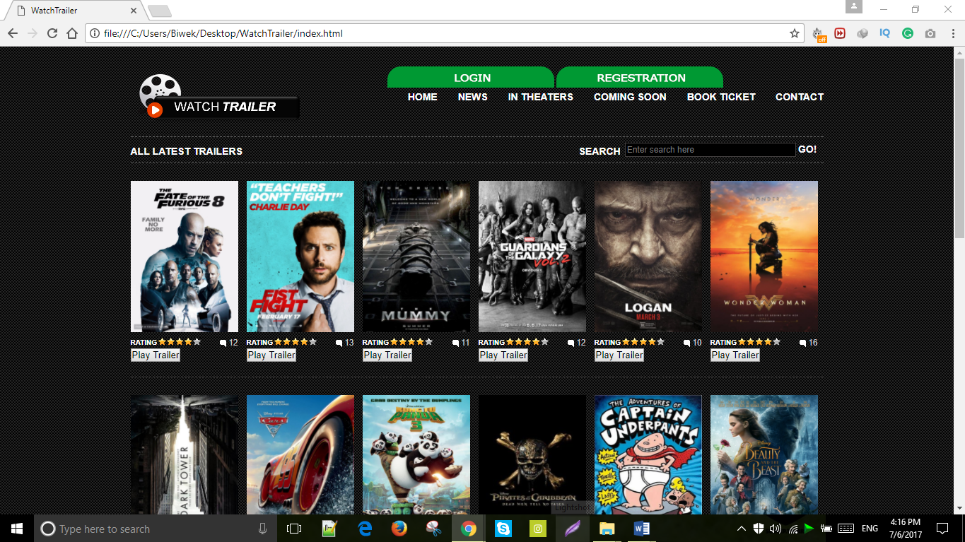

|  |  |
| --- | --- |
| **Test Case** | **2** |
| Objective | To examine the username field is blank in login page. |
| Expected Result | Must display “the username must be at least 5 character”. |
| Actual Result | It displayed the error message. |
| Conclusion | The test succeeds. |

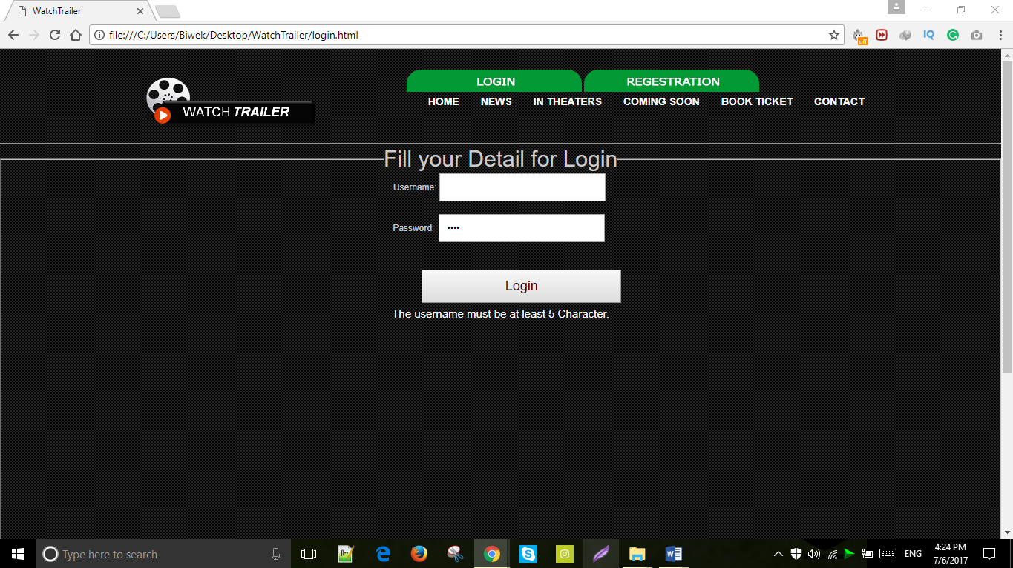

|  |  |
| --- | --- |
| **Test Case** | **3** |
| Objective | To inspect the password field is blank in login page. |
| Test Data | Admin12345 |
| Expected Result | Should display a window alert “Password field is empty”. |
| Actual Result | Display the alert “Password field is empty”. |
| Conclusion | The test succeeds. |

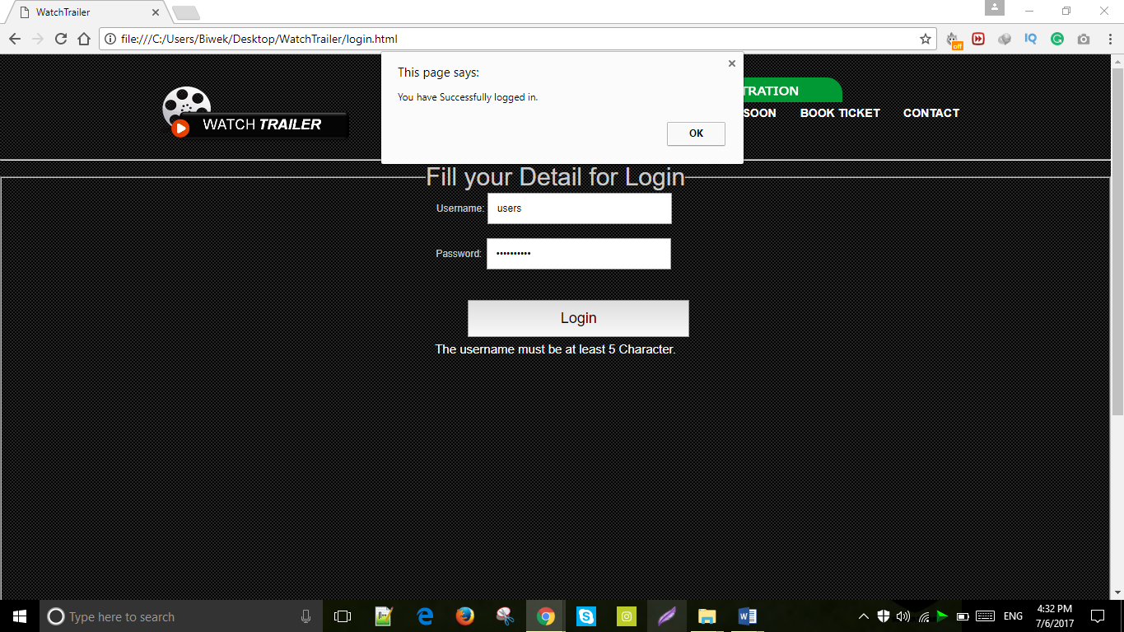

|  |  |
| --- | --- |
| **Test Case** | **4** |
| Objective | To inspect whether slider works or not. |
| Expected Result | Slider should work properly. |
| Actual Result | Slider works appropriately. |
| Conclusion | The test succeeds. |

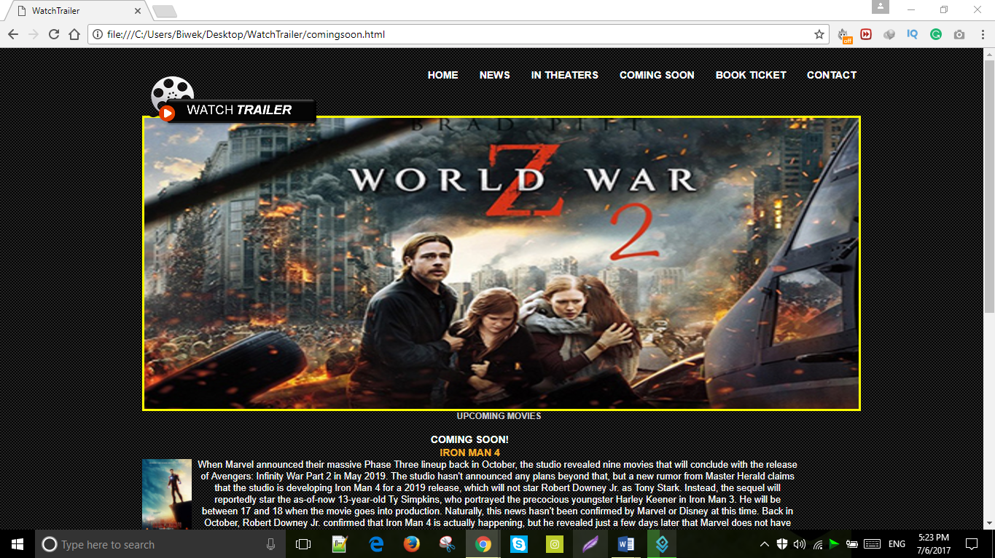

|  |  |
| --- | --- |
| **Test Case** | **5** |
| Objective | To examine home page is opened after login. |
| Expected Result | Home page should open after login. |
| Actual Result | Home page opens after login. |
| Conclusion | The test succeeds. |



|  |  |
| --- | --- |
| **Test Case** | **6** |
| Objective | To check the window alert message while entering correct username and password |
| Test Data | admin, user12345 |
| Expected Result | Should display the alert message ”You have logged into the website” |
| Actual Result | Display the alert message “You have logged into the website” |
| Conclusion | Test is successful |

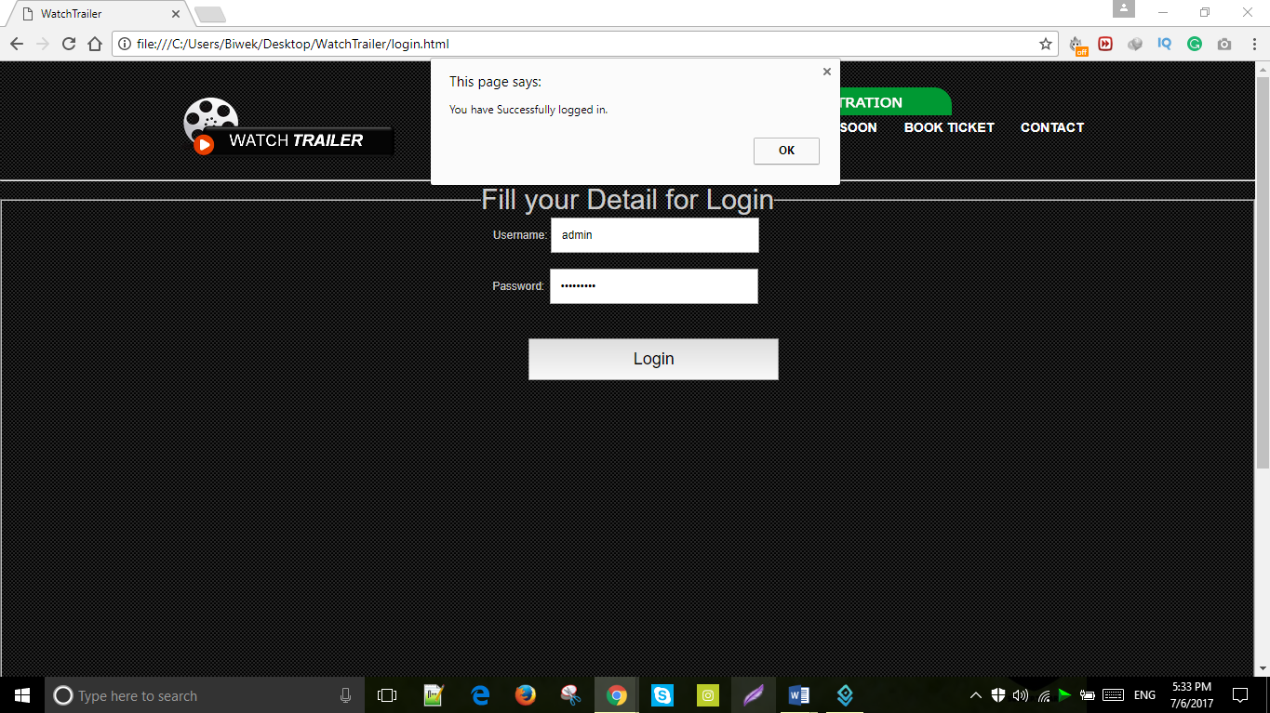

|  |  |
| --- | --- |
| **Test Case** | **7** |
| Objective | To inspect whether video is played after clicking on play trailer button. |
| Expected Result | Video should be pop-out when play trailer button is pressed. |
| Actual Result | Video opened properly. |
| Conclusion | The test succeeds. |

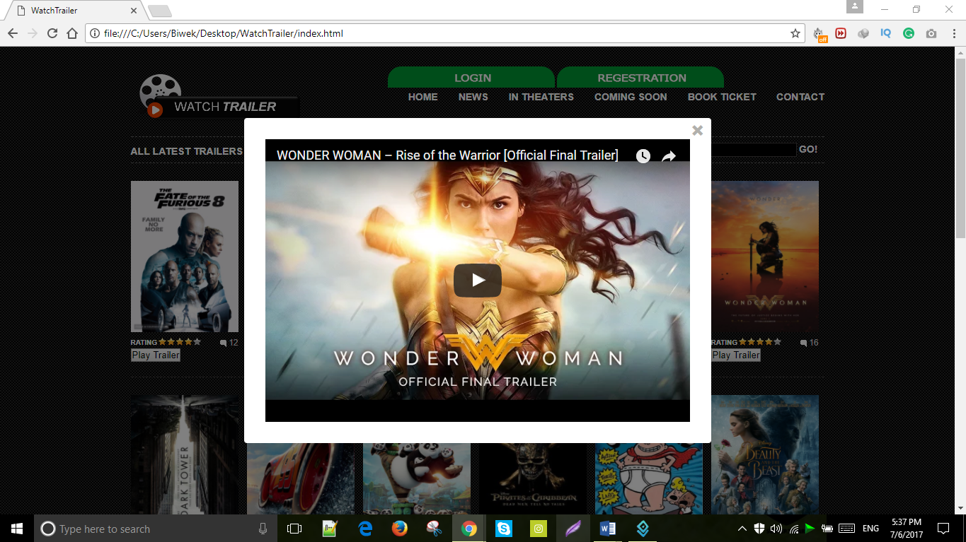

|  |  |
| --- | --- |
| **Test Case** | **8** |
| Objective | To check if form can be submitted without filling first name. |
| Expected Result | Social media links should function properly. |
| Actual Result | Social media pages open when pressed to social icons. |
| Conclusion | The test succeeds. |



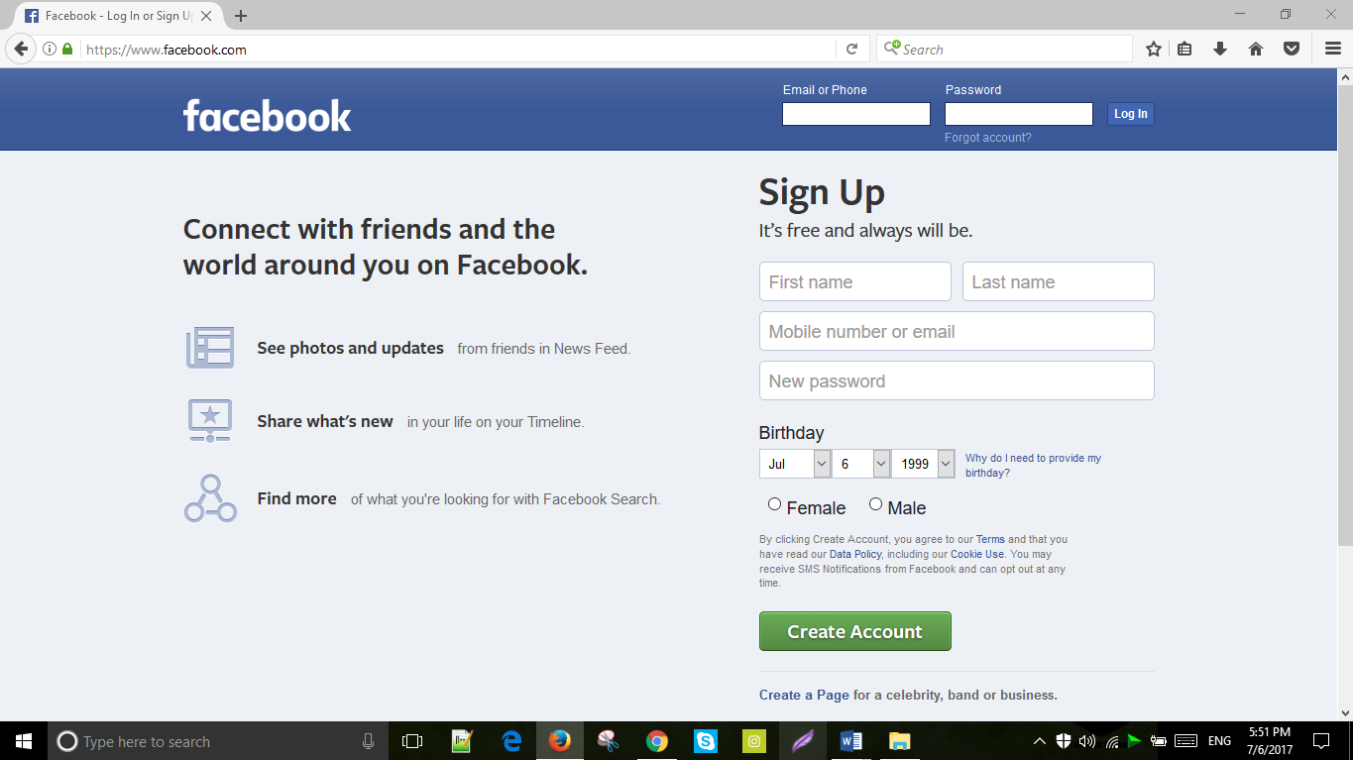

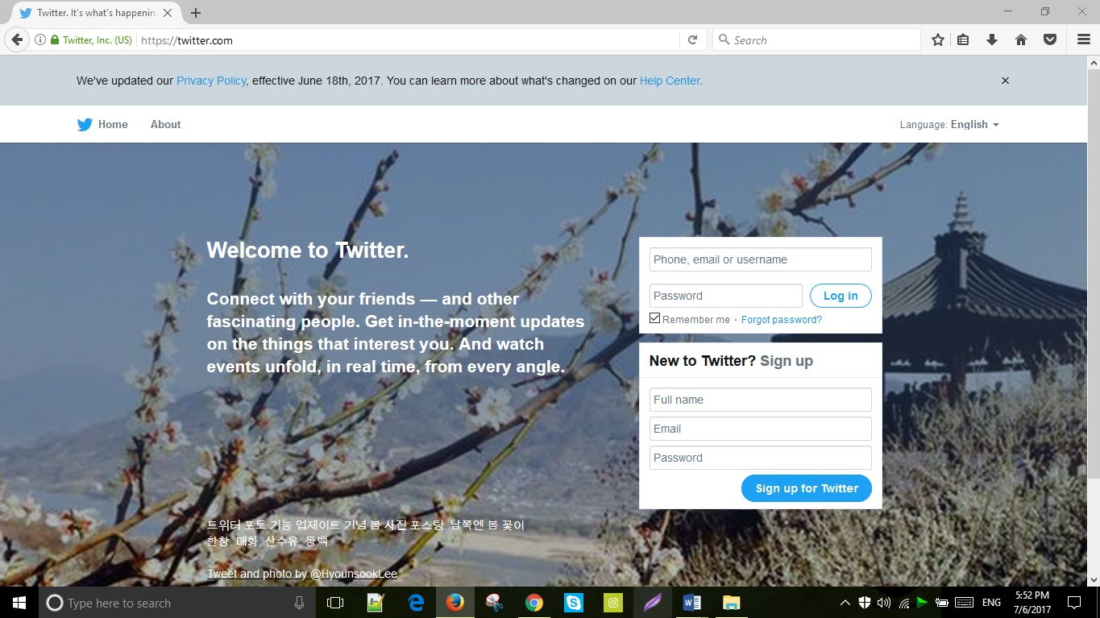

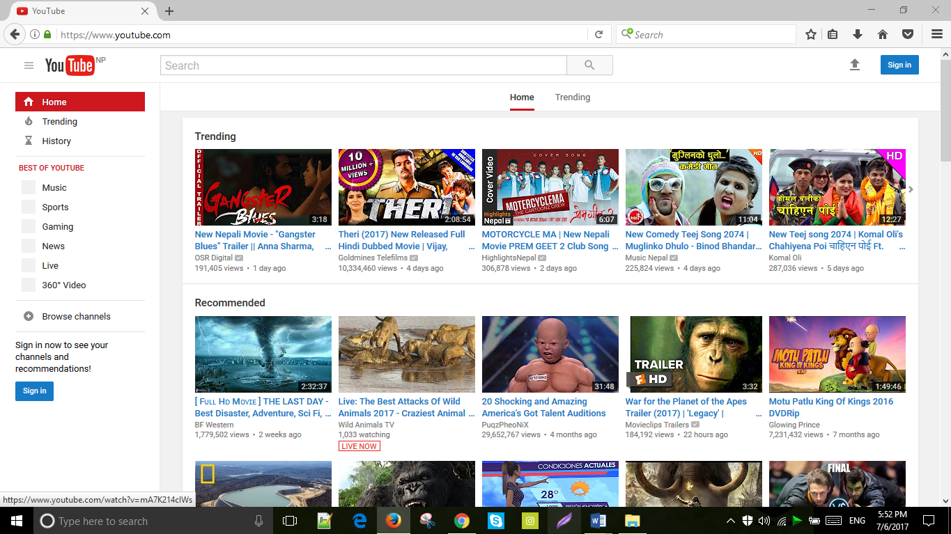

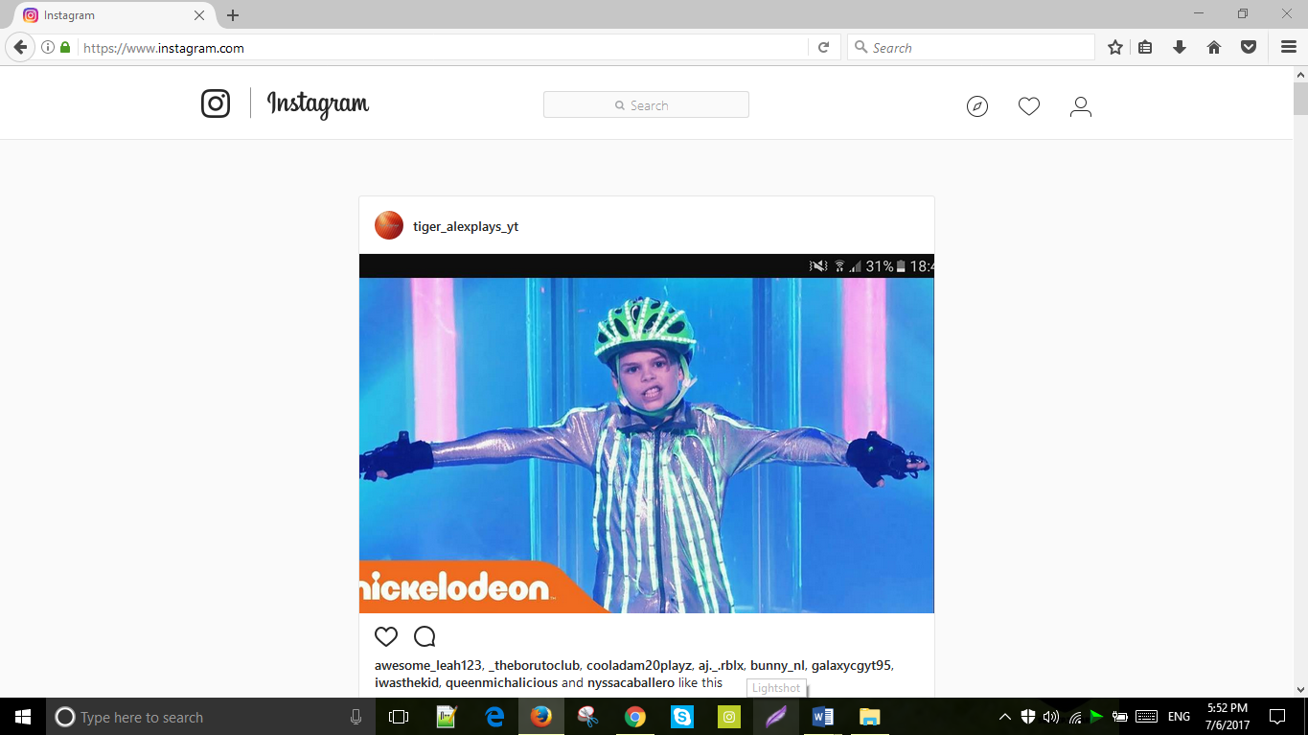

|  |  |
| --- | --- |
| **Test Case** | **9** |
| Objective | To check if form can be submitted without filling first name. |
| Expected Result | “Enter your correct name” should be displayed at bottom. |
| Actual Result | It shows “Enter your correct name”. |
| Conclusion | The test succeeds. |

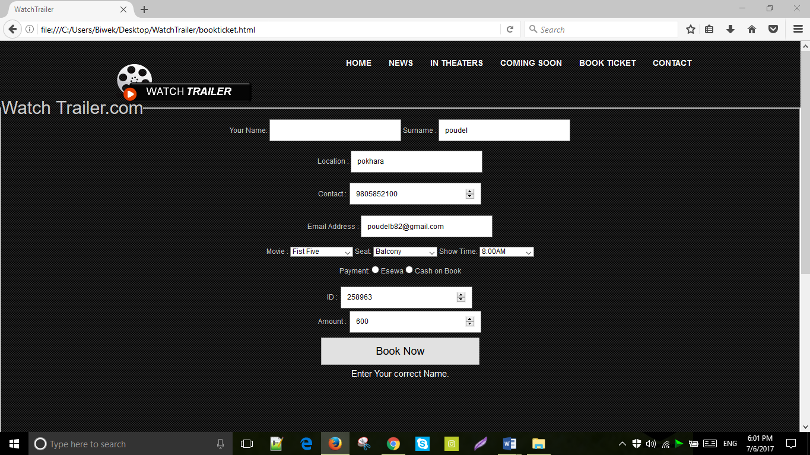

|  |  |
| --- | --- |
| **Test Case** | **10** |
| Objective | To examine if form can be submitted without filling surname. |
| Expected Result | “Please enter a valid surname” should be displayed at bottom. |
| Actual Result | It shows “Please enter a valid surname”. |
| Conclusion | The test succeeds. |

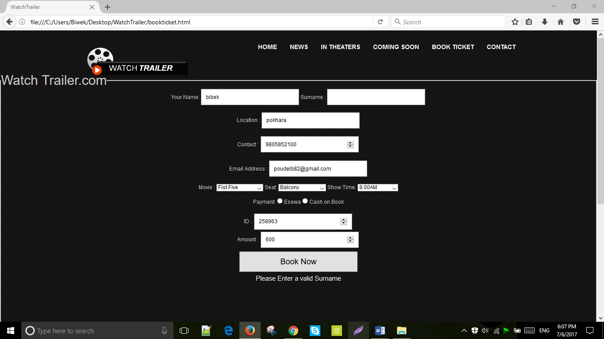

|  |  |
| --- | --- |
| **Test Case** | **11** |
| Objective | To inspect if form can be submitted with filling insufficient address. |
| Test data | Po |
| Expected Result | “Location must be 5 character” should be displayed at bottom. |
| Actual Result | “Location must be 5 character” is shown at the bottom of the page. |
| Conclusion | The test succeeds. |

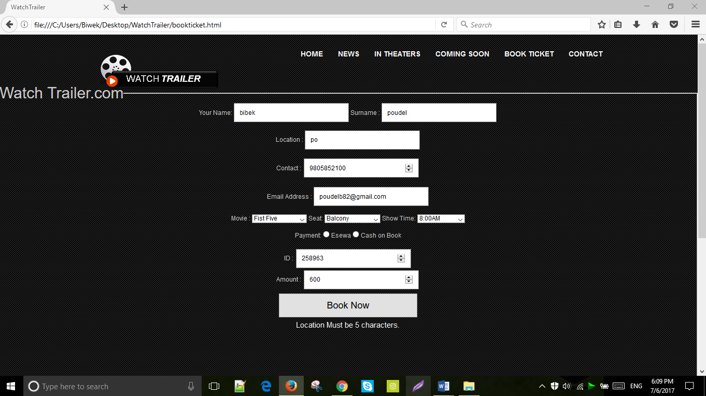

|  |  |
| --- | --- |
| **Test Case** | **12** |
| Objective | To examine if form can be submitted without choosing seat. |
| Test data | No data. |
| Expected Result | “Select a seat” should be displayed at bottom. |
| Actual Result | “Select a seat” is shown at the bottom of the page. |
| Conclusion | The test succeeds. |

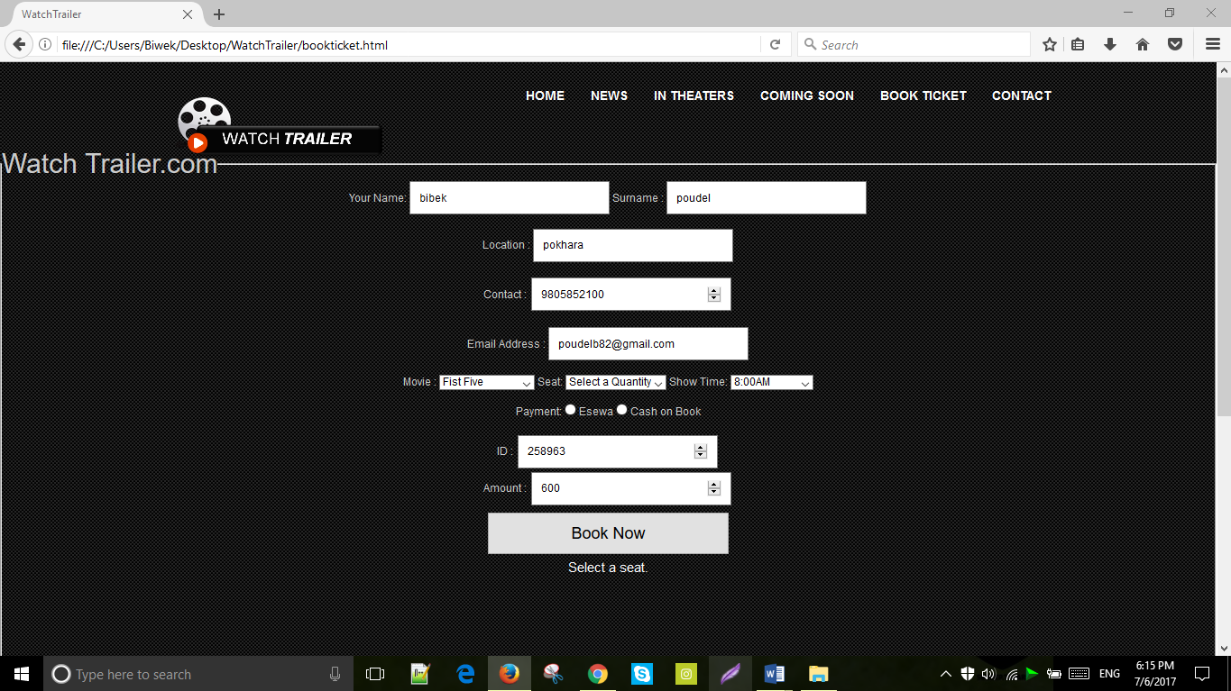

|  |  |
| --- | --- |
| **Test Case** | **13** |
| Objective | To inspect if form can be submitted without choosing movie. |
| Test data | No data. |
| Expected Result | “Choose a movie U want to watch” should be displayed at bottom. |
| Actual Result | “Choose a movie U want to watch” is shown at the bottom of the page. |
| Conclusion | The test succeeds. |

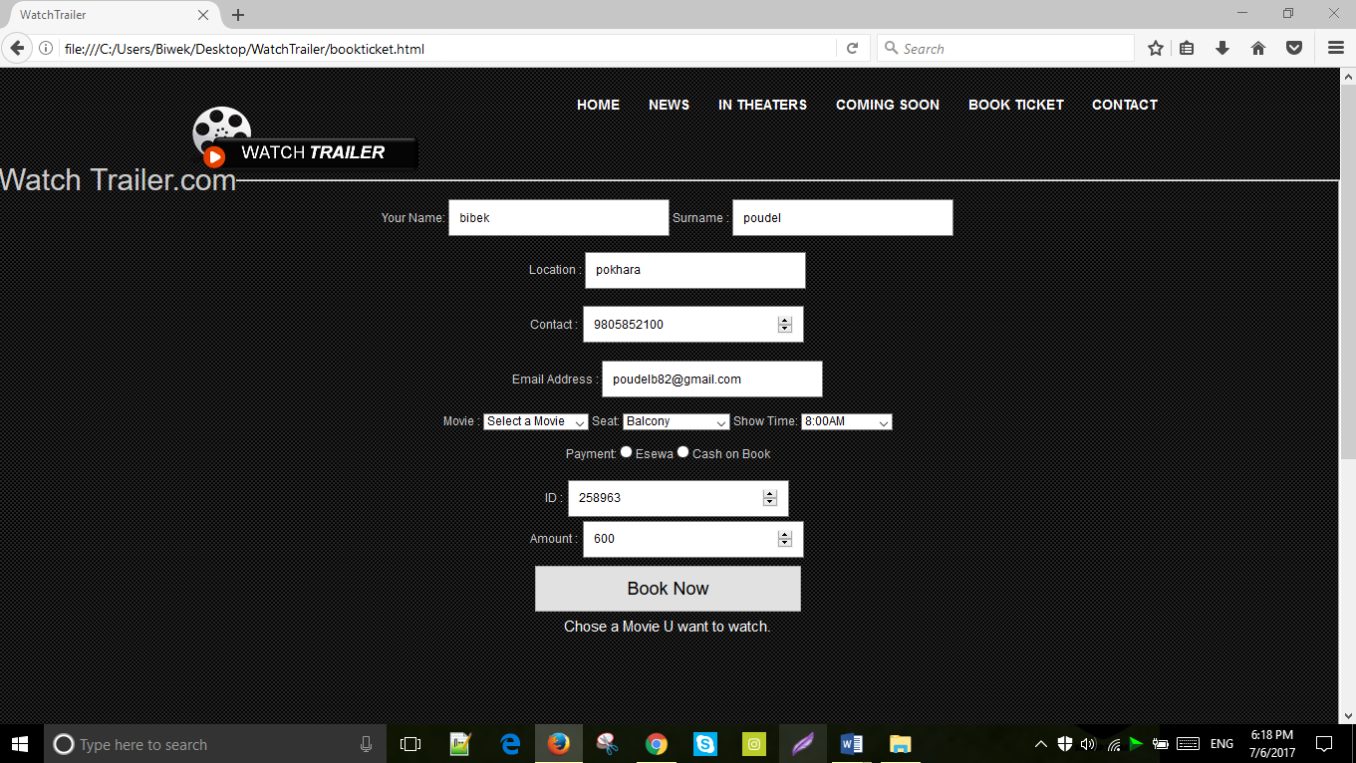

|  |  |
| --- | --- |
| **Test Case** | **14** |
| Objective | To examine if form can be submitted without selecting show time. |
| Test data | No data. |
| Expected Result | “Select show time” should be displayed at bottom. |
| Actual Result | “Select show time” is shown at the bottom of the page. |
| Conclusion | The test succeeds. |

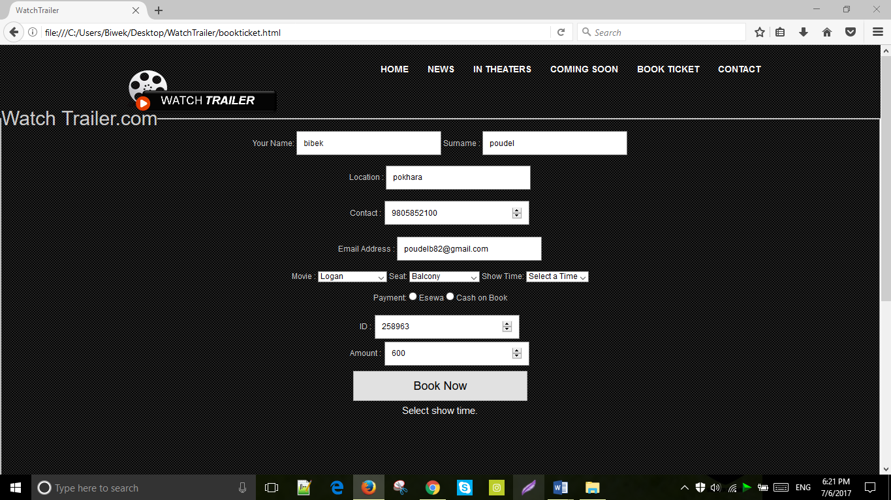

|  |  |
| --- | --- |
| **Test Case** | **15** |
| Objective | To inspect if form can be submitted without filling location. |
| Test data | No data. |
| Expected Result | “Location Must be 5 characters.” should be displayed at bottom. |
| Actual Result | “Location Must be 5 characters.” is shown at the bottom of the page. |
| Conclusion | The test succeeds. |

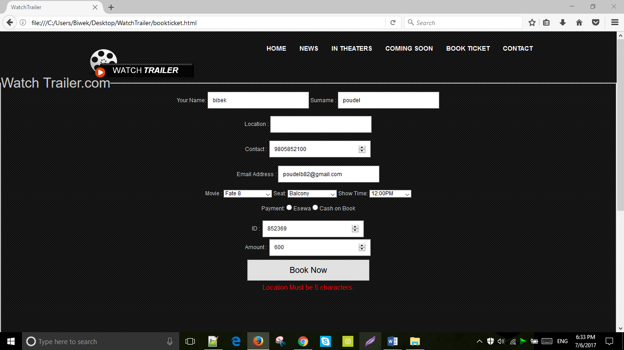

|  |  |
| --- | --- |
| **Test Case** | **16** |
| Objective | To examine if form can be submitted without filling valid email address. |
| Test data | pdl. |
| Expected Result | “Enter a Valid Email Address.” should be displayed at bottom. |
| Actual Result | “Enter a Valid Email Address.” is shown at the bottom of the page. |
| Conclusion | The test succeeds. |

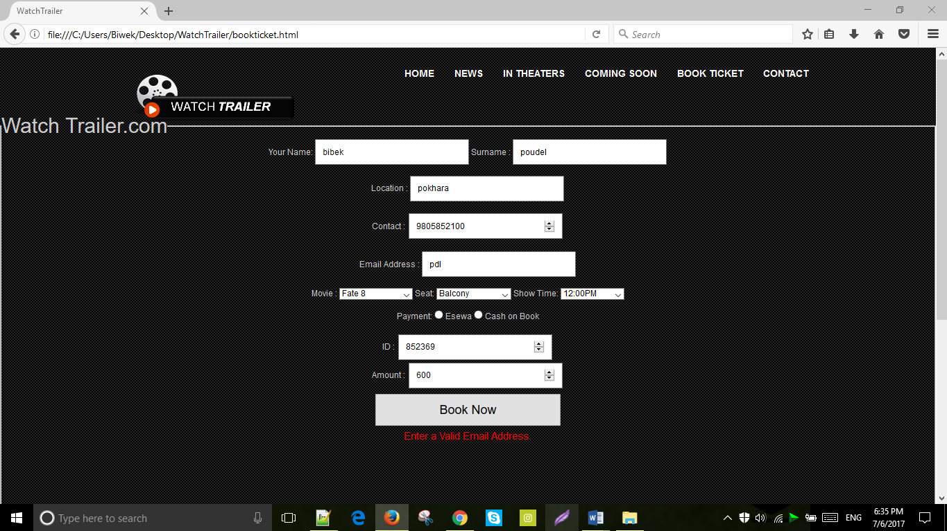

|  |  |
| --- | --- |
| **Test Case** | **17** |
| Objective | To inspect if form can be submitted with amount less than 100. |
| Test data | 78 |
| Expected Result | “Amount must contain hundreds.” should be displayed at bottom. |
| Actual Result | “Amount must contain hundreds.” is shown at the bottom of the page. |
| Conclusion | The test succeeds. |

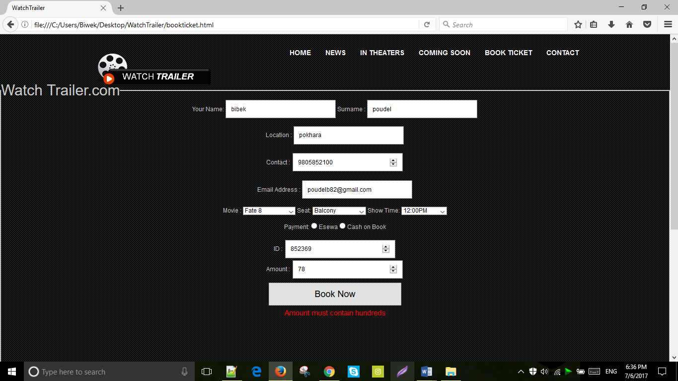

|  |  |
| --- | --- |
| **Test Case** | **18** |
| Objective | To examine if the increment and decrement by 1 button works for amount icon. |
| Test data | 4 , 2 . |
| Expected Result | Increment and decrement button should work properly. |
| Actual Result | Increment and decrement button works properly. |
| Conclusion | The test succeeds. |

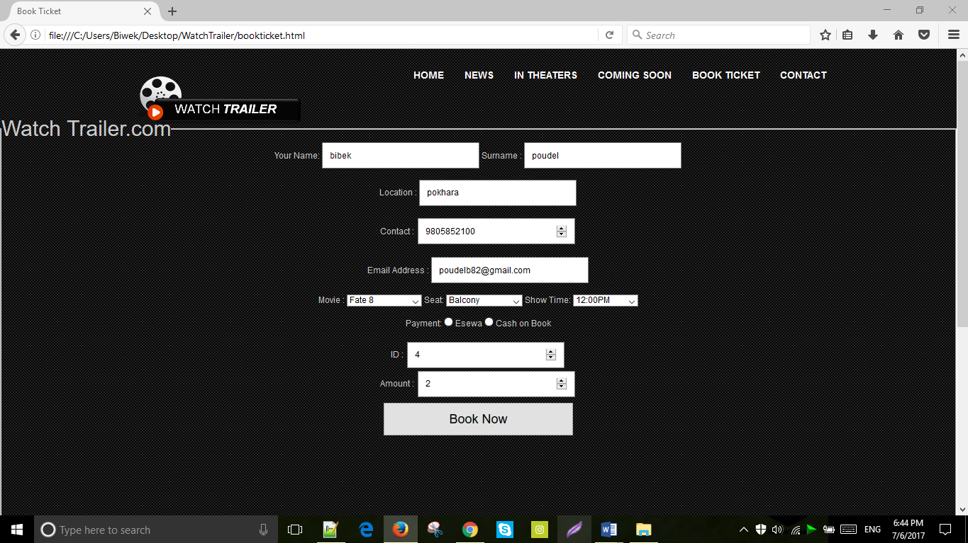

|  |  |
| --- | --- |
| **Test Case** | **19** |
| Objective | To examine if the button book now works or not. |
| Test data | No data |
| Expected Result | Window alert message “Thank you for your booking” should be displayed at top of the page. |
| Actual Result | “Thank you for your booking” is displayed at top of the page. |
| Conclusion | The test succeeds. |

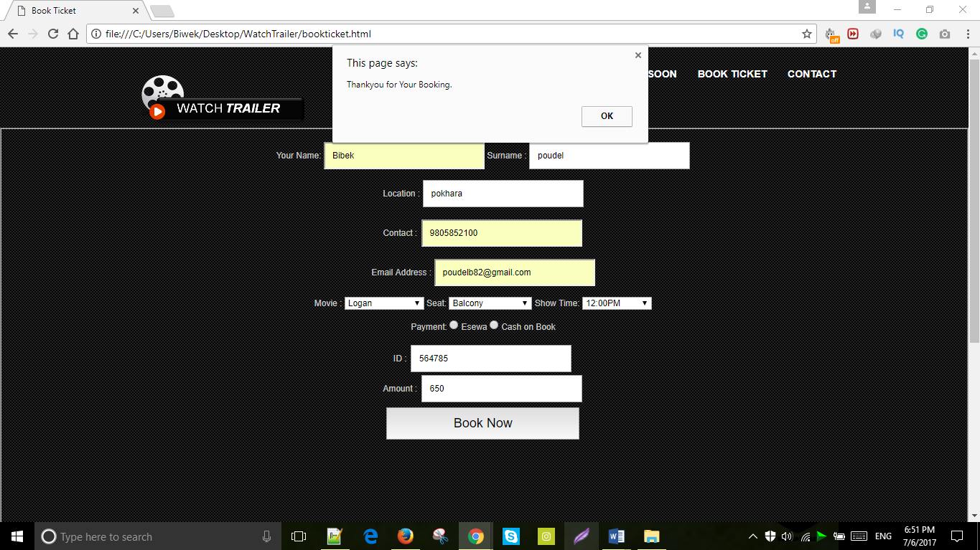

|  |  |
| --- | --- |
| **Test Case** | **20** |
| Objective | To know whether the read more button function properly or not. |
| Test data | No data |
| Expected Result | “Read more” button should work properly. |
| Actual Result | “Read more” button worked properly. |
| Conclusion | The test succeeds. |

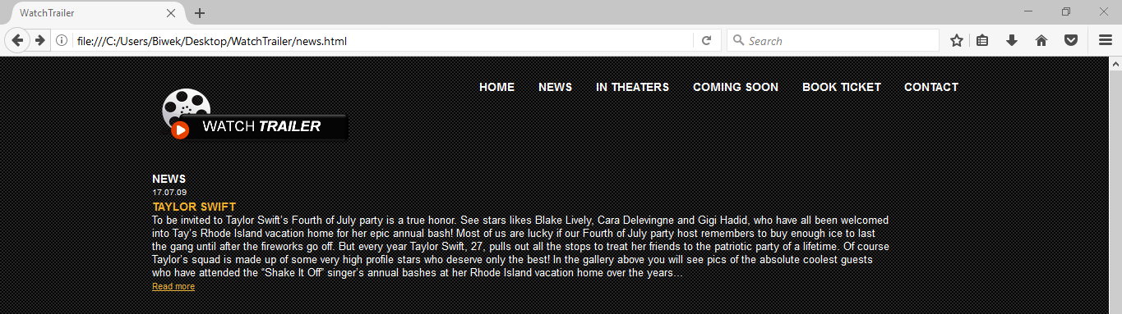

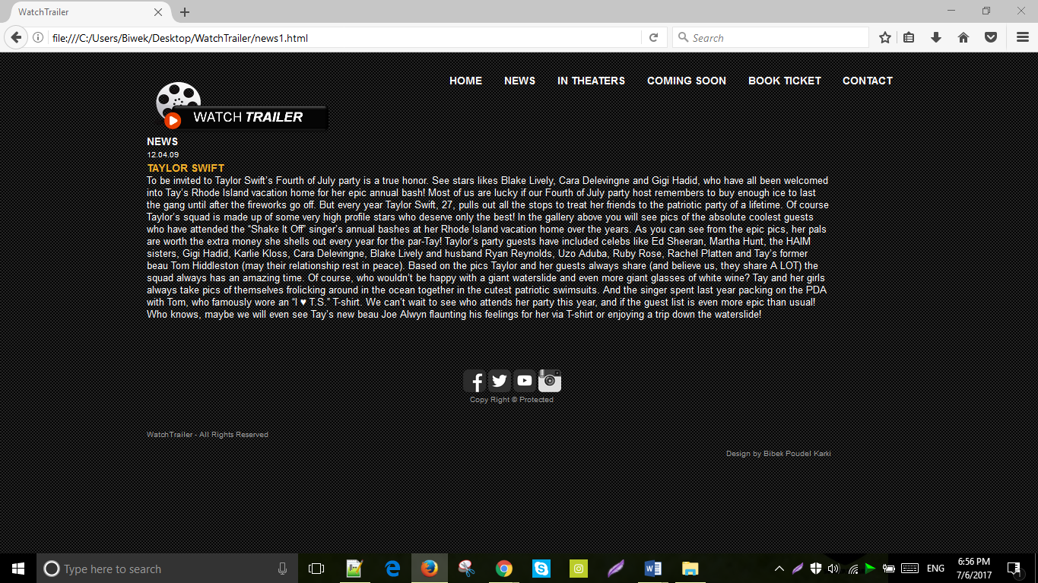

# User Guide:

## Minimum System requirement:

Software requirement:

* Operating System: window 2000 or above, vista, Linux, MACOS.
* Web browser: Mozilla browser, opera mini, Google chrome, safari, internet explorer.

Hardware Requirement:

* Hard disk: 12 GB to above variant.
* Video card: 60mb to above variant.
* Processor: Intel(R) Core(TM) to above variant.

## User Manual:

* Open the provided CD and play it.
* Install the browser in your PC such as chrome or opera.
* First open the watch trailer folder located inside the CD-Drive and then select and open index.html file.

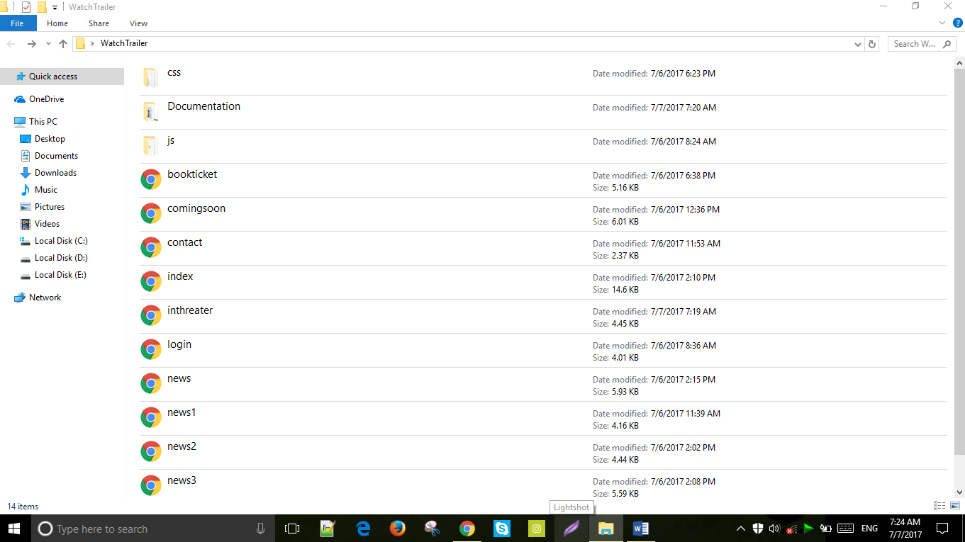

* When the user opens the home page i.e. index.html page, it shows others pages are linked with home page.

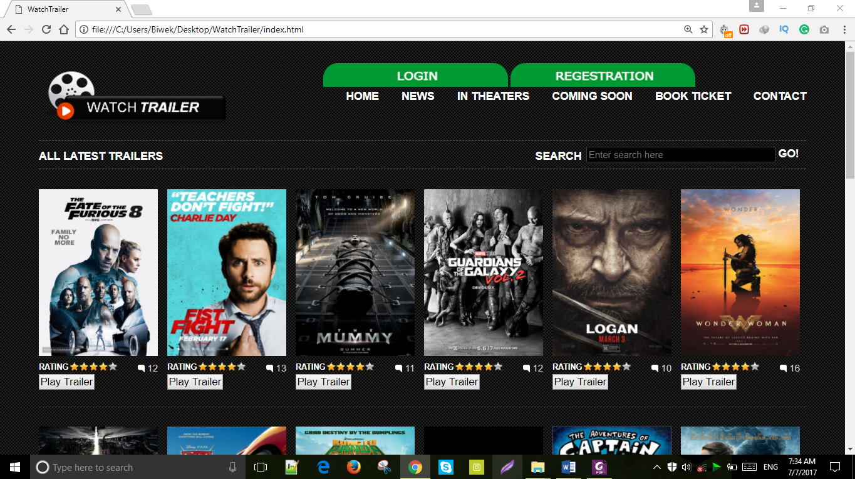

* To book a movie ticket, click “Book Ticket Link”.
* Fill up the provided form to book a ticket.

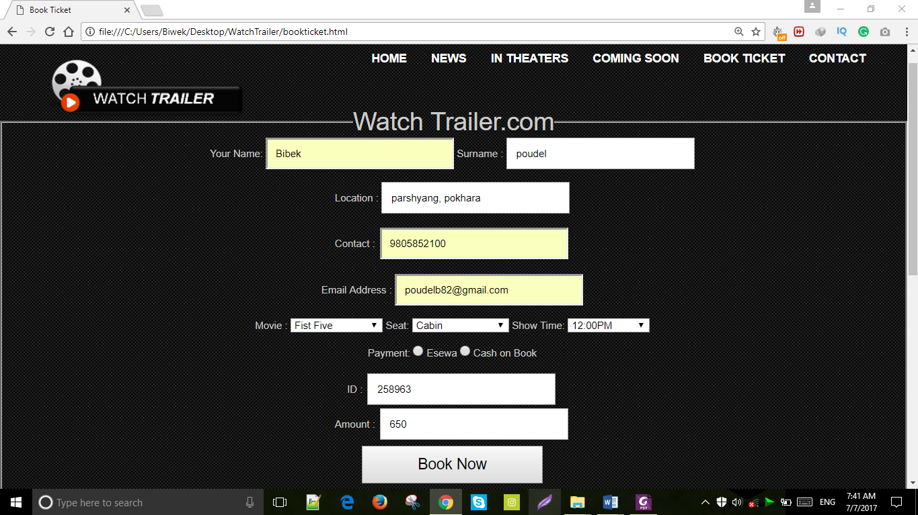

* Go to contact page to know about our website.



* Press the social media icon at the bottom of the page to visit them.



\

# Conclusion:

The main purpose of this website is to help the user about the all latest Hollywood movies trailer as well as their review, news and ticket booking system. This website is made by using JavaScript, CSS and HTML. It also consist of weakness, strength and enhancement which are discussed below:

## Strength:

* Images and video are of good quality.
* Images slideshow is used to make it more attractive and useful.
* It also consist of good user interface. So, that user can run it easily.
* Every links work properly.
* Every form are well-validated.
* It consist of simple color with attractive design.

## Weakness:

* It does have search bar at the top but it didn’t work.
* This website is not responsive.
* Admin control panel is not available to handle the website.
* It doesn’t consist of database for the storage of data.
* Username and password of the login form can be seen on the source code easily.
* The browser doesn’t support some of the JavaScript.

## Enhancement:

* Search button can be made functional.
* Database can be used to store the web data.
* Control panel can be made for admin.
* PHP, Java Applet, and many other programming language can be added to make this website more dynamic.
* User interface design can be made more attractive.
* The website can be made responsive.

# References:

* www.tutorialpoints.com
* www.wufai.edu.tw
* www.webstepbook.com
* www.javascript.com
* www.w3schools.com
* www.onlineprogrammingbooks.com
* www.htmlandcssbook.com/press
* Study guide CPG103 …. [Available at [www.icp.edu.np](http://www.icp.edu.np)]

## Turnitin Report:

